WELCOME FROM BRUCE & KAREN MCNEICE
‘Homeward Education Support’ has its roots in 1995 when the McNeice family established a non-profit ministry to provide home-educators with a legal advocacy and support service for families who teach and train their own children. Over nearly three decades, we have worked with over three thousand families as they launched out into this journey of training their children under God's watchful care, with enthusiasm, conviction and determination, occasionally mixed with fear. Our mission was to support and equip parents to train children, and to provide the resources that will best do this task. We also believed in supporting all home-educators whether using our recommended curriculum or not.
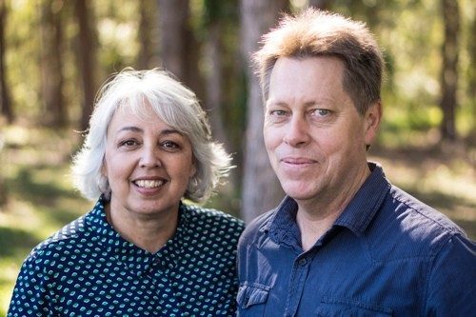
In 2007, Bruce & Karen were finishing off the education of their family (five children) at home. Realising that even though their own children had experienced a successful education, they wanted to research how to help children who needed remedial and special needs assistance. So, as Bruce had done some post-graduate studies in this area, they began to take on disengaged, failing, and special needs children to gain more experience at applying Charlotte Mason’s principles, and turning these children around from failure to success. Between 2007 and 2016, Bruce and Karen homeschooled up to twelve teenage children (from other families) each year and took most of them through to tertiary entrance. They gained more experience by having some of them living with them for a time and doing foster-care training. Now the next generation is coming through as some of Bruce and Karen’s 20 grandchildren are learning at home.
About Bruce: In his early married life, Bruce was originally a professional dancer (Ballet, Contemporary, and Ballroom), but realising the need for homeschoolers to have a support service, he returned to university to do further studies in the teaching of Primary, Secondary & Distance Education. He has been teaching and training students of all ages, since 1980; has done post-graduate research into home-education towards a Masters Degree in Education; been a homeschooling legal-advocacy consultant; then founding Principal of a Prep to Year 12 day-school and school of distance-education for five and a half years, before deciding to re-establish a home-education support service that would be free from government funding and influence.
About Karen: After tertiary studies in Social Work and Performing Arts, Karen launched into motherhood and homeschooling five children with a particular interest in creative approaches to education with practical 'hands-on resources'. During her homeschooling, she has experimented with a range of methods such as ‘programmed workbooks’, ‘natural learning’, the 'unit-study method', and the ‘Charlotte Mason Method’. She spent 10 years teaching teenagers from other families, while completing a humanities degree with Tabor College Adelaide majoring in History, Literature and Philosophy.
“When we started homeschooling, I wanted to harness and encourage my children's natural and God-given inquisitiveness. I wanted to give room for them to 'discover' and learn by 'doing' practical & creative learning activities (while also teaching foundational skills, knowledge & wisdom of course); and wanted them to think deeply about the world around them as well as learning what God thought about what He created. We wanted to learn together as a family, so a multi-age 'unit-study' approach with a Charlotte Mason flavour has worked well for us. We’ve always been greatly inspired by Charlotte Mason’s methods, so these became integral to our way of homeschooling.”
For those of you who are currently going through difficult times with your children, we want to encourage you that such great rewards will come out of your perseverance with your children. We cannot even begin to express what a wonderful privilege it is to enable our children to grow up being our friends and co-workers. What a joy it was to see our children growing in godly character as well as practical competence and social ability. It was encouraging to witness them coming through their teen years passionate about life and with a desire to not only fulfil their own calling & destiny, but to help other young people to achieve their potential in life.
Try to hear our heart. It is not that we want to give the impression that “we’ve made it”. We have made lots of mistakes and so have our children. Learning from mistakes is a part of life. We have co-journeyed with you and have had our own trials and challenges to work through. There were some things we could have done better. However, we have enjoyed a certain quality of family life that we believe should be available to everyone; if only they knew how to tap into this Abundant Life. Homeschooling won’t solve all your problems; and there is never a guarantee that your children will turn out exactly as you had hoped. As they spread their wings, they will no doubt make their own choices for good or ill. But the principles that we have learnt along the way and want to share with you, are profound & simple, yet, if applied diligently, can move you in a more positive direction.
We are not here to control what you do with your family. But, now that our children have grown and married with children of their own, we are here to serve and encourage you in your home-training. No doubt, you have lots of questions. Please don't hesitate to contact us if we can be of any further assistance; we're only an email or phone call away if you need. We look forward to serving you and your family in the future.
God bless you richly,
Bruce & Karen McNeice

