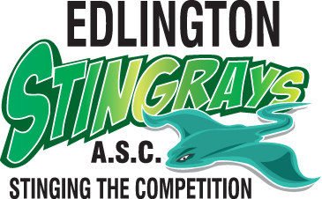
Member’s Code of Conduct
General behaviour

- I will treat all members of, and persons associated with, the ASA with due dignity and respect.
- I will treat everyone equally and never discriminate against another person associated with the ASA on any grounds including that of age, sexual orientation, gender, faith, ethnic origin or nationality.
- I understand that the use of inappropriate or abusive language, bullying, harassment, or physical violence will not be tolerated and could result in action being taken through the disciplinary or child welfare policies.
- I will display a high standard of behaviour at all times.
- I will always report any poor behaviour by others to an appropriate officer or member of staff.
- I will recognise and celebrate the good performance and success of fellow club and team members.
- I will respect the privacy of others, especially in the use of changing facilities.

Training

- I will treat my coach and fellow members with respect.
- I will make my coach aware if I have difficulties in attending training sessions as per the rules laid down for my squad.
- I will arrive in good time on poolside before the training session starts to complete poolside warm up as directed by my coach.
- I understand that if I arrive late, I must report to my coach before entering the pool.
- I will ensure that I have all of my equipment with me, e.g. paddles, kick boards, hats, goggles, etc.
- If I need to leave the pool for any reason during training, I will inform my coach before doing so.
- I will listen to what my coach is telling me at all times and obey any instructions given.
- I will always swim to the wall as I would do in a race, and I will practice turns as instructed.
- I will not stop and stand in the lane, or obstruct others from completing their training.
- I will not pull on the ropes as this may injure other members.
- I will not skip lengths or sets – to do so means I would only be cheating myself.
- I will think about what I am doing during training, and if I have any problems, I will discuss them with my coach at an appropriate time.
- If I have any problems with the behaviour of fellow members, I will report them at the time to an appropriate adult.

Competitions

- At competitions, whether they be open meets, national events or club galas, I will always behave in a manner that shows respect to my coach, the officers, my team mates and the members of all competing organisations.
- I understand that I will be required to attend events and galas that the Chief Coach has entered/selected me for, unless agreed otherwise by prior arrangement with the relevant official and coach.
- I understand that I must wear appropriate swimwear, tracksuits, T-shirts/shorts and hats as per the rules laid down by the organisation.
- I will report to my coach and/or team manager on arrival on poolside.
- I will warm up before the event as directed by the coach in charge on that day and ensure I fully prepare myself for the race.
- I will be part of the team. This means I will stay with the team on poolside.
- If I have to leave poolside for any reason, I will inform, and in some cases, get the consent of the team manager/coach before doing so.
- After my race, I will report to my coach for feedback.
- I will support my team mates. Everyone likes
to be supported and they will be supporting me in return.
- I will swim down after the race if possible, as advised by my coach.
- My behaviour in the swim down facility must be appropriate and respectful to other users at all times.
- I will never leave an event until either the gala is complete or I have the explicit agreement of the coach or team manager.

Signed: Date:

