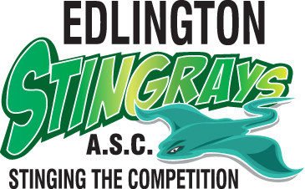

Code of Conduct for coaches and teachers

- Put the wellbeing, health and safety of members above all other considerations, including the development of performance.
- At all times, adhere to the ASA Code of Ethics, Rules and Laws.
- At all times, adhere to Wavepower.
- At all times, adhere to the ASA Equality and Diversity Policy.
- Consistently display high standards of behaviour and appearance.
- Treat all members with respect and dignity, value their worth and treat everyone equally, recognising their varying needs and abilities within the context of the sport.
- Develop an appropriate working relationship with members based on mutual trust
and respect.
- Always ensure that all teaching, coaching and competition programmes are appropriate for the age, ability and experience of the individual member.
- Always identify and meet the needs of the individual member as well the needs of the team/squad.
- Be fair and equal in team and training squad selection.
- Never exert undue influence to obtain personal benefit or reward. In particular, coaches must not use their position to establish or pursue a sexual or improper relationship with an athlete, member or someone close to them.
- Encourage and guide members to accept responsibility for their own behaviour and performance.
- Continue to seek and maintain their own professional development in all areas in relation to coaching and teaching children.
- Complete a child safeguarding training course every three years in line with the guidance in Wavepower.
- Treat all information of a personal nature about individual members as confidential, except in circumstances where to do so would allow the child to be placed at risk of harm or continue to be at risk of harm.
- Encourage all members to obey the spirit of the rules and regulations both in and out
of the pool.
- Co-operate fully with other specialists (e.g. other coaches, officials, sport scientists, doctors or physiotherapists) in the best interests of
the member.
- Never encourage or condone members, volunteers, officials or parents to violate the rules of the organisation or the sport, and report any violations appropriately.
- Observe the authority and the decision of the officials and only question those decisions in the appropriate manner.
- Treat all competitors and teams of other organisations with respect, whether that is in victory or defeat, and encourage all members to do the same.
- Refer all child safeguarding concerns in accordance with the procedures detailed in Wavepower.

Signed: Date:
This code is an extension to the ASA Code of Ethics. Both should be followed.

