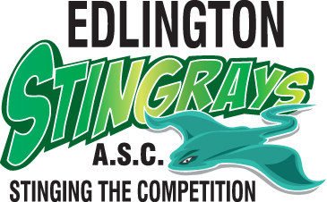

Code of Conduct for committee members, officials and volunteers
  - At all times, adhere to the ASA Code of Ethics, Rules and Laws.
  - At all times, adhere to Wavepower.
  - At all times, adhere to the ASA Equality and Diversity Policy.
  - Adhere fully to the role and job description as outlined by the organisation and never use that role to gain favour for yourself or any individual member.
  - Consistently display high standards of behaviour and appearance.
  - Treat all members with respect and dignity, value their worth and treat everyone equally, recognising their varying needs and abilities within the context of the sport.
  - Encourage and guide members to accept responsibility for their own behaviour and performance.
  - Continue to seek and maintain your own development in line with your role and complete a child safeguarding training course, if appropriate to your role.
  - Treat all information of a personal nature about individual members as confidential, except in circumstances where to do so would allow the child to be placed at risk of harm or continue to be at risk of harm.
  - Encourage all members to obey the spirit of the rules and regulations both in and out
of the pool.
  - Never encourage or condone members, volunteers, officials or parents to violate the rules of the organisation or the sport, and report any violations appropriately.
  - Observe the authority and the decision of the officials and only question those decisions in the appropriate manner.
  - Treat all competitors and teams of other organisations with respect, whether that is in victory or defeat, and encourage all members to do the same.
  - Refer all child safeguarding concerns in accordance with the procedures detailed in Wavepower 2016-19.

Signed: Date:
This code is an extension to the ASA Code of Ethics. Both should be followe

