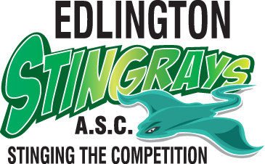

Parent’s Code of Conduct
  - I will complete and return the Medical Information Form as requested by the organisation and provide details of any health conditions/concerns relevant to my child on the consent form. I will report any changes in the state of my child’s health to the coach prior to training sessions or events. I will ensure that the organisation has up-to-date contact details
for me and for any alternative person(s) as required.

  - I will deliver and collect my child punctually to and from training sessions/events. I will inform a member of the committee or coaching
staff if there is an unavoidable problem.
If the organisation changes my child’s lane and/or changing times, I will remember that the change is to provide appropriate levels
of training and to enable my child to progress, and I should therefore support and encourage this at all times.

  - I will ensure my child is properly and adequately attired for the training session/ events including all mandatory equipment,
e.g. hats, goggles, etc.

  - I will inform the coach/welfare officer before a session if my child is to be collected early from a training session/event and if so, by whom.

  - I will encourage my child to obey the rules and teach them that they can only do their best.

  - I will behave responsibly as a spectator during training/events and treat members, coaches, committee members and other parents of members of both my child’s organisation and any other organisation with due respect, in accordance with the ASA commitment
to equality and diversity.

  - I will not use inappropriate language within the organisation environment.

  - I will show appreciation and support my child and all the team members.

  - I will ensure my child’s needs are met in terms of nutrition and I will listen to advice given from the coach/nutritionist.

  - I will support the coach and committee appropriately and raise any concerns I may have in an appropriate manner to the welfare officer.
  - I will not enter poolside unless requested to do so or in an emergency.

  - If I wish to have a discussion with the coach, I will check with the welfare officer as to how this can be arranged.

  - Most of all, I will help my child to enjoy the sport and to achieve to the best of their ability.

The organisation will:

- Inform you at once if your child becomes ill and will ensure their wellbeing until you are able to collect him/her.
- Ensure good child safeguarding guidelines are followed at all times to keep your child safe.
- Ensure all activities are properly supervised/ taught/coached and that consent is obtained for any activity outside of that previously agreed.

You have a right to:

- Make a complaint to the organisation if you feel the organisation or a member of the organisation is not acting appropriately or in accordance with ASA/organisation rules and regulations. Details of how to do this can be obtained from the welfare officer.
- Make a complaint on behalf of your child to the ASA Office of Judicial Administration.

Signed:

Date:

