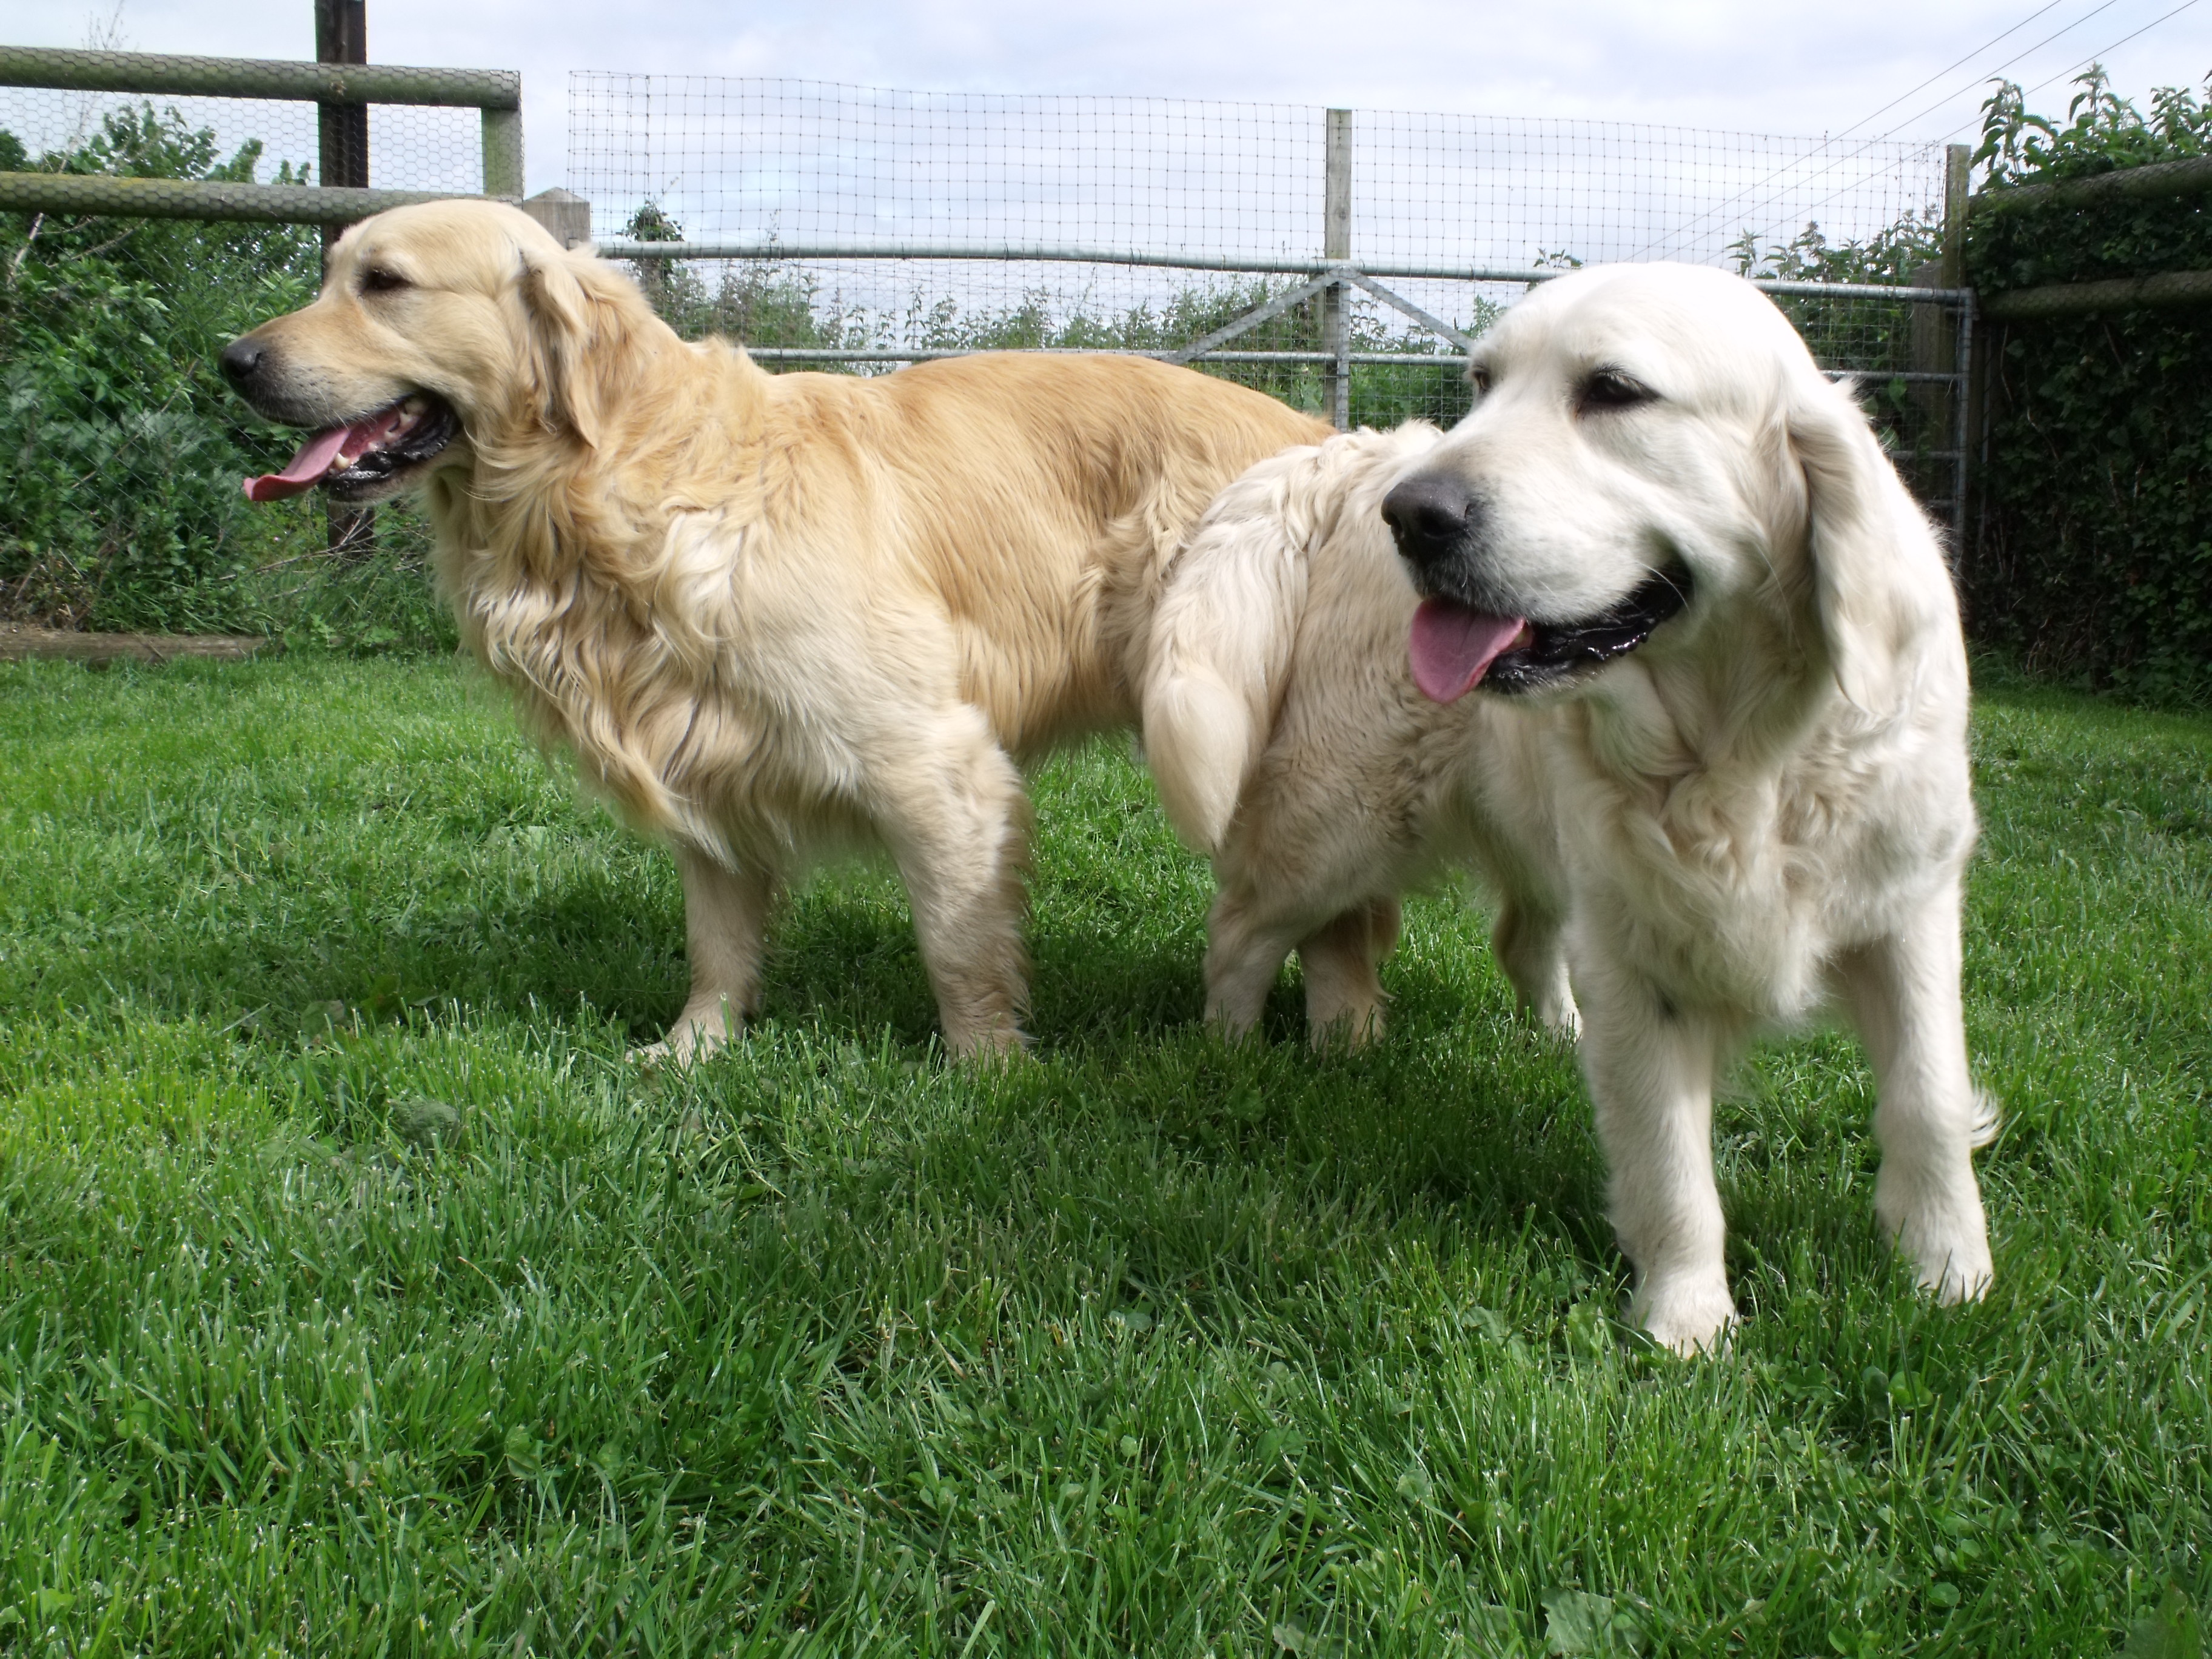the golden retriever experience
invites

Pawl Pawson

for a 2 hour session of fun-filled dog cuddles for four on
a date of your choice from 1st April to 31st October 2022

Happy Birthday Pawl! Yes, you are going to the Golden Retriever Experience!! Love Mum & Dad xx

Book your pre-paid session at thegoldenretrieverexperience.com

