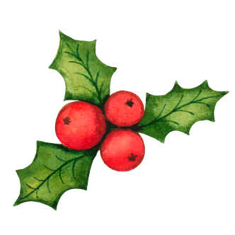
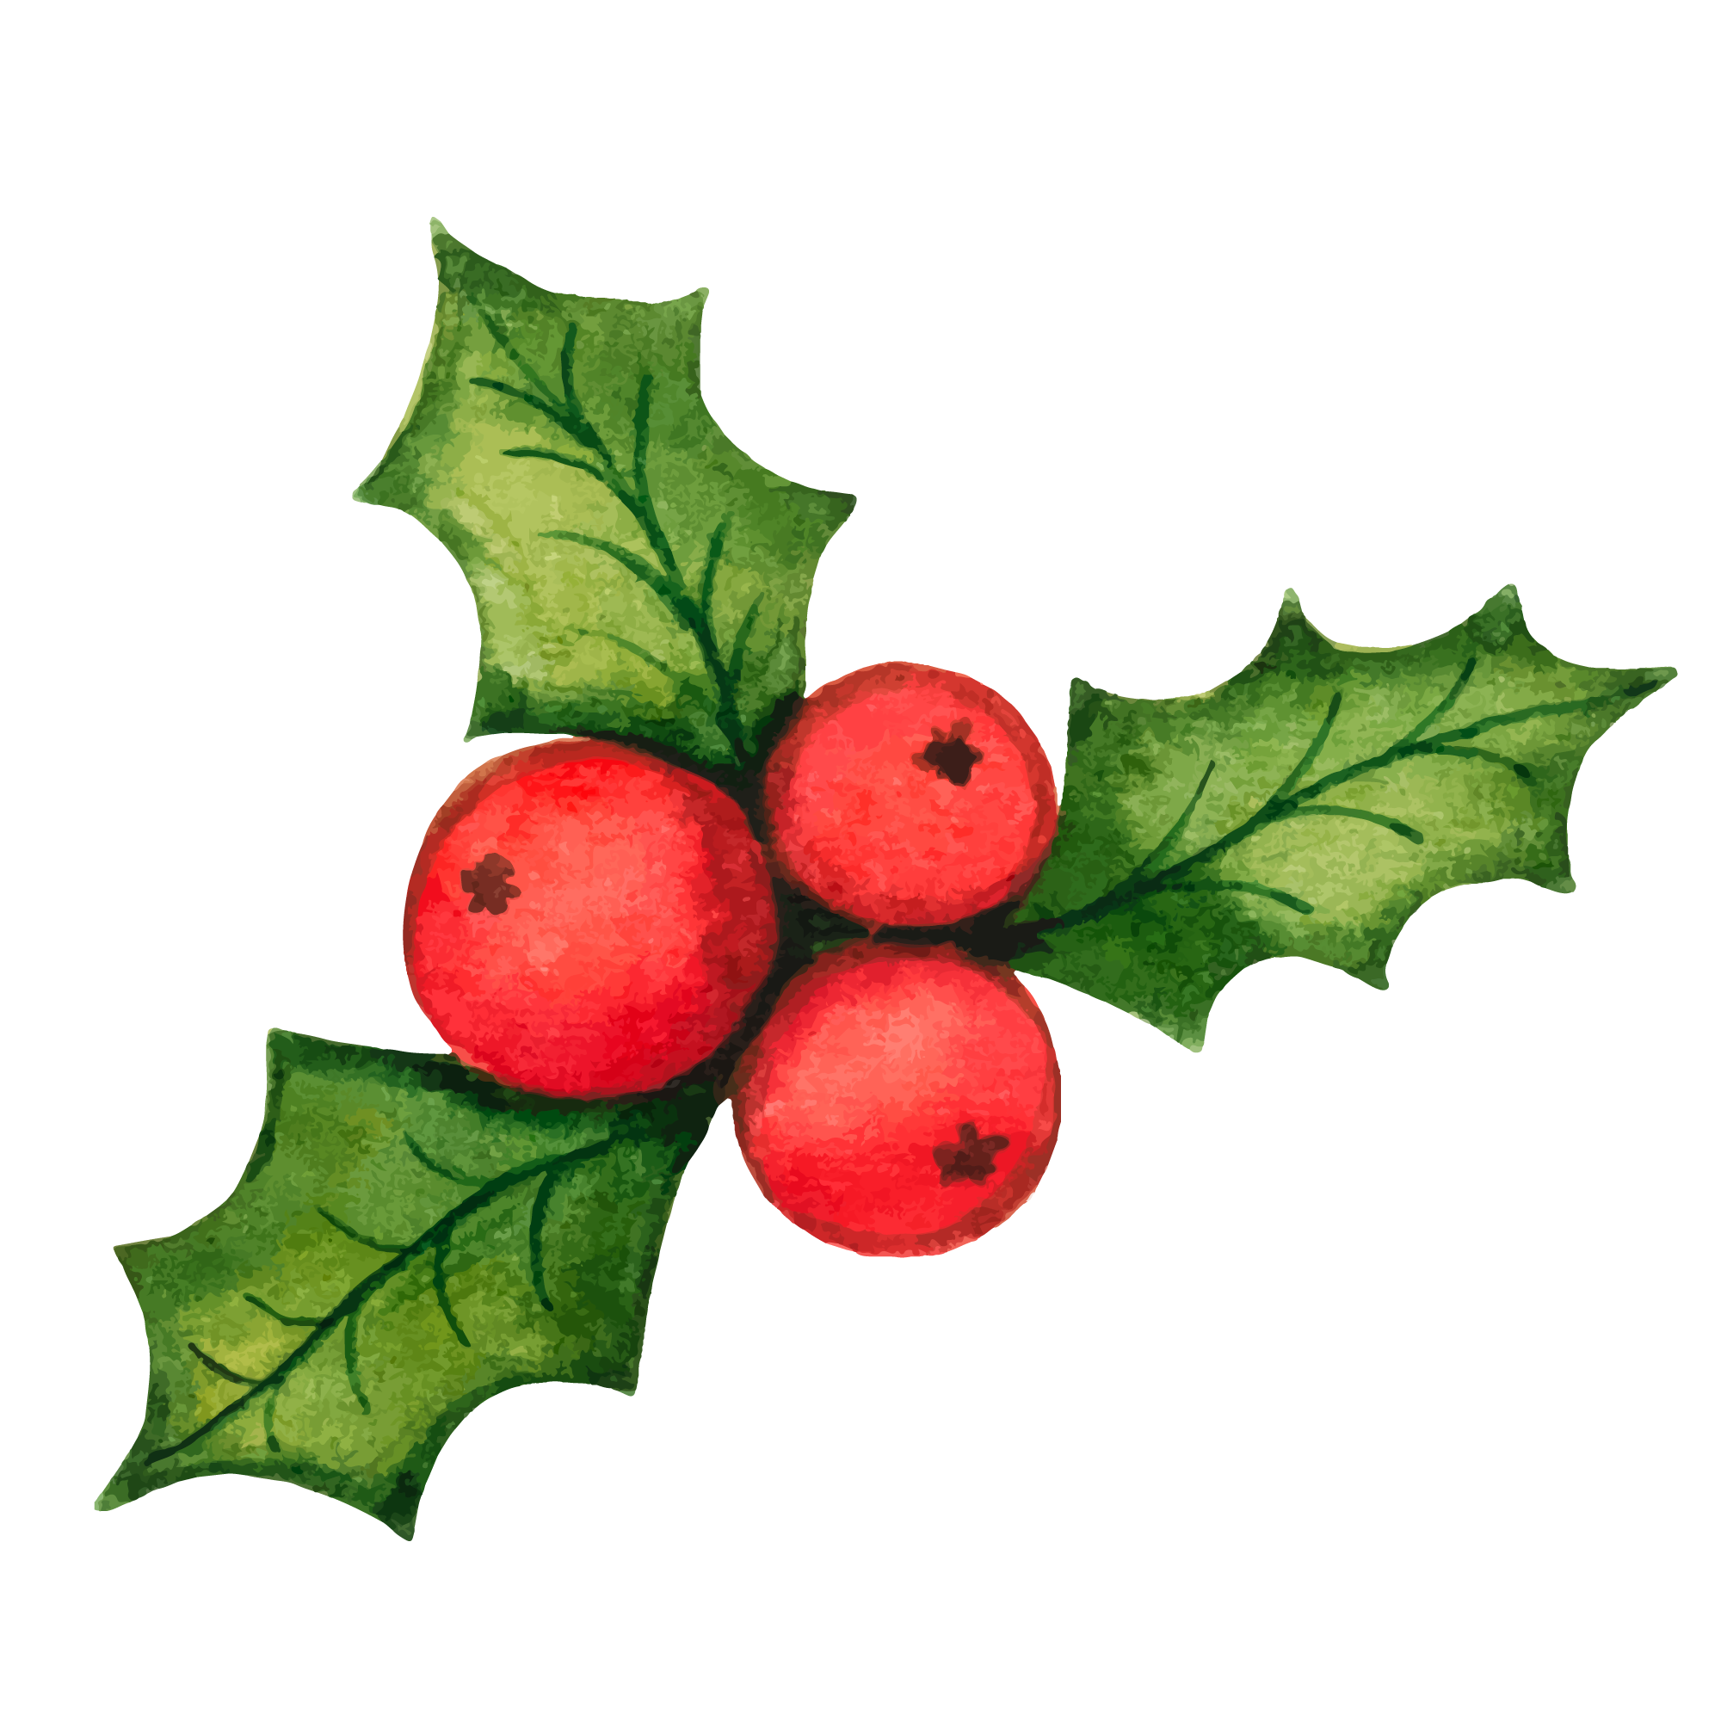the golden retriever experience

invites

Pawl Pawson

for a 2 hour session of fun-filled dog cuddles for two on
a date of your choice from 1st April to 31st October 2022

Merry Christmas Pawl! Lots of Love xxx
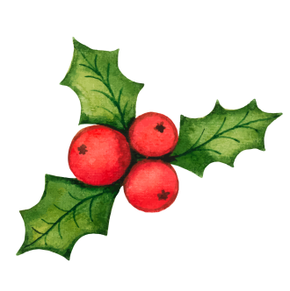
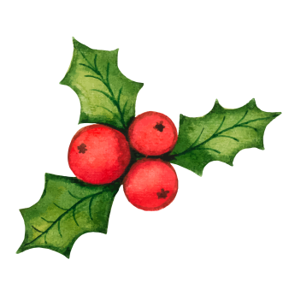
Book your pre-paid session at thegoldenretrieverexperience.com

