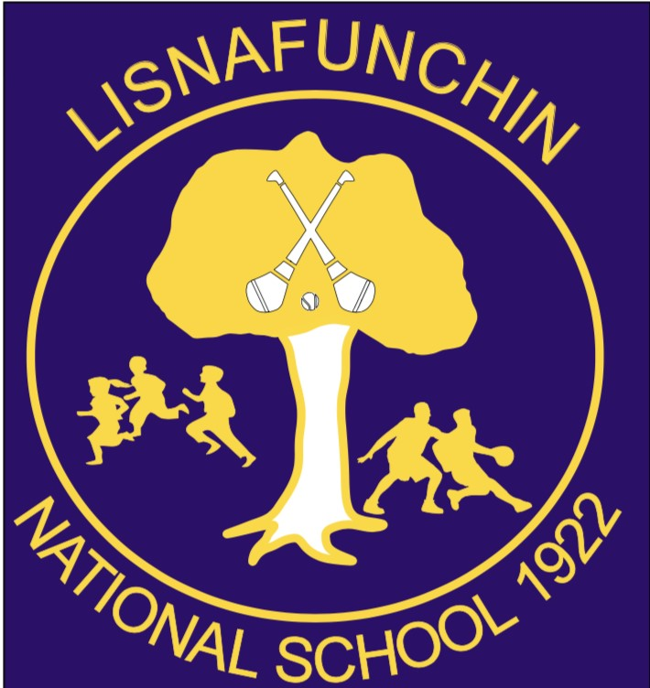
Information and Communication Technologies (ICT) Policy/Digital Learning Plan

Introductory Statement
This document is a statement of the aims and objectives, principles and strategies for ICT in Johnswell National School. The policy was first developed in 2019
The purpose of this policy is to provide an overview of ICT in our school and to set out our general aims and goals in delivering ICT to the pupils. Our policy provides us with a framework for long and short term planning which will be of benefit to the teaching and learning of ICT in Johnswell NS. Our policy provides information for all teachers, the Board of Management and parents of the approaches and methodologies being used in the teaching of the ICT, emphasising the key messages of ICT.
Vision for ICT
ICT is a powerful tool which is central to the educational process. The Staff at Lisnafunchin NS recognise the potential of ICT at the heart of the curriculum in terms of learning and teaching and as a core competence for the pupils. We aim to develop and strengthen the use of ICT to support learning and teaching. We want our pupils to become independent, autonomous learners who are confident and competent using technology. We are aware of the rapid development and the increasing complexity and range of uses of ICT (much broader than just computers), the increase of interactive technologies in schools and the development of communication through broadband.
Rationale
Why should our pupils use ICT?
ICT can develop thinking skills and problem solving strategies.
· ICT can enable pupils to locate, gather, synthesis, analyse, reconstruct, communicate and present
information.
· ICT can provide opportunities for deeper analysis of concepts and processes.
· ICT can allow pupils to gain more control over the direction of their learning.
· ICT can present social opportunities for collaboration on joint tasks both face to face in the classroom
and online.
· ICT can develop creativity.
· ICT can encourage learning out of school in other settings.
· ICT can allow pupils to gain knowledge, understanding and skills beyond that of the teacher.

Aims
Our aims in using ICT are to:
· Raise levels of pupil competence and confidence in using ICT – by developing children’s knowledge,
understanding and skills in using a range of ICT tools to enhance learning experiences across the
curriculum.
· Offer equal entitlement of ICT to all pupils.
· Raise levels of teacher competence and confidence in integrating and using a range of different
technologies into their planning, teaching and assessment of children’s work.
· To enhance and enrich children’s learning and add to its enjoyment.
· Provide access to internet, interactive learning resources and whiteboards.
· Develop children’s independent learning skills using ICT across the curriculum.
· Develop information handling and research skills.

To what use will ICT be put?
- School Administration – Aladdin software
- Research software e.g. Encarta Encyclopaedia, Wikipedia
- Adventure games that stimulate higher order thinking skills and problem solving
- Word Processing of children’s work
- Research on the internet
- Communication via email
- Music composition and digital recording
- Storage of Records of achievement/portfolio assessment
- Special Needs pupils

Current Infrastructure
- In keeping with our mission, we perceive ICT technologies being used as a tool of teaching and learning in each classroom.
- Our current broadband provider is Ripplecom, as dictated by Department of Education and Skills Schools Broadband scheme. We have satellite broadband and 3 wireless access points circulated around the school to maximise coverage.
- We currently have 28 Samsung tablets for use in group work. We also have 4 asus laptops for student use.
- Each classroom has a touchscreen board and teacher laptop

Current Usage of Facilities
- Tablets and laptops are used as a medium of teaching and learning in all the classrooms on an as-needed basis. Teachers liaise with each other to ensure fair access.
- Current usage includes early reading work and early number work; mathematical application; development of thinking and problem solving skills; word processing, desktop publishing; use of multimedia encyclopaedia and typing skills; internet work; presentation of project work; creating art work; spelling; development of fine motor skills; music composition and recording.
- Staff are encouraged to attend ICT courses for up-skilling and continuous professional development.
Teaching and Learning through ICT in our School

Organisation of Resources
· There is are 15 shared tablets and three shared chromebooks which provides a connection to the internet
and educational apps.
· All classrooms have touchscreen boards.
· There is one networked printer located in the top corridor store. This has scanning capabilities

The internet provides a wealth of educational resources that support the strands of the Irish Primary School Curriculum.
ICT Progression from class to class
Infant Classes Familiarity; Competence using touchscreen technologies; Use of educational games for maths/phonics; Digital recording of children’s work reading/reporting/photograph/video

3rd class Familiarity; Competence using keyboard; Internet Research
4th class Familiarity; Competence using keyboard; Internet Research, Data Manipulation
5th class Familiarity; Competence using keyboard; Internet Research; Search Engines; Data
Manipulation; Coding Skills
6th class Familiarity; Competence using keyboard; Internet Research; Search Engines; Data
Manipulation; Coding Skills; Publication of Work;

Roles and Responsibilities of ICT co-ordinator
· Provide leadership and direction.
· Play a key role and liaise with the Principal and staff in the drawing up of a whole school policy for
ICT.
· Support, guide and motivate colleagues in the use and development of ICT across the curriculum.
· Advise staff on ICT training and support which is available to them.
· Ensure that the use of ICT is managed and organised to meet school aims and objectives.
· Contribute to the monitoring and evaluation process.
· Keep up to date with recent developments in ICT and advise colleagues appropriately.
· Source and update ICT software.
· Identify and assess new approaches to the use of e-learning
· Report technical problems to principal.
· Monitor the work being carried out in ICT throughout the school to ensure progression.
· Complete action plan for dissolving boundaries project.
· Monitor and update the school website.

Responsibilities of Class Teachers
· Assess pupils’ skills.
· Share ideas, resources, skills and practices with fellow teachers on staff.
· Integrate ICT throughout curriculum.
· Have read the schools internet acceptable use policy.
· Inform the ICT post-holder of any technical problems and resources which need replacing.
· Post updates on classwork to the school website.

Classroom Management of ICT Resources
- Children will have planned opportunities to use ICT resources to carry out individual work
- Whole class activities – touchscreen boards and tablets
Planning, Monitoring and Evaluation
· Planning at whole school level
· The Principal and ICT co-ordinator discuss how ICT is incorporated into the school development plan
· A line of development in ICT ensuring progression and continuity for children has been drawn up and
agreed by all staff.
· ICT is embedded into the schemes of work of each teacher.

Assessment, Recording and Reporting
· Children’s use of ICT is assessed and recorded by the class teacher:
· Formative assessment – observing and questioning during classroom activities
· Summative assessment methods – collecting samples of children’s ICT work
Teachers will report on a child’s progress to the next teacher
- by discussing progress
- by passing on samples of work
Teachers will report on a child’s progress to parents
- by discussion during formal parent teacher meetings

Provision for pupils with SEN in Mainstream
It is important to recognise the potential of ICT to help address children’s individual learning needs. ICT is used to enhance the learning experiences of children with special educational needs within the school.
- Where appropriate specialist hardware equipment such as tablets or laptops are used to meet children’s individual needs.
- Where appropriate specific software can be used.
- There are a range of accessibility features available
- Where appropriate, teacher developed resources such as word banks are used to assist learning.
Teachers shall familiarise themselves with the variety of graded levels within suitable software in order to provide differentiation and cater for children with special educational needs within their classrooms.
Equality of Access
All children will have equal access to the use of ICT across the curriculum Children of all ages, ability levels and backgrounds will have equal access to ICT resources.

ICT in the Home and in the Community
An increasing number of children have access to computers in the home or through their out-of-school activities.
Children will be encouraged to make use of home computers and ICT resources.
Where appropriate children will be given opportunities to make use of ICT resources to:
- Carry out research to support classroom work and projects
- Use suggested websites provided by teacher to support learning
- To complete work begun in school
· Work carried out on home computers should be valued. It is important to ensure that a consistent
approach to children’s use of home computers is taken in each class as a child progresses through
the school.
· As indicated in our approach to equity of access, children who do not have ICT resources at home
should not be disadvantaged. To seek to facilitate this, provision may be made to permit the use of
computers at time set aside within the school day.

Health and Safety
In all classrooms consideration is given to health and safety in the location and positioning of equipment.
The following issues are addressed.
· Position and posture of the child.
· Children should be seated correctly at the tablet or laptop.
· When using the device the child should be able to sit upright on a chair which gives some back
support, having their arms roughly horizontal when using a keyboard.
· The child’s body should face forwards, not twisted sideways.

Reducing Risks
· Due care shall be taken not to overload extension cables or double socket adapters where it is
necessary to use such equipment.
· Leads should not trail on the floor.
· Damaged plugs or leads shall be replaced.
· Ventilation grills should not be blocked as overheating may occur.
· There is a slight risk of triggering epileptic seizures from excessive screen flicker. As monitors can
vary in the steadiness of screen image due care will be taken to use a monitor with minimum
screen flicker where an individual child may be at risk.

Continuing Professional Development
Staff development in ICT is ongoing within the school. It is our aim to raise the level of teacher competence and confidence in ICT by:
- Becoming familiar with digital and online technologies.
- Continuing to have Apple Professional Development training where possible during Croke Park Hours
- Making provision for ICT in-service training.
- Providing in–school support for teachers requiring assistance in developing particular aspects of ICT skills knowledge and understanding.
- Displaying information on the staff notice board for ICT courses.

Teacher Planning and Reporting
Johnswell NS recognises the advantages of using ICT as a tool for teacher planning, preparation, record keeping and reporting. All teachers use ICT to prepare yearly, fortnightly and weekly plans. End of Year Reports are also completed using ICT, facilitated by the Aladdin Admin Software System. Additionally, the school has access to a number of educational companies’ online resources for planning including cjfallon.ie and folensonline.ie.
School Website
The school website will be kept updated regularly with current information regarding events and ongoing work by pupils in the school. It will also be used as a tool for informing and involving parents in their child’s education.

Policy Review
As ICT resources increase and pupil and teacher ICT competence develops the ICT Policy will be reviewed to evaluate its effectiveness. This policy will be updated on an ongoing basis as further information becomes available and particularly in light of continuing investment in Technology in Education.

Appendix 1 Websites
English
www.theschoolbell.com
www.alphabet-soup.net
http://www.monsterexchange.org/
www.funbrain.com
www.starfall.com Website offers early literacy activities.
www.twinkle.co.uk
www.pbskids.org
www.storynory.com
Maths
www.enjoymaths.co.uk
www.maths-drills.com
www.numberline.co.uk
www.mathszone.co.uk
www.funbrain.com
www.themathworksheetsite.com Generates maths worksheets
www.mangahigh.com
www.iboard.co.uk
Gaeilge
www.theirishpage.com
www.gaelscoil.com
www.seomraranga.com
www.tg4.ie
SESE
http://www.teachnet-uk.org.uk/2005%20Projects/History- Partition and the 1916 Rising
Using%20ICT/using%20ict%20for%20history/resources.htm Partition and the 1916 Rising
www.ireland.com/focus/easterrising Created in association with the DES, this site explores the events surrounding the 1916 Rising.
www.schoolhistory.co.uk
www.primaryscience.ie
http://starchild.gsfc.nasa.gov/docs/StarChild/StarChild.html
http://www.bbc.co.uk/schools/primaryhistory/vikings/http://www.ncte.ie/viking/index.html
www.askaboutireland.ie
www.learningplanet.com
www.araskids.ie The official website of the President of Ireland for children. http://cyberschoolbus.un.org/otherunsites.html Lots of information and links on developing countries.
www.kbears.com Lots of information about animals and countries provided in a fun interactive way.
Art
www.allfreecraft.com
http:library.thinkquesr.org/J001159/famart.htm All about famous artists
www.dltk-kids.com
Music
http://www.sfskids.org/templates/home.asp?pageid=1
PE
http://www.cul4kidz.com GAA resource page: includes activities, worksheets, history, photos, quizzes, coaching tips, action videos.
http://test.scoilnet.ie/res/crosswords/MM57PEGAA.html GAA crossword
http://www.teachnet.ie/stpats2006/athletics/Athletics%20Powerpoint%20final%20one.pptOverview of athletics in Powerpoint
http://www.rte.ie/sport/gaa/championship/mediaplayer.html?fundo/fd_skilllist Videos of hurling/football skills
http://ceim.gaa.ie Céim ar Aghaidh/Step Ahead uses the fun of Gaelic games to deliver an exciting range of exercises and worksheets to support all subjects
General Resources
www.cjfallon.ie
www.folensonline.ie
www.bbcbitesize.co.uk
www.edhelper.com
www.lessonplanet.com
www.primaryrescources.co.uk
www.apples4theteacher.com
www.scholastic.com
www.teachingideas.co.uk
www.pppst.com
www.teachnet.ie
http://www.priorywoods.middlesbrough.sch.uk/resources/restop.htm priory woods (special needs)
http://www.bpl.org/KIDS/Netiquette.htm netiquette for kids
www.topmarks.co.uk Gives suggestions for sites that work well on the interactive whiteboard.
www.schooldays.ie Information for both teachers and parents.
http://www.ceim.gaa.ie/ GAA website has excellent resources to support all areas of the curriculum.
Religion
http://www.higherpraise.com/PassionMovie.htm has a movie which tells story of Jesus’ life.

