**Acceptable Use Policy (Access to Internet)/ Home Learning**

The aim of this Acceptable Use Policy ( AUP) is to ensure that pupils will benefit from learning opportunities offered by the school’s Internet resources in a safe and effective manner both at school and at home during periods where school is closed to in-person teaching.

This policy was first developed in 2006 and updated regularly, in September 2021 was reviewed in light of Covid-19 and online learning. The school and board most recently reviewed the policy in 2023 as developments in technology continue to impact on education in particular. Over the past few years we have installed Interactive Whiteboards in all classrooms, and have purchased laptops and ipads for use by the pupils. In the last two school years we have moved to online learning for periods of time during the school year, have loaned ipads to students to facilitate this, and we are updating our AUP to reflect pupils’ increased use of digital technologies at home for school-directed educational activities.

Internet use and access is considered a school resource and privilege. Therefore, if the school AUP is not adhered to this privilege will be withdrawn. It is envisaged that school will review the AUP annually. This version of the AUP was created in September 2023 and endorsed by the Board of Management.

**In -** **School  Strategies**

The school will employ a number of strategies in order to maximise learning opportunities and reduce risks associated with the Internet. These strategies are as follows:  
General  
• Access to internet in school will always be supervised by a teacher.  
• Filtering software and/or equivalent systems will be used in order to minimise the risk of exposure to inappropriate material.   
The school internet is generally protected by the filter and firewall provided by the NCTE/PDST (National Centre for Technology in Education• The school will regularly monitor pupils’ Internet usage.  
• Pupils and teachers will be provided with training in the area of Internet safety.  
• Uploading and downloading of non-approved software will not be permitted.  
• Virus protection software will be used and updated on a regular basis.  
• The use of personal memory sticks in school is not allowed, unless approved by a teacher.  
• Pupils will observe good “netiquette” (i.e., etiquette on the Internet) at all times and will not undertake any actions that may bring the school into disrepute.

**World Wide Web**  
• Pupils will use the Internet for educational purposes only.  
• Pupils will never disclose or publicize personal information.  
• Pupils will not visit Internet sites that contain obscene, illegal, hateful or otherwise objectionable materials  
• Pupils will be taught appropriate use of the internet, using the [www.webwise.ie](http://www.webwise.ie/) teaching materials.

**Email/Mobile Smart Phones**  
Pupils will not have access to email facilities at school. Any emails to other children/schools, will be sent through the school email address. Students will not send or receive any material that is illegal, obscene, defamatory or that is intended to annoy, upset or intimidate another person.

* **All smart phones and smart devices for students are banned in school.** This is in line with the departments ‘Keeping Childhood Smartphone Free’ policy.
* Students will not reveal their own or other people's personal details, such as addresses or telephone numbers or pictures.
* Students have the use of ipads throughout the school day but will have no access to social media to share content created in class.
* Students will never arrange a face-to-face meeting with someone they only know through emails or the internet.
* Students will note that sending and receiving email attachments and photographs is subject to permission from their teacher.
* The staff(principal and deputy) will publish work online on social media. This is to engage with the parents and wider community. The focus of the pictures will be on the work produced, as opposed to the students themselves.

**School Website/Social Media**

* The use of the schools social media account and website are for the promotion of school activities, and to create greater communication between school, community and parents.
* The purpose of the school website and social media is to promote the school in an effort to boost enrolment numbers.
* Pupils will be given the opportunity to publish projects, artwork or school work on the school website and on the school’s website and Instagram Apps.
* Principal and deputy principal will have sole access to website and social media.
* Children will not be named or identified in the posts.
* Commenting will be disabled.
* The publication of student work will be co-ordinated by a teacher.
* Pupils’ work will appear in an educational context on Web pages/Social Media.
* No photographs, audio or video clips of individual pupils will be published on the public gallery of the school website/school social media without parental permission. • Personal pupil information including surnames, home address and contact details will not be used on school web pages.
* Pupils will continue to own the copyright on any work published.
* Occasionally we become involved in local or national projects where the organisers want to use photos of the pupils engaged in activities for their own websites or for the press. An example of this was the 100-Year History book project where our students appeared in the local newspaper and on its website. The school will give parents notice of occasions when this might happen and allow them the right to refuse publication.

**Support Structures**  
The school will inform pupils and parents of key support structures and organisations that deal with illegal material or harmful use of the Internet. Teachers will give instruction on appropriate use of the internet and how to use it safely.  
We also use the Webwise internet site to promote safe use of the internet for pupils in 3rd, 4th, 5th and 6th classes. We use the services of the NCTE , [www.webwise.ie](http://www.webwise.ie/) and

**Guidelines for pupils for Online Learning**

The school will continue to use Seesaw, Zoom and other similar apps to facilitate a ‘virtual classroom’ in the event of school closures. Parents must take responsibility for the supervision of their pupils involved in schoolwork at home, and the school recommends that all parents have parental filters on their devices. The school loans ipads to students who do not have access to ones at home - there is a parental filter on all of the school devices but students should always work on the internet in a public place at home and at school.

For video calls

Pictures or recordings of the video call are not allowed.

1. Remember our school rules - they are still in place, even online.
2. Set up your device in a quiet space, with no distractions in the background.
3. Join the video with your microphone muted.
4. Raise your hand before speaking, just like you would do in class.
5. If you have the chance to talk, speak in your normal voice, using kind and friendly words.
6. Show respect by listening to others while they are speaking.
7. Ensure that you are dressed appropriately for the video call.
8. Be on time - set a reminder if it helps.
9. Enjoy! Don’t forget to wave hello to everyone when you join!

*This is a working document. As we try out new ways of supporting distance learning, the document will be updated.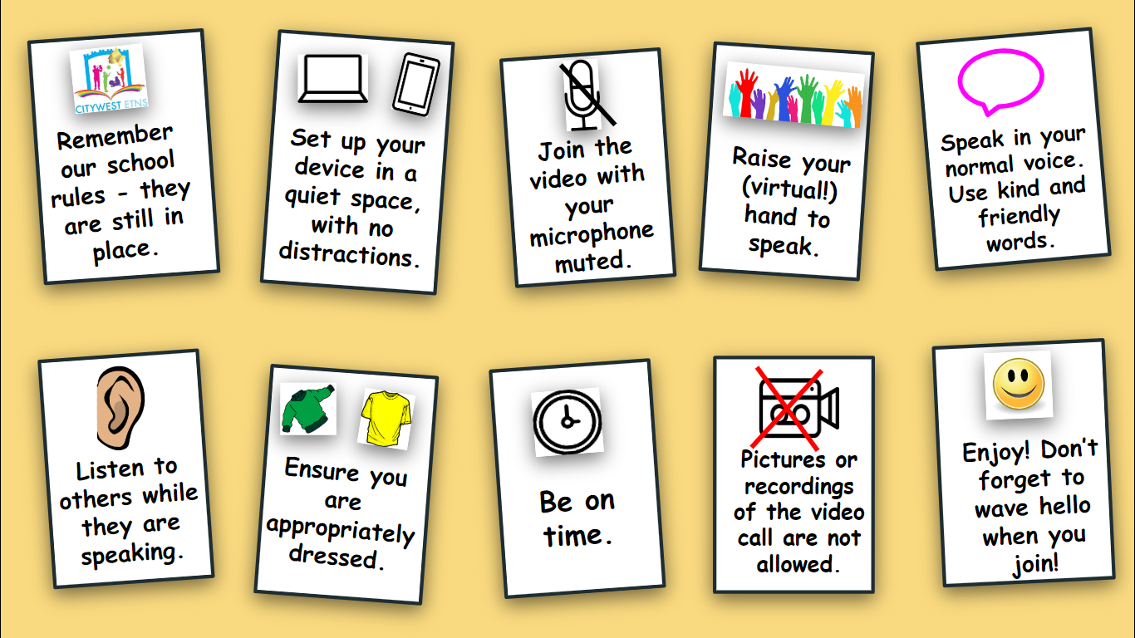*

**Guidelines for parents and guardians:**

For Video Calls/

1. Under no circumstances can pictures or recordings be taken of video calls.
2. Ensure that the school has the correct email address for inviting you to join apps and meetings.
3. The main purpose of a video call is to maintain a social connection between the school staff and pupils at times when in-person schooling is not possible. Encourage pupils to listen and enjoy the experience.
4. Be aware that when participating in group video calls, you can be seen and heard unless you are muted or have disabled your camera.
5. You will automatically enter a waiting room before you are accepted.
6. Please ensure that your child is on time for a scheduled video, or they may be locked out. Please request to join the call approximately five minutes before the scheduled start time. This will give school staff time to verify your email address.
7. Make sure to familiarise your child with the software in advance. For video in particular, show them how to mute/unmute and turn the camera on/off.
8. Participants in the call should be dressed appropriately.
9. An appropriate background/room should be chosen for the video call.

It is important to note that any breach of the above guidelines will result in a discontinuation of this method of communication. A breach may also result in a person being immediately removed from a meeting or in a meeting being immediately terminated. In this case, the child’s parent will receive a report on the incident.  
​

Chairperson BOM, Lisnafunchin School.

Date: 25/09/24 Date for Review: September 2026

**Please detach this form and return to school.**

**Permission Form**  
Please review the attached school Internet Acceptable Use Policy, sign and return this permission form to the class teacher. This form will be kept on file until your child is finished in Lisnafunchin NS.

Name of Pupil:______________________Class:______________________

Parent/Guardian  
As the parent or legal guardian of the above pupil, I have read the Acceptable Use Policy and grant permission for my son or daughter or the child in my care to access the Internet. I understand that Internet access is intended for educational purposes. I also understand that every reasonable precaution has been taken by the school to provide for online safety:the school internet is protected by the filter and firewall provided by the NCTE/PDST (National Centre for Technology in Education), but the school cannot be held responsible if pupils access unsuitable websites.  
I accept the above paragraph □ I do not accept the above paragraph □  
(Please tick as appropriate)

In relation to the school website [www.lisnafunchinprimary.com](http://www.lisnafunchinprimary.com) and the school’s Instagram apps I accept that, if the school considers it appropriate, my child’s schoolwork and group photographs/videos of my child participating in school events may be chosen for inclusion. I understand and accept the terms of the Acceptable Use Policy relating to publishing children’s work on the school website/social media apps.  
I accept the above paragraph □ I do not accept the above paragraph □  
(Please tick as appropriate)

Signature: _____________________________Date: ___________________

Address: ______________________________  Telephone: _______________

------------------------------------------------------------------------------------------------------------------------