1st October, 2024

Admission Policy and Application Form
A copy of the school’s Admission Policy and the application link for Admission for the School Year 2024/25 is available as follows: –
To download at: www.lisnafunchinprimary.com
Fill out enrolment link to the best of your ability. If you have further inquiries, please contact principal.
-If you would prefer a hardcopy of enrolment form please download and post/email to school:
Lisnafunchin NS,
Castlecomer
Kilkenny
R95TKD2
principal@lisnafunchinschool.com
Open Night: 7:30 October 23rd 2024

Admissions for the 2024 / 2025 school year:
The following are the dates applicable for admission to Junior Infants for school year 2024/2025
1. The school will commence accepting applications for admission on
Monday, October 7th.
Closing date for applications: November 4th 2024

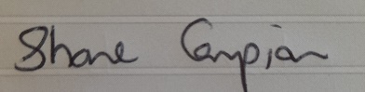

Shane Campion, Principal.

