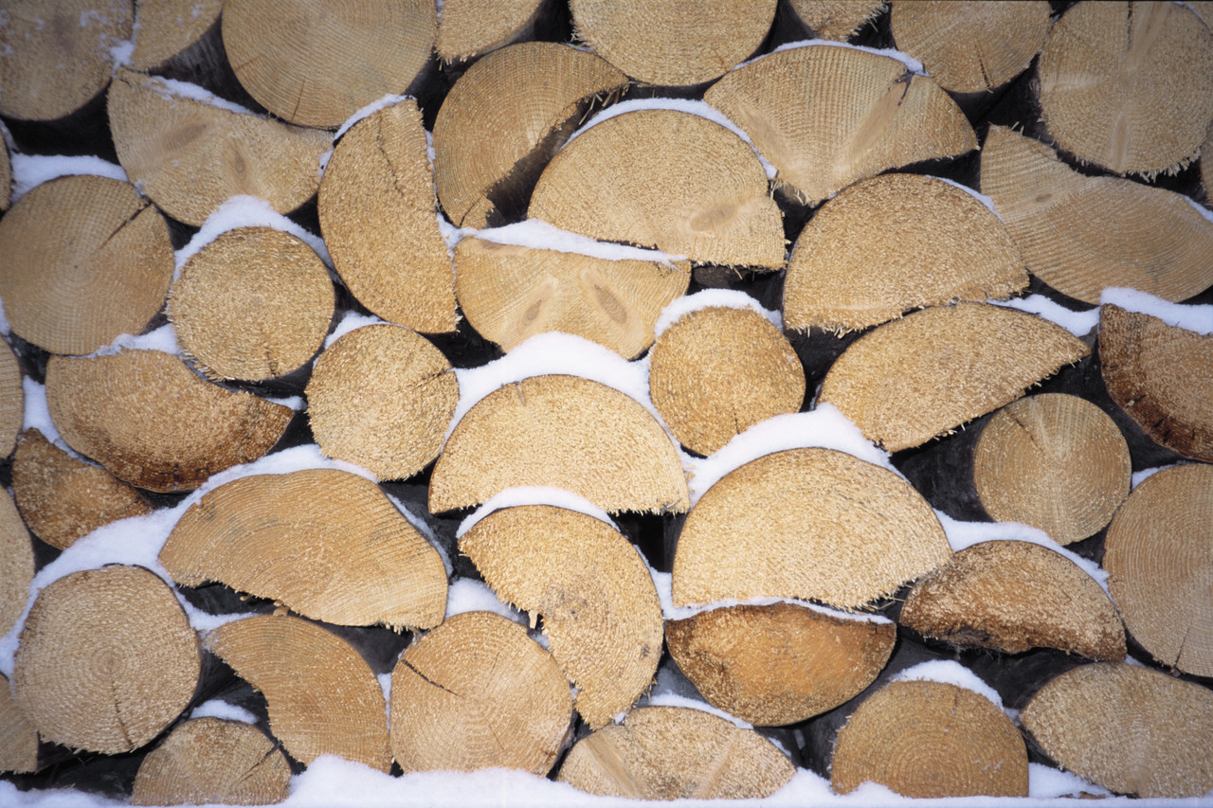**Wood: Dead is just dead…not dry!**

***“I will just use that dead tree.”***

***“That oak died and was cut up years ago. I will just split it right before I use it. “***

**Do you think those statements are correct? Do you believe that a dead tree means dry wood? If so, you could not be more wrong. Wood for a stove, fireplace or other heater needs to be seasoned correctly. And that means split and dried out in the sun and wind with air around the sides and bottom for at least 6 months.**

**►Wood directly on the ground wicks up moisture from the ground as well as gets mold and rot.**

**►Wood covered with tarp or plastic traps moisture and it stays in the wood.**

**“An unsplit oak log that came from a dead tree that was lying on the ground for five years tested out at 38% moisture”.**

**Seasoned wood means less than 20% moisture!**

**You are losing money if your wood is not dry!**

**You can lose more than 2200 BTUs (this means money going up and out your chimney) burning unseasoned wood.**

**Unseasoned wood:**

**Emits more emissions**

**Smokes**

**Makes you use more wood**

**Costs you money**

**Seasoned wood:**

**Burns hotter**

**Burns cleaner**

**Less emissions**

**Use less wood**

**Saves you money**

**Be Smart – Burn Wise!**

**Cut, split and store wood for seasoning correctly.**

**Get a moisture meter and check your wood before you purchase. You will redeem your cost in just one season of using the dry seasoned wood you should.**

**Burn Wise – Burn Right, Burn Hot, Burn Clean**

**Combustion Appliance Training & Education, Inc.**

**4319 Twin Valley Road, Suite 9**

**Middleton, WI 53562**

**www.nchpba.org**



Affiliated with North Central Hearth, Patio & Barbecue Association, Inc.