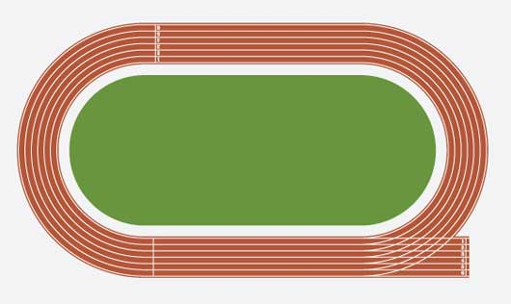100/200 Meters



100 Meters 200 Meters

Warm up: All activities in track and field can be hard on muscles, so care must be taken to warm up with stretches and drills. Sprints and jumps need lots of warm up to avoid injury. Please use the stretches and drills on pages 4-5.

Technique

Starts: Blocks are rarely necessary. A good standing start is the best and easiest for young runners.

The Standing Start

Have students stand side by side along a line (use chalk if necessary). Explain what students should do when they hear the following directions:

1. **On your marks:** Place the power leg directly behind the starting line (your front foot) with the "weaker leg" (your back foot) about 1.5 feet behind it. Feet should be shoulder-width apart. Stand erect and still.
2. **Set/Get set:** Bend at the knees and lower head and shoulders until they are slightly above hip level. Body weight should be on the front foot. The opposite arm is moved forward in a bent position, ready to drive backward at the "Go" command, and the other arm is placed slightly back to balance. Hold the position.
3. **Go:** Step forward first with the back foot, pushing off the front foot while thrusting the opposite arm backward. Drive forward vigorously with arms and legs. Gradually, come to an erect position over about 10 feet distance while running forward. Remind students that standing up too soon will slow them down.
4. Practice starts before the first meet so they will be ready for the gun. Most starters will say “On Your Marks” “Set” and then shoot the gun. Some may leave out “Set.” Practice both ways.
5. Make sure runners learn to run all the way to the end of the race. They need to know where the finish line is.

**Practice**

Students should take time to practice the different starts, including running 30 to 50 feet out in front after takeoff. It is suggested to practice about 8 to 10 starts per student. Depending on numbers and ability levels students may do less or more. Students can also practice racing each other out of the start.

Form for Sprinters

Head and Shoulders

During a sprint, students should drop their jaw and relax their face muscles, shoulders, and hands. To help kids recognize unnecessary tension, have them pretend to be a noisy boat by blowing air out of their mouth while vibrating their cheeks and lips. Then have them do this while jogging in place. Students should recognize that making the sound relaxes and reduces tension in their body.

Arms and Hands

While sprinting, students should cup and relax their hands. Palms face inward toward the body and wrists are relaxed. Arms are coordinated with legs so the left arm pumps downward as the right knee comes up and vice versa. Arms should move at the shoulder forward and backward without crossing the body.

Posture

Students should run with their core and torso erect. Keep their spines straight and the shoulders back with a slight forward lean. Keep the head up so the chin is parallel to the ground and keep the torso stable.

Feet

While sprinting, students should hit the ground on the ball of the foot and push off again with the ball of their foot. The heels should not hit the ground.

Legs

Sprinters need to lift their knees high, driving each knee forward and up until the thigh is almost parallel to the ground.

Strides

"Strides" are controlled sprints between 40 and 80 meters in length. The emphasis is on executing proper technique.

To practice proper sprinting form, divide students into pairs. Each student should do 10 strides, resting for one to two minutes between each repetition. Tell students to focus on maintaining a smooth rhythm and a balance between stride length and frequency.

Games: The games of “Foot Fire” and “Formula One Race” are good exercises for speed. They can be found on the website below.

For more information, see <http://www.nyrr.org/youth-and-schools/running-start/training-plans/track-and-field-training-plan/starts>

For 200 meter info, see <http://www.nyrr.org/youth-and-schools/running-start/training-plans/track-and-field-training-plan/200-and-400-meters>