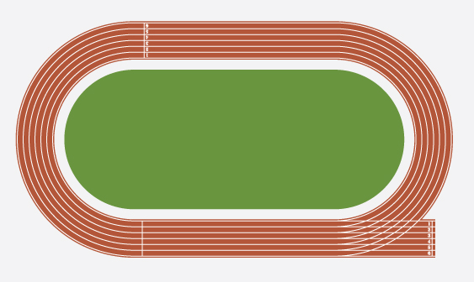
400/800 Meters

400 Meters: One Lap 800 Meters: Two Laps

Warm up: All activities in track and field can be hard on muscles, so care must be taken to warm up with stretches and drills. Please use the stretches and drills on pages 4-5.

Technique
Starts: The standing start is the best way to start both of these races. Make sure to have your runners practice starting before the first meet. The starter should start by saying “Come to your marks” and the gun. Be sure to practice by adding “Set” in case that is added. (“Come to your marks” “Set” and the gun)

Practice
These events take a lot of endurance. These runners need to be treated like distance runners. They need both running background and interval work. This is best done with games and interesting activities, but it is important that runners understand the distance that has to be run so they are not surprised at the first meet.

Drills
Curves
You will need cones, a stopwatch, a measuring wheel/tape, and a whistle. Set up four cones (number them or use four different colors) in a horizontal line, each 10 yards apart, at a distance of 10-40 yard from the starting cone, depending on skill level.
In groups of two, runners begin at the starting cone and run straight ahead. When you call out a number or color, they will loop around that specific cone and return to the starting cone. Runners should loop around two or three cones before finishing their turn. You can alter the activity by varying the radius of the curves, increasing speed, or delaying the announcement of the next selected curve.
Strategy for the 400-Meters
- The first part of the 400-meter dash should be run aggressively, but not at an all-out sprint. Split the race into three parts.
- Accelerating near full speed for the first 50 meters
- For 150 meters you should run under a controlled deceleration. Focus on driving your arms and legs picking your knees up through the second turn
- Hold your form and finish strong over the last 100 meters
Drills for the 400-Meters
Interval Training: Use cones to divide a track into nine sections. Have your runners jog, sprint, do high knees, and run in different sections. They can start out jogging and do short sprints and drills. Have them finish with an all-out sprint. To make the intervals more difficult, increase the distance and time spend on each section.

For more information, see http://www.nyrr.org/youth-and-schools/running-start/training-plans/track-and-field-training-plan/200-and-400-meters

