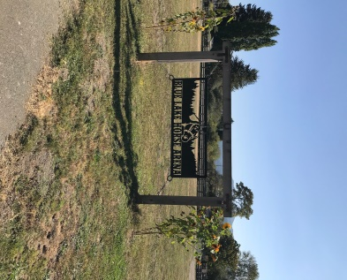
Driving Directions to 210 Chartin Rd from 101
Take exit, 716A for CA-299 E toward Weaverville/Redding
Take exit 5 toward Blue Lake
Continue onto Blue Lake Blvd
At the traffic circle, take the 1st exit onto Chartin Rd
Take 2nd left to stay on Chartin
Destination will be 3 blocks down on the right

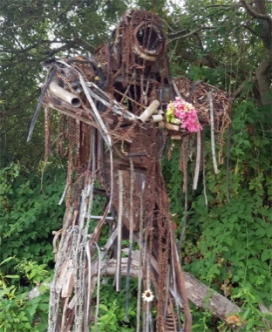
Course Directions TK-2
Starting at the corner of the horse arena head towards the bridge
over Power Creeks
After the bridge take a right onto Powers Creek trail
Run until you meet the giant steel bigfoot, this is your turn around
Head back to the arena

Course Directions for 3-5
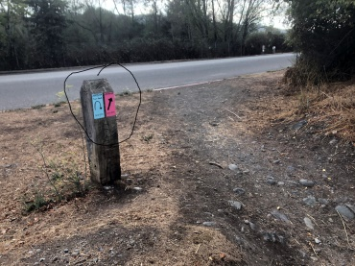
Starting at the corner of the horse arena head towards the bridge over
Power Creeks
After the bridge take a right onto Powers Creek trail
Run to the end of the trail where it meets Taylor Way and turn around
Run to the other end of Powers Creek trail where it meets Hatchery Rd
and turn around
Head back to the horse arena to finish

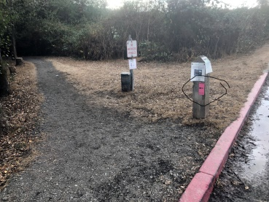
Course Directions for 6-8
Starting at the corner of the horse arena head towards the bridge
over Power Creeks
After the bridge take a right onto Powers Creek trail
Run to the end of the trail where it meets Taylor Way
Carefully cross the street to continue onto the Levee Trail
Take a left to stay on the Levee
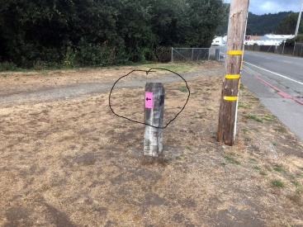
Run the Levee until you hit Hatchery Rd
Take a left onto the sidewalk of Hatchery Rd
Cross Taylor Way
Take the left back onto Powers Creek Trail
Take a right over the bridge and head to the horse arena to finish

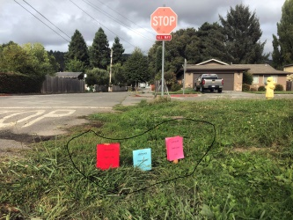
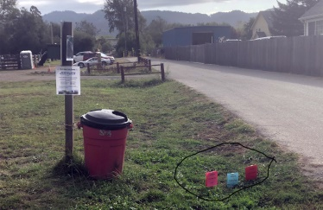
Start Finish

