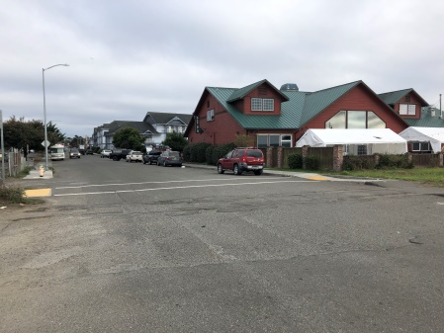**Driving Directions to Hikshari Trail**

From the north, follow Hi 101 past the mall.

Turn right on Truesdale Street.

From the south, turn left just past Best Western.

Turn left on Truesdale Street.

Go past Shamus T Bones (the picture).

The parking lot at the end of the road is blocked.

Find parking along the street and walk through the parking lot.

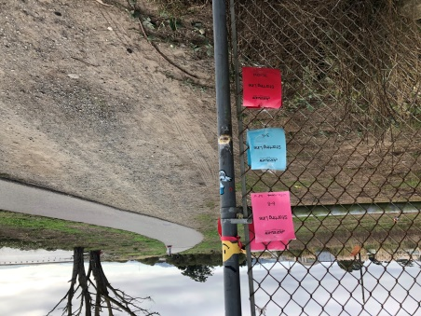

**Course Directions: Start**

Walk through the parking lot and follow the trail to the south.

You will see the starting line with the markers on the fence (picture).

All races begin at this location. All runs go south.

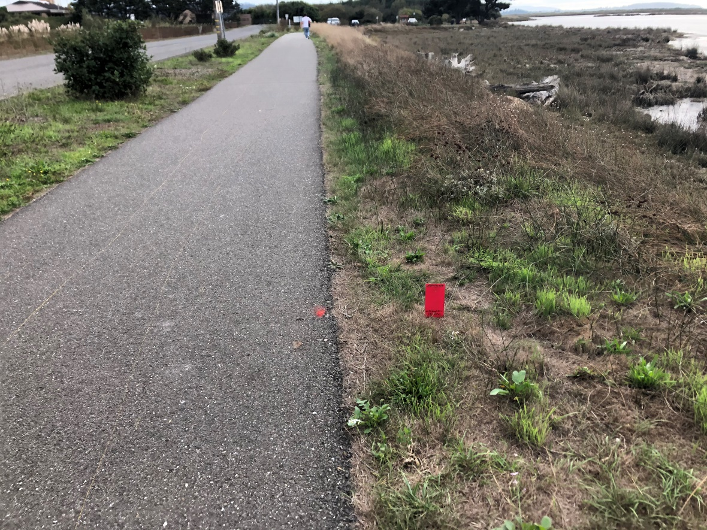

**Course Directions K-2**

The K-2 turnaround is .4 miles on the right.

Turnaround at that point and come back to the start.

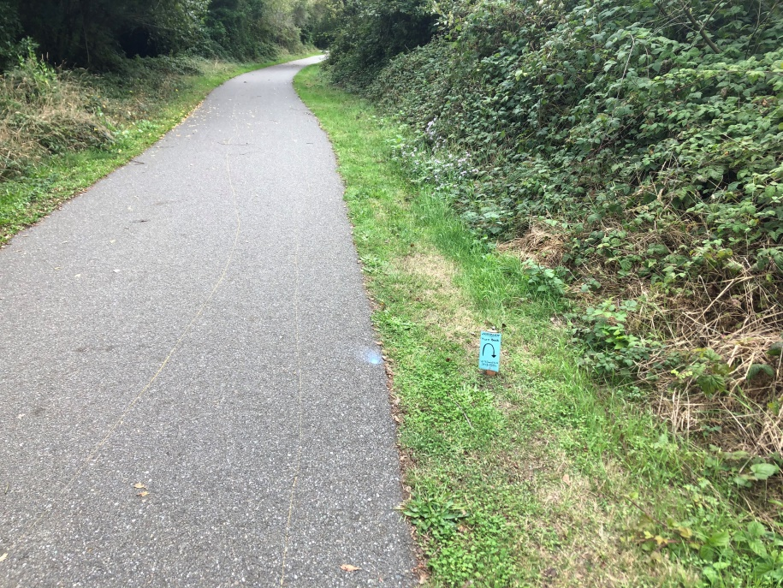

**Course Directions for 3-5**

The 3-5 turnaround is .7 miles on the right

Turnaround at this point and come back to the start.

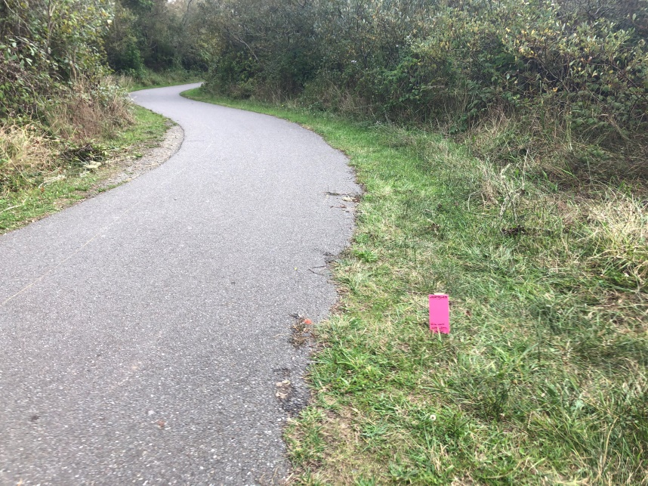

**Course Directions for 6-8**

The 6-8 turnaround is .9 miles on the right.

Turnaround at that point and come back to the start.

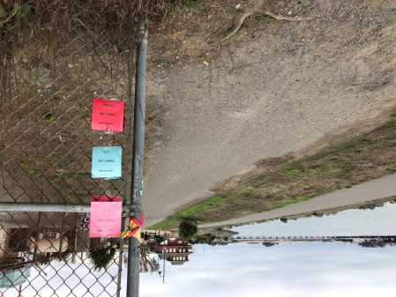

**Finish Line**

Get your time and send it in.