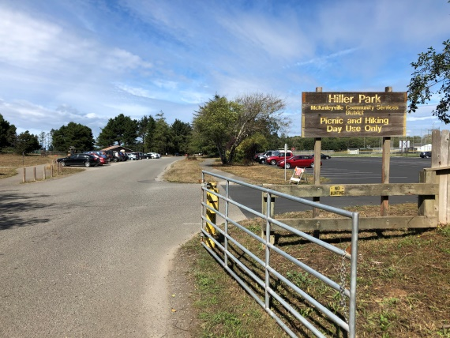
Driving directions to Hiller Park 675 Hiller Rd
From South 101
Take School Road exit and go Right.
Take left on Washington Ave until in turns into Mckinleyville Ave.
Turn left on Hiller Road.
After crossing over 101, take the first right.
From North 101
Exit Murray Road and go Left.
Turn right on McKinleyville Ave.
Turn left on Hiller Road.
After crossing over 101, take the first right. Lots of Parking

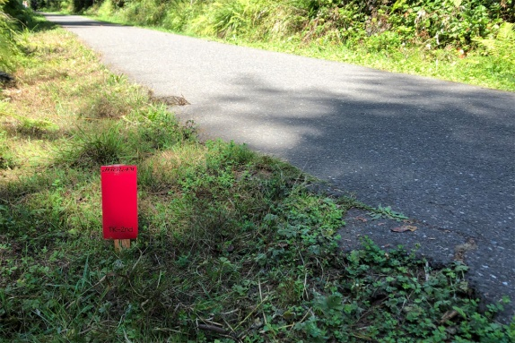
Course Directions TK-2
Starting at the information kiosk (maps will be posted). Run North.
You will go .3 miles you will see a red marker on your left
and to the right of the trail you will see a sawed of tree round
(freshly cut). There will be a chalked red turnaround arrow.
This will be your turn around point.
Head back to information kiosk and finish where you started.

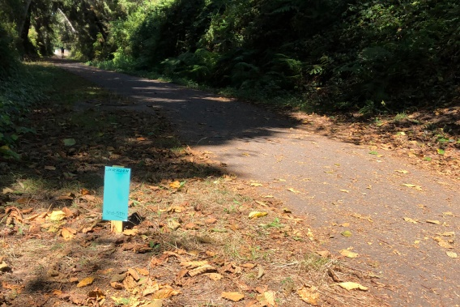
Course Directions 3-5
Starting at the information kiosk (map will be posted). Run North.
You will head out .5 miles and you will see a blue marker to your
left and stairs to your right of the trail. There will be a chalked
blue turnaround arrow.
Turn back to information kiosk and finish where you started

Course Directions 6-8
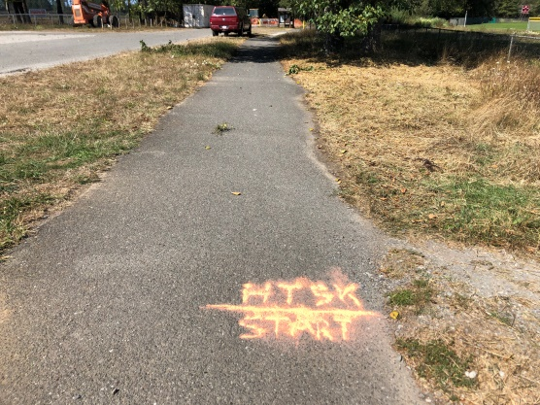
The starting line is the orange chalk near the trail to the soccer
parking lot about 50 yards south of the kiosk.
Run north past the information kiosk for .7 miles.
You will see a pink sign on the left side of trail on the ground
in front of a cement block ( if you gone to the road,
you have gone too far).
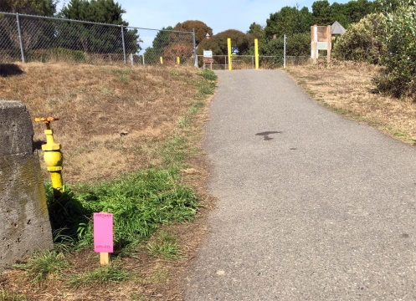
Turn around and head back to the same starting line.
6th-8th Start/Finish Line

