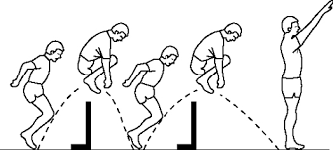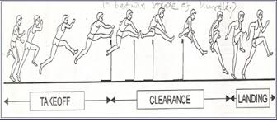100/200 Hurdles

**Hurdle distances for track:**

**100m hurdle spacing:**  13m to H1 with 8.5m between and 10.5m to the finish  
**100m hurdle spacing:**  13m to H1 with 8.5m between and 10.5m to the finish



8.5 meters

Start 13 m to the 1st hurdle 10 hurdles in the race-8.5 meters between each hurdle 10.5 m to finish line

It is not necessary to have a track or 10 hurdles. It is good to have at least 4 or 5 hurdles. The spacing is important so athletes can practice the correct distances from start to 1st hurdle, hurdle to hurdle and to the finish. All hurdles in the elementary school races will be the same height, 30,” the lowest setting on a high school hurdle. If you make your own hurdles, try to make them adjustable to a lower height for practice, especially if you have younger runners.

On the final page of this booklet I have given you a web site which will guide you through hurdle assembly. It takes a bit of time and costs close to $100.00 for 4 hurdles. You may be able to get someone to donate materials and even build them. If you wish to have hurdlers, and don’t have a track close by, this is a way to get started. BE CAREFUL! All hurdles should be made to fall in one direction, so teach kids to go over them properly and to take care of them. They should be aware of that same rule at each track meet. Going over a regular hurdle backward can cause problems for the athlete and the hurdle.

On the second hurdle page, I added some videos. Watch how the hurdler in the first one goes over the hurdle and work to get close to that with your runners. It doesn’t matter which leg each runner uses as a lead leg, but most will use the left leg if right handed. It is good to teach both legs as lead, especially if your runner wishes to run faster.

If a runner steps five times between the hurdles, he will always be using the same lead leg. To get faster, he must use four steps and then will have to switch legs. To go over a hurdle, the athlete needs to be running fast and begins jumping well before the hurdle. He leads with his knee, then kicks his foot up and over the hurdle. His leg should come back down into a running stride. The back let folds over the hurdle with the rear foot nearly touching his butt. It should just go over the top of the hurdle and snap back down to put the athlete into a full sprint again.

The hurdler will run the 100 (10 hurdles) or 200 meters (5 hurdles), while taking what amounts to a long, gliding stride over each hurdle. The competitors will spend as little time in the air as possible. They’ll get their feet back on the ground quickly after clearing each hurdle, then will continue running with consistent strides so they can clear the next obstacle just as smoothly as the last. At the youth level, the beginning hurdler is going to run up to the hurdle, slow down, jump over the hurdle, then start running again. It almost doesn’t matter how small you make the barriers in practice. Anything reasonably close to the size of an actual hurdle is going to elicit the run-jump-run reaction. Therefore, patience on the coaches’ part is just as important as skill development on the competitors’ part when teaching the sport to new hurdlers.

**Safety and comfort:**

As with any running event, a good stretching routine is a must. Even young, active, flexible runners will benefit from a good warm-up. The next step is getting the runners comfortable with clearing hurdles, and beginning to teach them to avoid the run-jump-run instinct, which can only be accomplished through repetition. While the youngsters are learning, they’ll need some barriers to clear. Youth events, depending on the competitors’ ages, generally begin with 30-inch hurdles, so beginners should start with lower barriers, if possible. Additionally, the barriers must be light and safe, so the kids won’t be injured when striking a hurdle. Some hurdles can be lowered for youth, but you may need to make your PVC hurdles adjustable to a low height.

**Technique:**

Among the teaching points for beginning hurdlers, the start will be the easiest. At higher levels, of course, races can be won or lost out of the blocks. But there’s plenty of time to work on starting technique. Novices must focus on selecting a lead hurdling leg (usually the left for right-handers), then developing a consistent stride pattern, because the stride pattern determines which leg is placed in the back of the starting blocks. If the hurdler takes an even number of steps to the first hurdle, the lead leg goes in the back block, and vice-versa for an odd number of steps.

Next, nothing beats repetition when you’re teaching hurdle clearance. But a little visualization never hurts. Have your prospective hurdlers walk up to a youth-sized hurdle. For those who are leading with their left leg, have them walk to the right of the hurdle, lift their lead leg and stretch it out, to demonstrate that their leg can rise above the hurdle. Repeat the drill on the other side of the hurdle, but have them lift their rear leg up in proper position off to the side, with the knee as high as possible, to show that the trail leg can also pass above the hurdle without a jump. Yes, they’ll still jump the first few times, but as their comfort increases, the visualization will remain in their mind and help them progress.

Start the novices out clearing just one practice barrier, but make sure they sprint to a finish line after clearing it, to get used to the rhythm of a hurdles race. Many races, after all, are won between the final hurdle and the tape. Next, add a second hurdle, so the competitors can begin developing a stride pattern between hurdles. Again, repetition is the best teacher. As the athletes progress, gradually increase the height of the practice barriers, and increase their number. At some levels, youth hurdlers will face eight barriers, moving up to a maximum of 10.

Most hurdlers will begin running with 5 steps between hurdles, reaching each hurdle with the same lead leg. For a hurdler to improve, he/she needs to run 4 steps between each hurdle. That means he/she must switch the lead leg, so switching the lead leg will need to be taught.

**Conclusion:**

Don’t worry about the fine points at the beginning. Just get the hurdlers comfortable clearing the barriers without jumping, while developing a reasonably consistent stride pattern. As they improve, begin to emphasize proper clearance techniques, with the lead leg snapping up, the upper body leaning forward, and the trial leg rising up and to the side, with the knee higher than the foot.

Developing Beginning Hurdlers  
1) To me, the most important thing to teach beginning hurdlers is to sprint on the balls of their feet, not on their toes (too tall), and not on their heels (too low), which is most common. Running between the hurdles on the balls of the feet, with the chin up and back straight, is essential to being able to execute proper hurdling mechanics. Beginning hurdlers will often rock back on their heels because they’re afraid of the obstacle, so getting back on their heels is a way to gear up for hurdle clearance. Once you’re on your heels, there’s nowhere to go but up, whereas a hurdler wants to go *forward*, *into* the crossbar, in order to reduce air time as much as possible.  
2) Lead with the knee, lead with the knee, lead with the knee. Want me to say it again? Lead with the knee. Coaches need to teach athletes that the knee of the lead leg should never be fully locked at any time during hurdle clearance. As the hurdler takes off into the hurdle, the knee of the lead leg should be driving directly at the crossbar in order to ensure low hurdle clearance and a quick snapdown back to the ground. Many beginning hurdlers swing the whole leg from the hip, which makes for all kinds of balance problems with the hips, the arms, as well as with the legs. One way I explain it to my hurdlers is to say that your lead leg knee is your steering wheel. It guides you, it directs you, it *leads* you. If the foot of the lead leg is getting ahead of the knee too soon, then the foot is leading the way, which is nothing but trouble.  
3) Beginning hurdlers should do a lot of hurdle drills. Even experienced hurdlers should, but it is essential that beginning hurdlers do so, so that they can develop muscle memory that will enable them to internalize proper hurdling mechanics. Walk-overs are a good drill for beginners. Set up five to ten hurdles at 30” to 33” high, lined up directly behind each other, and have the athlete walk over the hurdles, focusing on keeping the hips square and driving up the knees. Another good drill for trail-leg mechanics is the fence drill. Put a hurdle anywhere between 30” and 36” inches, and have the hurdler put his hands against a fence or wall, and circle his trail leg around the crossbar a series of times. Three sets of ten is usually a good number. This drill helps to develop mechanics, and it also strengthens the groin muscles which bear the brunt of the strain on the trail leg side of the body when hurdling at full speed. Another basic is the lead leg drill and the trail leg drill in which five hurdles are set up on the regular hurdle marks, and the hurdler bounces five steps between the hurdles, clearing with just one leg. Isolating one leg helps the hurdler to get a feel for how that leg should be moving up and over the hurdle without having to worry about bringing the whole body over the hurdle. It’s also a good warm-up. Three times each side over five hurdles is a good number.

**200 Hurdles**

There are only 5 hurdles in the 200 meter hurdle race. The first hurdle is 50 meters from the start, and it is 10 meters to the finish line from the final hurdle. It is 35 meters between hurdles. This event is only a 7th/8th grade event in the meets, but some younger runners may enter the 7th event if they are prepared.

I don’t worry very much about the distance in this race, but it is a good idea to try a couple of times, if possible, before a meet. Generally, I plan carefully for the 100 hurdles and let the athlete try the longer race. Hurdle form is the same, but it goes around a turn, which makes the race a bit more difficult.

Good technical video: <https://www.youtube.com/watch?v=yjly0wkPLHU> This video shows the arm action and the legs going over the hurdle. These are good basics.

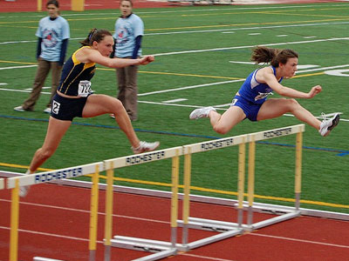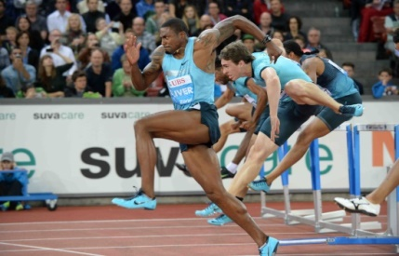Good advanced drills, but can be used to work with younger kids. Few hurdles needed. <https://www.youtube.com/watch?v=ATUfTQ7tESE>