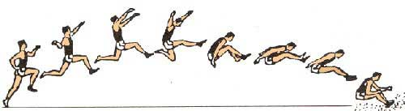
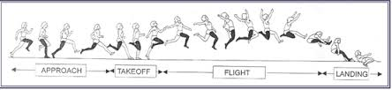
Long Jump

Warmup: Be sure to use the stretching and drills before beginning any work on long jump. There is also a section on building your own long jump pit. If there is no pit, it is best to work on steps to the board and form. It is difficult to work on long jump without a pit, unless you can find a soft landing area.

Long Jump Guidelines
Long jump competitors use a runway, a takeoff board, and a sand pit. The objective is for an athlete to jump as far forward as possible. Athletes cannot plant their feet past a white take-off board before the sandpit. This is considered a foul and the jump does not count.
Explain to students that the longer they stay in the air, the further they will go. They need speed and height to go further. Athletes should land steady and with their feet as close together as possible. Their jump will be measured from the foul line to the closest point they touched. Therefore, it is important to tell athletes not to land with their hands behind them.

Long Jump Techniques
As a precursor to the running long jump, use the standing long jump and then the three-step long jump to solidify proper technique.
Standing Long Jump
You will need cones and a measuring tape for this activity. Athletes stand at the take-off board (or a marked-out line) with feet shoulder-width apart and knees bent. Swing both arms backward and then thrust them forward and upward while jumping explosively off the balls of both feet. Jumpers should land on both feet, thrusting the body forward at landing. Repeat this drill 20 to 30 times. Have athletes focus on jumping high and landing with control.
Three-Step Long Jump
Once athletes have mastered the standing long jump, begin teaching the three-step technique. You will need cones, measuring tape, and a long jump mat. As a general rule, righties takeoff on the left foot and lefties on the right foot, but there are exceptions. Take three brisk running strides before jumping. The right-handed jumper, for example, takes one brisk step with the left foot, one with the right, and then one more with the left. On the third step, the takeoff foot should be on the board, with the knee bent. Both arms should be thrust upward while jumping explosively off the ball of the foot. Emphasize landing on both feet with a forward thrust so that the jumper falls or hops forward. Use this method for a while before moving to the full running long jump.
Approach
You will need cones, measuring tape, and a long jump mat. Mark the recommended starting point with a cone, adjusting as needed for age and skill. A good starting point is eight strides away from the take-off board, but you can allow kids to start a few strides before or after the marker if they want. For the novice jumper, do not be concerned with the exact number of strides taken to the takeoff board. For most kids between 8 and 15 years of age, a run-up of eight to 10 strides, perhaps increasing to 12 or 16, is ideal.
Tell students to gradually build speed during the run-up so that they are near full speed a few strides before take-off. They should aim for fast, relaxed pace without over striding or slowing down in the last few steps. Give each athlete two to four jumps.
Takeoff
Adjust the distance from the takeoff board to the pit/mat depending on the age and skill of the jumper, leaving plenty of room for landing on the mat and falling forward after landing.
When the foot strikes the takeoff board, it should be in a â€œflat footâ€ position. Body weight should be directly over the board. A powerful extension of the opposite leg (from the toes to the hips) will provide a strong lift forward and upward; the knee should be thrust forward and high into a flexed position. At the same time, thrust both arms upward, with the chest, hips, chins, and eyes lifted to help achieve height. Give each athlete two to four jumps.
Obstacle Course
Set up five to 10 different stations. Depending on the course, you will need cones and/or boundary markers, a stopwatch, a measuring wheel, a whistle, a long jump mat, hoops, and a jumping box. In groups of up to 4, athletes spend 30 seconds to one minute at each station, moving to the next one on your signal. Stations can include a crab crawl or bunny hops between cones; exercises like squats, lunges, jumping jacks, hopping or balancing on one leg; box jumps or jumping in between hoops arranged on the course; sitting down and standing up with or without using hands; sprinting for 10-50 meters; or a speed drill using the agility ladder.
Help for Long Jump: http://www.nyrr.org/youth-and-schools/running-start/training-plans/track-and-field-training-plan/long-jump
More Help: http://www.nyrr.org/youth-and-schools/running-start/training-plans/track-and-field-training-plan/long-jump-further-development
Triple Jump
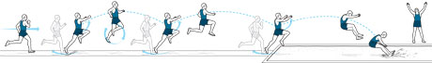

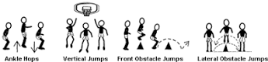
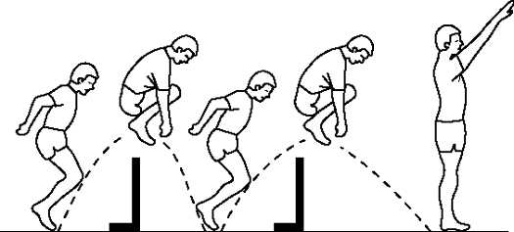
The exercises below are good for both the long and triple jump.

The Triple Jump is one of the most enjoyable events for students and for coaches. It takes a lot of practice, but it is fairly easy to see a lot of improvement. Not many people can coach it well, so a good coaching job can create a great deal of success.
Triple jump technique is much like the game hop scotch that young children play. An athlete must take off and land on the same leg then land on the next opposite leg before landing in the pit. This event has many of the same characteristics that the long jump displays during the approach. At takeoff, however the differences end, good triple jumpers will take off at a much flatter angle than in the long jump. We will examine the technical requirements and methods to develop them as well as how to set up the training day and week. The triple jump has 1) Acceleration 2) Maximum Controllable Speed 3) Takeoff and the Hop 4) The Step and 5) The Jump and Landing.
Teaching the Rocking Start
The athlete will begin with their takeoff foot forward and rock back so most of their weight is on the rear leg. Make sure they swing their arms in opposition to their legs when pushing out of this position and “rocking” back over their front leg. All forces should be directed horizontally into the ground. By starting in this fashion the athlete is able to use momentum generated from the rock to aid the start. It helps insure a consistent reliable, start that leads to an accurate approach.
Coaching Cues for Acceleration Work
Push, lean from the ankle. Tell the athlete to be patient while executing this part of the approach, allowing the foot contact with the ground to gradually stand them up.
The Takeoff and Hop
Elite athletes set up the takeoff and first phase (hop), novice ones survive the landing from their long jump like takeoff. In the triple jump, there is no need to coach takeoff height most beginners will need to be convinced that running through the board is more important. There should be no marked difference between takeoff and previous steps of the approach other than the heel to toe (rocking) ground contact. Attempting to run past the foot while it is on the board is a great cue. Horizontal movement is the emphasis of the takeoff action. Allow the stretch on the hip flexors to put the takeoff leg in position for the step rather than actively “cycling”. By avoiding cycling the leg the transition to slower tempo of jumping is smoother. You can get very technical with coaching the free limbs, simply put have them continue to move as close to running as possible. The hop will generally be the longest of the three phases. Most importantly, it should set up the step and conserve horizontal momentum.
The Step
Getting athletes to be in position for the step is most important. Much of this is done by focusing on the approach and hop. Some work to ready the athlete for this crucial transition is necessary. General coaching cues are to maintain horizontal velocity and to be patient (wait for the ground to come to you). Contact is best made with the rocking full foot contact described in the other phases.
The Jump
At this point in the jump, the athlete has slowed considerably. It is crucial to success of the jump to have ground contact underneath the body. This reduces deceleration and allows the athlete to continue to apply forces horizontally. Most jump phase work will be done in conjunction with other phase work. Isolating this part could have the athlete setting up a long jump like takeoff. Some “weak leg” long jumps will help the athlete feel what will happen during this phase. Additional single leg hopping after some step work is a good way for the athlete to better align themselves during this phase. An example would be for a left foot takeoff LLRRR or LLRR.

Drills and practice information can be found at http://www.everythingtrackandfield.com/webapp/wcs/stores/servlet/PBOnePieceView?storeId=10152&catalogId=10753&pagename=303
Drill video: https://www.youtube.com/watch?v=YTk6iimgzCg
Triple Jump Slow Motion: https://www.youtube.com/watch?v=X-euvqJONd8
Drill video: https://www.youtube.com/watch?v=4PMDDGoYxcQ
Good basic triple video: https://www.youtube.com/watch?v=9Pv2hUyODK4

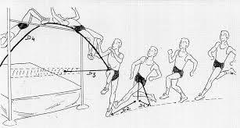
High Jump
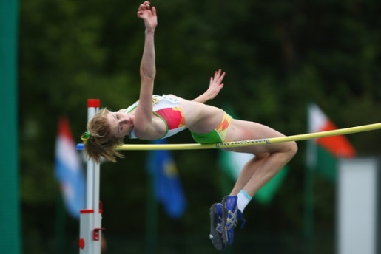

As always, be sure to stretch before beginning.
Technique:
There are three basic parts to a high jump – approach, takeoff and clearance. Each part will likely be taught separately at first, using a variety of high jump drills . When teaching the approach, coaches will likely focus on maintaining the correct running speeds at different parts of the approach, on taking a proper angle to the bar and on hitting the correct takeoff point. Intuitively, young jumpers may want to take off as close to the bar as possible. This, however, will cause the jumpers to leap almost straight up – at too narrow of an angle – and they’ll likely knock the bar off on the way down, even if they achieve sufficient height. Potential jumpers will also determine a takeoff leg – the strongest leg will be on the inside during the jump, making the opposite the takeoff leg. Takeoff and clearance drills may begin with the backflips mentioned previously. The young jumpers will then move on to clearance technique, perhaps learning the old-fashioned scissors kick first, to get them used to flying over the bar, then later advancing to the modern “flop” technique.
Drill - Back flips:
﻿To start getting your jumpers comfortable with landing in the pit, have them stand with their heels against the front of the pit, with the “bar” (rope, cord, etc.) low, and have them jump over the rope and land on their backs. At this point, don’t worry about getting their feet up in the air.
When the jumpers are comfortable landing in the pit on their backs, tell them to repeat the drill, but this time make sure they can see their hands and feet when they’re in the air. This will begin teaching them to clear the bar in a correct position.
﻿Drill - Scissors kick:
﻿To continue getting your young athletes comfortable with high jumping, have them simply take a step or two and scissor-kick over the bar, landing on their back. Make sure they push off with the outside leg, and raise the inside leg, closest to the bar. Begin the drill without any type of bar, then add your rope or cord. The jumpers can try this drill from both sides, to begin getting a feel for which side they’re comfortable with.
When they’re comfortable with this drill, repeat it, but have the coach stand a few steps in front of an upright, at a 45-degree angle to the center of the “bar.” As the jumpers clear, have them turn their feet to point at the coach. Next, the coach will move in front of the bar - but out of the jumpers’ paths, of course. The jumpers will again turn their feet toward the coach while in flight. This teaches your jumpers how to turn in the air.
﻿Determining the takeoff leg:
﻿Beginning jumpers must determine which leg they with take off with. There are several ways to figure this out. In the high jump, kids can simply try both sides and decide which is more comfortable. Alternatively, you can put a ball on the ground have them kick it. Whichever foot they kick the ball with is their inside foot for the high jump. Another method is to have them stand up straight and tell them to fall forward as far as they can. One foot will naturally shoot forward to break their fall. That is the inside leg. The other is the takeoff foot.
If the jumper’s right foot is the inside foot, he’ll begin his approach from the right side, and vice versa.
﻿Setting up the approach run:
﻿To set up the approach run - for a jumper starting from the right - have the jumper stand at the side of the pit, with the standard at his/her back. The jumper walks five paces forward, then turns around to be sure he/she is parallel to both standards (they should be lined up, from the jumper’s point of view). The jumper then turns 90 degrees, so his/her shoulders line up with the standards, and runs forward 10 steps, with the coach marking the position of the fifth and tenth steps. Try this at least three times to be certain the marks are consistent, then measure the final marks for the fifth and tenth steps.
The tenth step is the jumper’s takeoff point. The fifth step is where he/she will begin turning toward the bar.

Information about high jump: http://trackandfield.about.com/od/highjump/p/highjumpdrills.htm
Video for learning to turn and land in the flop position: https://www.youtube.com/watch?v=_EetvCQanf0
Nice student breakdown of the jump: https://www.youtube.com/watch?v=wnaYlvlgLm8

