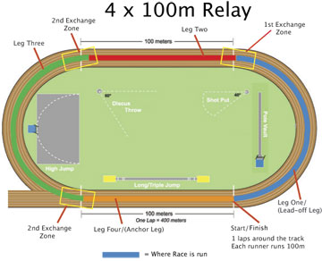4 x 100 Meter Relay

Warm-up relays*(5-10 minutes)*

You will need cones and a stopwatch. Divide team into even groups two yards apart from one another on a line. Each group stands opposite a cone 10 to 50 yards away (depending on the level of the group). Relay legs can include sprints, side steps, high knees, butt kicks, two-legged jumping, and hopping. Teams should tag each other on the hand at the changeover. This can serve as dynamic stretching at the same time.

Guidelines for Relays

In relays, individual runners come together as a team. Use this event as an opportunity to discuss teamwork and good sportsmanship. Official relays are run on the track and consist of four legs, each run by a different runner. During practice sessions you can add more legs and do different drills as noted below. The goal of a relay team is to move the baton around the track as quickly as possible. Athletes must move at a fast pace whenever they have the baton.

Starting With the Baton

You will need cones and relay batons. For younger groups, the starting runner can use the standing start with the baton grasped between all fingers in one hand. An older student can use the crouched start, gripping the baton with the middle, ring, and pinkie fingers and placing the thumb and forefinger behind the starting line. Depending on their level, athletes should practice both starts.

Baton Exchange

**The Exchange Zone:** The baton must be passed in a 20-meter exchange zone. Either runner may be outside of the zone during the exchange, but the baton must be inside the zone.

**Holding the Baton:**  The baton should be held at the bottom end for the easiest exchange.

**Timing:** Two subsequent legs must match their speeds during the exchange. This requires the outgoing runners to start running when the incoming runner is 5 to 6 meters away.

Exchange Technique

Except for the first leg, relay runners use a modified start. There are two types of baton exchanges: the Visual Exchange and the Blind Exchange.  (See the[Relays-Further Development](http://www.nyrr.org/youth-and-schools/running-start/training-plans/track-and-field-training-plan/relays-further-development) for Blind Exchange.)

Visual Exchange

The most effective starting position for the Visual Exchange is the crouch start. The outgoing runner's body should face forward with their left hand extended behind them—they can turn their head to look over their left shoulder (they will see the baton go into their hand). It is the responsibility of the incoming runner to place the baton in the outgoing runner's left hand (they then switch it to their right hand while running). Remind students to always receive with the left hand and pass with the right. The incoming runner must keep running at full speed until the outgoing runner has secured the baton in their hand.

Have athletes practice in pairs for five to 10 minutes for 50 to 100 meters and then in teams of four for five to 10 minutes.

Wrap-up Game

Olympic Relays

You will need cones and a stopwatch. Divide runners into teams and have each one choose a country to represent. Make each station a different strength-training exercise (jumping jacks, push-ups, sit-ups, etc.). Runners go from one station to the next doing a set of repetitions. You can have each runner do the entire course, or assign them "legs."

For a more difficult relay, add more stations or require more repetitions at each station. Please refer to the Supplementary Sessions for more station options.

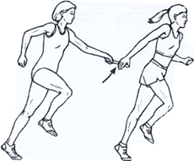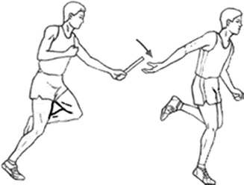The 4×100 [relay](http://en.wikipedia.org/wiki/Relay_race) or sprint relay is an [athletics](http://en.wikipedia.org/wiki/Athletics_%28sport%29) [track](http://en.wikipedia.org/wiki/Track_and_field) event run in lanes over one lap of the track with four runners completing about 100 meters each. The lead-off runners begin in the same stagger as for the individual [400m](http://en.wikipedia.org/wiki/400_metres) race. A relay baton is carried by each runner and must be passed within a 20 m exchange (or “passing” zone), which is usually marked by colored lines or triangles.  The center of the first exchange zone is 100m from the starting line, the second exchange zone is centered 200m from the starting line, and so on. The acceleration zone allows for the outgoing runner to gain speed and it extends 10m from the exchange zone.

Overhand Exchange Underhand Exchange

4 x 100 Relay (cont.) & 4 x 400 Meter Relay

Here are some guidelines to consider when matching an athlete to a 4x100 relay leg.

**Lead-Off Leg**

The lead-off leg requires an athlete who is fast out of the starting blocks and runs a good corner. The only exchange technique necessary is to be able to pass the baton.  This leg requires less practice time compared to the second and third legs, where receiving and passing the baton is required.

**Second Leg**

The second leg of the relay runs the backstretch, with very little or no curve running. The athlete needs to develop both passing and receiving skills to be effective in this leg.  Many coaches choose to place their best sprinter here, with the intention of having this runner carry the baton farther than the other runners.  This is done by getting the baton to the runner of the second leg early in the first exchange and passing it late to the third leg runner. Excellent speed and speed endurance is very important for this leg, particularly if you plan for this runner to carry the baton for an extended distance.  Being a quick accelerator is helpful if you want this runner to get the baton early in the exchange zone.

**Third Leg**

The third leg requires a runner who can run a good curve and has the ability to receive and pass the baton.  As with the second leg, the third leg can be intentionally lengthened or shortened by the coach.  Some coaches will place their slowest runner in the third position and try to pass the baton late to this runner and have the runner give up the baton early in the exchange zone to the fourth leg.  Some coaches will do the opposite and fill the third leg with a fast runner (Usain Bolt has run this leg for the Jamaicans) and in doing so try lengthen this leg.

**Fourth Leg**

Often coaches will put either their fastest or second fastest athlete in this position. It requires a very competitive athlete who can finish the event by either catching or holding off other challengers into the finish line. This athlete needs only to be able to receive the baton well, but does not need to pass it, and he or she does not need to run a curve well. As with the leadoff runner, practice time for this leg is reduced compared to the 2nd and 3rdlegs.

Baton Exchange: Below are exchange techniques that students can develop to improve their speed and effiency. Athletes should practice all exchanges in pairs and then in small groups. *A general guide for children is to start running when the incoming runner reaches a checkpoint that is five to six yards away.*

Blind Exchange: There is no visual contact between runners in a blind exchange. The only time the outgoing runner should look back is to see when the incoming runner reaches the checkpoint. At this point, the outgoing runner should accelerate at full speed as if he or she were running a 100-meter dash. Runners must have confidence that their practice and timing will allow the baton to be exchanged smoothly. Athletes should practice without the baton first, starting their run 5 to 6 yards away from the exchange.

Incoming and Outgoing Runners: Remind students it is the responsibility of the incoming runner to place the baton in the outgoing runner's hand. The outgoing runner must trust their teammate and not feel blindly for the baton. A lack of trust may result in a dropped baton or poor handoff outside the exchange zone. After accelerating, the outgoing runner should extend his or her left hand back. The exact hand position should be whatever is most natural and comfortable while running full speed—remind runners to keep their shoulders facing forward. This technique creates smoother baton exchanges by allowing a straight line for arms and shoulders to match up. It also allows the runners to use the inside of the lane, resulting in a slightly shorter distance. After making the exchange, the incoming runner should continue to run through the zone and stay in their lane. Athletes should practice this in partners and in teams for 10 minutes.

Push: The outgoing runner holds the receiving hand at shoulder height with the thumb down, the palm facing the incoming runner, and the fingers pointing to the inside of the track. The incoming runner holds the baton straight up and down and pushes the baton into the hand.

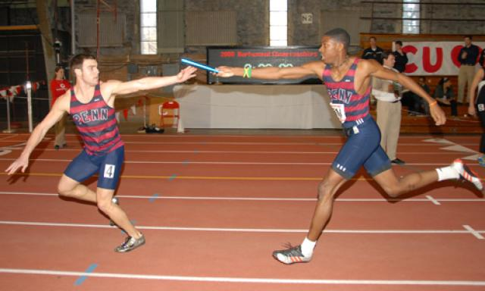

**4x400 Relay**

The 4x400 Relay handoffs are much simpler, but need to be practiced. Do not use blind handoffs as they tend to be much slower and don’t address the speed of the incoming runner. Handoffs have to be within the 20 meter zone which surrounds the finish line. The zone is almost never a problem, but should be addressed.

In a 4x400 relay, the first runner must stay in lanes all the way around the track as in a regular 400 meters. The second runner must receive the baton in the same lane as the first runner. The third runner will receive the baton according to his/her place in the race, usually with the help of an official. The fourth runner receives the baton in the same way. Runners must be careful to not bump another runner in receiving the baton or turning to run. Once the baton runner gives up the baton, he/she must get out of the way of other runners making the baton exchange.

For more information, visit: [4x100 Relay](http://www.nyrr.org/youth-and-schools/running-start/training-plans/track-and-field-training-plan/relays-further-development) and [More 4x100 Relay](http://www.nyrr.org/youth-and-schools/running-start/training-plans/track-and-field-training-plan/relays)