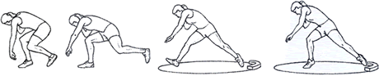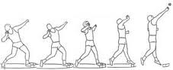Shot Put

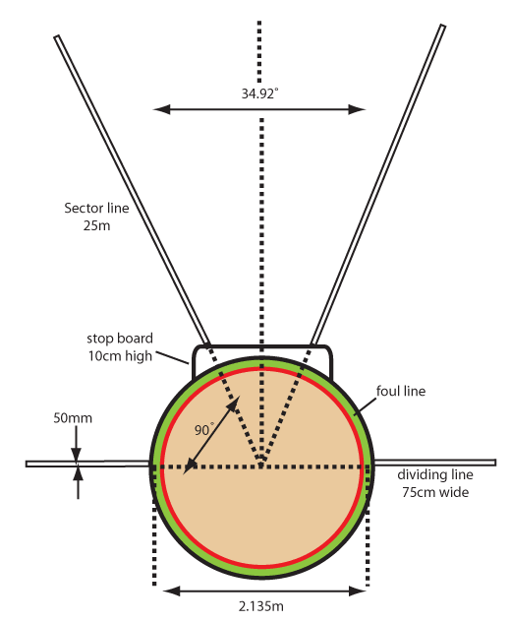Safety Considerations

Mastering shot put technique is crucial to prevent injuries. Before teaching shot put, remind your students that they should not throw the shot like a baseball; the motion will be more like a push. For beginners, it is best to use a shot or ball light enough that you can focus on technique. Regulate throwing and retrieving and

be sure to rope or fence off the landing area. Never turn your back on an athlete about to throw.

Core Exercises

Crunches: [watch the video](http://www.nyrr.org/youth-and-schools/running-start/coaching-videos/middle-school/stretches-strength/crunches)-[Crunches](http://www.nyrr.org/youth-and-schools/running-start/coaching-videos/middle-school/stretches-strength/crunches)

Leg Exercises

Squats: [watch the video](http://www.nyrr.org/youth-and-schools/running-start/coaching-videos/middle-school/stretches-strength/squats)-[Squats](http://www.nyrr.org/youth-and-schools/running-start/coaching-videos/middle-school/stretches-strength/squats)

Lunges: [watch the video](http://www.nyrr.org/youth-and-schools/running-start/coaching-videos/middle-school/stretches-strength/lunges)-[Lunges](http://www.nyrr.org/youth-and-schools/running-start/coaching-videos/middle-school/stretches-strength/lunges)

Arm Exercises

Push-ups: [watch the video](http://www.nyrr.org/youth-and-schools/running-start/coaching-videos/middle-school/stretches-strength/push-ups)-[Push Ups](http://www.nyrr.org/youth-and-schools/running-start/coaching-videos/middle-school/stretches-strength/push-ups)

Modified Push-ups for athletes that are unable to do full push ups

High Knee Skipping: [watch the video](http://www.nyrr.org/youth-and-schools/running-start/coaching-videos/middle-school/form/high-skips)-[Knee Skipping](http://www.nyrr.org/youth-and-schools/running-start/coaching-videos/middle-school/form/high-skips)

Guidelines for Shot Put

Track and field standards call for a circle seven feet in diameter. The "throw" is made from behind a 4-foot-long toe board. Demonstrate proper technique for the grip, stance, approach, and release. Show students how a "throw" is measured from the toe board to where it first lands. During practice, estimate distances using a measuring tape. Make sure to demonstrate a foul, which happens when the thrower steps past the thrower's line. It is best if each kid gets two or three "throws" per turn during practice.

**Grip**

You will need cones and/or boundary markers and shot puts (6 lb. for 7th & under and 8th girls and 8 lb. for 8th boys), depending on age and gender). Rest the shot in the hand at the base of the fingers. Wrap the thumb and fingers around the shot. The middle three fingers should be spread out slightly and serve as a force in the "throw." The pinkie and thumb are used for lateral support. Angle the wrist so the palm faces up. Have your athletes line up and practice the grip. They can watch one another to analyze proper technique.

**Stance**

You will need cones and/or boundary markers, and shot puts (4.4-8.8 lb., depending on age and gender). The thrower stands sideways, with feet shoulder-width apart, in the direction of the "throw," with the throwing arm furthest away from the toe board. If you do not have a toe board, you can mark the area with chalk or cones. Place the shot close to the chin so it rests against the neck under the jaw, with the thumb touching the collar bone. Lift the elbow of the throwing arm so it is parallel to the ground. Bend the knees slightly in preparation for the approach. Have all athletes line up and practice the grip and stance. Students can watch one another to analyze proper technique.

**Approach**

For beginners, progress from a standing put to a three-step (or shuffle) approach. During practice, you can place a cone in the landing area as a target for students to "throw" past. Other cones can designate new goals or to show the longest put for the day. Give athletes five to 10 attempts depending on ability with the standing throw before progressing to the three-step approach.

**Standing Shot Put**

Bend at the knees, leaning back to put most of the weight on the back foot.

Raise the non-throwing arm up for balance while keeping the throwing arm parallel to the ground.

Drive forward with the legs and body as the put is made.

**Three-Step Shot Put**

The thrower starts a few feet behind the thrower's cone. For added power, the thrower takes three sideways steps toward the throwers' cone, keeping the shot as far back as possible until the actual "throw." The thrower will then be in the basic standing shot put position and can complete the "throw." This should be a smooth, continuous motion.

All throwers begin in the proper stance. Right-handed throwers will stand sideways with the left side of their body facing the landing area; they will put weight on the right foot. To step sideways, they will start with their left foot, take their second step on the right foot, and take a third step on the left foot, sliding it to the thrower's cone while shifting weight back onto the right foot. Give athletes 5 to 10 attempts.

Wrap-up Game

**In the Hole!**

You will need chalk, cones, bean bags, hoops, and a stopwatch. In partners, athletes start behind a cone with hoops or chalk circles one, two, and three yards away. Place the hoops one behind the other and align them with the cone. Each team gets three bean bags. One at a time, partners aim their three bean bags at each circle, using the shot put motion to "throw". To make the game more difficult, increase the distance or introduce a time limit.

Details on exercise info can be found at: <http://www.nyrr.org/youth-and-schools/running-start/training-plans/track-and-field-training-plan/strength-and-endurance>

All shot put information can be found at: <http://www.nyrr.org/youth-and-schools/running-start/training-plans/track-and-field-training-plan/shot-put>

How to grip a shot: <https://www.youtube.com/watch?v=qpKZ2pSxXtk> How to hold the shot against the neck: <https://www.youtube.com/watch?v=14PZyqQWCEc>

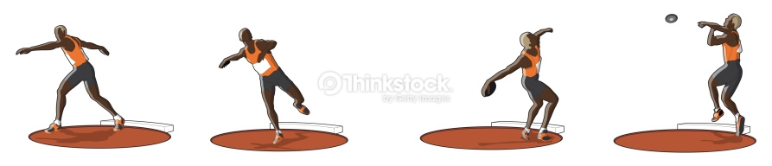Discus

The discus is a tough event to master, but kids love trying. It is also one of the more dangerous events, and coaches have to be very careful to set aside an area where the practice can be held safely.

A high school discus ring has a diameter of 2.5 m, which translates to 8 feet and 2.5 inches. This is larger than a shot-put ring, which is 7 feet in diameter. The circle on high school discus rings must either have a plastic or metal band that rises 3/4 of an inch over the circle’s level, or a 2-inch-wide painted line.

You do not need to have a perfect discus ring, but it is good to have an idea of the size so your thrower can know how to stand and the be able to follow the discus rules.



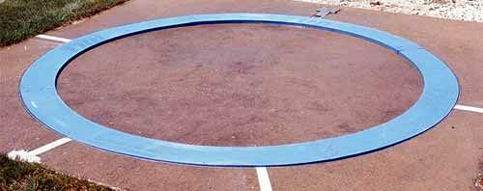

First, a thrower must walk correctly before he can run. In other words, he must know how to grip and release the discus properly before he takes standing throws. Then, he must master the standing throw before he throws from a pivot on the right foot. Last, he must pivot correctly before he takes complete throws.

    All beginning throwers see older throwers and want to attempt full throws, but when they begin these on their own, they develop and reinforce flaws which they may never lose.

    The first area of importance is the grip. The beginner may either spread his fingers or place the index and middle finger together with the joint of the first knuckle on the outside edge of the discus. Have the beginner stand with his arm at his side and squeeze the discus like a bar of soap so that it squirts out forward. Most beginners will release the discus out the back of their hand.

    Second, have two beginners stand five yards apart and "bowl" the discus back and forth. This teaches them to release the discus correctly. If they do not release it correctly, it will not roll to the partner. After they can bowl it back and forth several times without either one of them having to move sideways to catch it, they should back up to 10 yards until they are successful at that distance and so on back to about 20 yards.

    Next, the throwers move on to releasing the discus horizontally or "skimming" the discus. They stand about 20 yards apart and throw the discus back and forth releasing the discus horizontally working on level flight. They should understand that the faster a discus rotates, the farther it will travel, so a good release is vital.

**The Standing Throw**

    In teaching the discus we break the throw into four parts: 1) exiting the rear of the ring as the throw begins over the left foot; 2) driving out of the back and landing on the right foot in the center of the ring; 3) pivoting on the right foot until the left foot touches in the power position; 4) throwing from the power position.

    The teaching progression takes these four parts and works backwards. In teaching the discus, we will use a "whole-part-whole" approach. Show the beginner what a full throw looks like and explain that we will master the final step and then work backwards one step at a time before attempting the full throw.

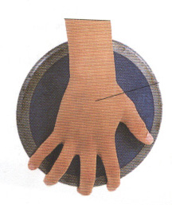    Standing throws should not only provide a warm-up, but they should emphasize technique that will improve the full throw, not just the standing throw. For example, excessive lunging forward during the standing throw will add distance to the standing throw but detract from the full throw.

You grip the discus loosely in your palm with the rim resting on your fingertips and use your thumb to hold it in place. Your feet will be hip-width apart and turn your body slightly back as you extend our arm back.

Great starter video: <https://www.youtube.com/watch?v=e5e16U5hnzY>

How to hold the discus: <https://www.youtube.com/watch?v=KytMRh2j_T8>

How to wind up the discus: <https://www.youtube.com/watch?v=5g55gNbpQVs>