Track



Made

Easy

Track and Field Handbook

Program for Humboldt County Track and Field

Presented by the Humboldt Redwood Running Association for Youth (HRRAY)

and

College of the Redwoods Track Team

Thursday, February 27, 2025

Track Events Field Events



100/200 Meters Long Jump

400/800 Meters Triple Jump

1500/3000 Meters High Jump

4 x 100 Relay Shot Put

4 x 400 Relay Discus

100 Meter Hurdles

200 Meter Hurdles

Stretching and Warm Up Drills

Organization

Have students form a large circle around you. While you lead the stretching exercises, it is also a great opportunity to build team leaders. After a couple of weeks, you can have the students lead the stretching. This will allow you the freedom to observe if runners are stretching correctly and provide instruction and encouragement as necessary. It is a good time to review the workout or plan for the next meet. Encourage the students to count as they do the stretch. Each stretch should be held for 20 to 30 seconds.

Arm Scissors

Stand with the feet shoulder-width apart. Hold the arms straight out to the sides and parallel to the ground. Swing the arms in front of and behind the body in a wide crisscrossing, or scissoring, motion. With every swing, alternate the top arm. [Watch the video](http://www.nyrr.org/youth-and-schools/running-start/coaching-videos/middle-school/stretches-strength/arm-scissors): [Arm Scissors](http://www.nyrr.org/youth-and-schools/running-start/coaching-videos/middle-school/stretches-strength/arm-scissors)

Dynamic Calf Stretch

Starting on all fours, raise your hips up in the air so the body forms an upside- down “V.” The knees and elbows should be straight. Lift one foot off the ground and rest it on the opposite ankle. Very gently, lower the heel of the planted foot as close to the ground as possible. Pointing your grounded foot straight ahead, keep the leg straight. Lift your heel, rising back up onto the ball of your foot at a fluid, controlled pace. Lower your heel as close to the ground as possible without over-stretching, and repeat. [Watch the video](http://www.nyrr.org/youth-and-schools/running-start/coaching-videos/middle-school/stretches-strength/dynamic-calf-stretch): [Calf Stretch](http://www.nyrr.org/youth-and-schools/running-start/coaching-videos/middle-school/stretches-strength/dynamic-calf-stretch)

Heel Walks

Stand tall with good posture, keeping your shoulders back. Raise your toes off the ground. Step forward with your left leg and push your body-weight into your heel, pointing your toes to the sky. This movement will activate the anterior tibialis (the muscle that runs down the front of your leg from your knee to the ankle area). Step forward with your right leg and repeat the process. Continue alternating legs.

Hamstring Stretch

Cross one foot over the other and reach up toward the sky with both arms. Counting down from 10, slowly bend forward at the hips until your upper body is as low as it can comfortably go, with your arms reaching toward your toes. Breathe fluidly and try reaching a little farther on each exhale. Slowly return to an upright stance. Repeat on the other leg.

Quadriceps Stretch

Stand tall with good posture, keeping your shoulders back. Bend your left knee and grab your left foot behind you with your left hand. At the same time, rise up onto the toes of your right foot. Hold this position for approximately two seconds. Release your left foot, let the left leg step back, and repeat the process with your right leg. Continue alternating legs. [Watch the video](http://www.nyrr.org/youth-and-schools/running-start/coaching-videos/middle-school/stretches-strength/quad-stretch): [Quad Stretch](http://www.nyrr.org/youth-and-schools/running-start/coaching-videos/middle-school/stretches-strength/quad-stretch)

Glute Stretch

Start by lying flat on your back with your knees bent and your feet on the floor. Rest one ankle on top of the opposite knee. Reaching through the legs, gently pull the bottom thigh toward your chest, raising the bottom foot off the ground. Hold the stretch and then repeat on the other side. [Watch the video](http://www.nyrr.org/youth-and-schools/running-start/coaching-videos/middle-school/stretches-strength/glute-stretch): [Glute](http://www.nyrr.org/youth-and-schools/running-start/coaching-videos/middle-school/stretches-strength/glute-stretch)

Seated Trunk Twist

While seated and with your legs straight out in front, bend your right leg and cross it over your left. Place your right foot flat on the ground next to your left knee. Place your left elbow on the outside of your bent knee, gently pushing your leg inward. Put your right hand on the ground behind your body for stability and gently twist your torso to the right. [Watch the video](http://www.nyrr.org/youth-and-schools/running-start/coaching-videos/middle-school/stretches-strength/seated-trunk-twist): [Trunk Twist](http://www.nyrr.org/youth-and-schools/running-start/coaching-videos/middle-school/stretches-strength/seated-trunk-twist)

Neck and Shoulder Warmup

For the **Neck Warmup**, stand tall and relaxed, drop the chin toward the chest, and gently roll your head toward one shoulder in a semicircular motion. Roll it back to the front and around to the other shoulder. Don’t let your head fall too far backward, as this can strain the neck and spinal cord. For the **Shoulder Warmup**, stand tall and relaxed, then rotate the shoulders in a big, smooth, circular motion. Bring the shoulders back, then up toward the ears, and then forward and down. [Watch the video:](http://www.nyrr.org/youth-and-schools/running-start/coaching-videos/middle-school/stretches-strength/neck-shoulder-warm-up) [Neck/Shoulder](http://www.nyrr.org/youth-and-schools/running-start/coaching-videos/middle-school/stretches-strength/neck-shoulder-warm-up)

DRILLS

High Knees

Keeping your arms at your sides, slowly lift your knees so the thighs are parallel to the ground. Add arm swing while maintaining a slow pace. Pick up the pace and lift your knees as quickly as possible while maintaining good overall form. Focus on lifting your knees up and down rapidly. [Watch the video](http://www.nyrr.org/youth-and-schools/running-start/coaching-videos/middle-school/form/high-knees): [Knees](http://www.nyrr.org/youth-and-schools/running-start/coaching-videos/middle-school/form/high-knees)

Butt Kicks

Keeping your arms at your sides, slowly kick one foot and then the other toward your buttocks. While still kicking at a slow pace, add arm swings to the leg movements. Pick up the pace, moving as quickly as possible while remaining in the same place. Add forward motion and do Butt Kicks quickly down a straightaway. [Watch the video](http://www.nyrr.org/youth-and-schools/running-start/coaching-videos/middle-school/form/butt-kicks): [Butt Kicks](http://www.nyrr.org/youth-and-schools/running-start/coaching-videos/middle-school/form/butt-kicks)

High Skips

Jump powerfully off one leg while lifting the opposite thigh to a position parallel to the ground. Drive your arms up powerfully in opposition to the legs. Alternating arms and legs, continue the exaggerated skipping motion down a straightaway. [Watch the video](http://www.nyrr.org/youth-and-schools/running-start/coaching-videos/middle-school/form/high-skips):  [High Skips](http://www.nyrr.org/youth-and-schools/running-start/coaching-videos/middle-school/form/high-skips)

All of the information and videos used in this booklet can be found at the New York Road Runners website: <http://www.nyrr.org/youth-and-schools>

There is far more information, including videos, that can be accessed in the site.

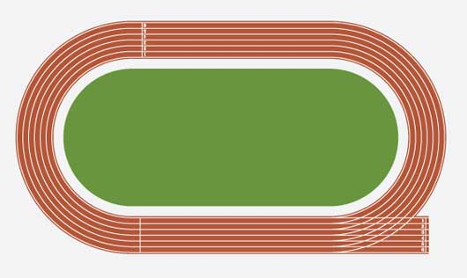100/200 Meters



100 Meters 200 Meters

Warm up: All activities in track and field can be hard on muscles, so care must be taken to warm up with stretches and drills. Sprints and jumps need lots of warm up to avoid injury. Please use the stretches and drills on pages 4-5.

Technique

Starts: Blocks are rarely necessary. A good standing start is the best and easiest for young runners.

The Standing Start

Have students stand side by side along a line (use chalk if necessary). Explain what students should do when they hear the following directions:

1. **On your marks:** Place the power leg directly behind the starting line (your front foot) with the "weaker leg" (your back foot) about 1.5 feet behind it. Feet should be shoulder-width apart. Stand erect and still.
2. **Set/Get set:** Bend at the knees and lower head and shoulders until they are slightly above hip level. Body weight should be on the front foot. The opposite arm is moved forward in a bent position, ready to drive backward at the "Go" command, and the other arm is placed slightly back to balance. Hold the position.
3. **Go:** Step forward first with the back foot, pushing off the front foot while thrusting the opposite arm backward. Drive forward vigorously with arms and legs. Gradually, come to an erect position over about 10 feet distance while running forward. Remind students that standing up too soon will slow them down.
4. Practice starts before the first meet so they will be ready for the gun. Most starters will say “On Your Marks” “Set” and then shoot the gun. Some may leave out “Set.” Practice both ways.
5. Make sure runners learn to run all the way to the end of the race. They need to know where the finish line is.

**Practice**

Students should take time to practice the different starts, including running 30 to 50 feet out in front after takeoff. It is suggested to practice about 8 to 10 starts per student. Depending on numbers and ability levels students may do less or more. Students can also practice racing each other out of the start.

Form for Sprinters

Head and Shoulders

During a sprint, students should drop their jaw and relax their face muscles, shoulders, and hands. To help kids recognize unnecessary tension, have them pretend to be a noisy boat by blowing air out of their mouth while vibrating their cheeks and lips. Then have them do this while jogging in place. Students should recognize that making the sound relaxes and reduces tension in their body.

Arms and Hands

While sprinting, students should cup and relax their hands. Palms face inward toward the body and wrists are relaxed. Arms are coordinated with legs so the left arm pumps downward as the right knee comes up and vice versa. Arms should move at the shoulder forward and backward without crossing the body.

Posture

Students should run with their core and torso erect. Keep their spines straight and the shoulders back with a slight forward lean. Keep the head up so the chin is parallel to the ground and keep the torso stable.

Feet

While sprinting, students should hit the ground on the ball of the foot and push off again with the ball of their foot. The heels should not hit the ground.

Legs

Sprinters need to lift their knees high, driving each knee forward and up until the thigh is almost parallel to the ground.

Strides

"Strides" are controlled sprints between 40 and 80 meters in length. The emphasis is on executing proper technique.

To practice proper sprinting form, divide students into pairs. Each student should do 10 strides, resting for one to two minutes between each repetition. Tell students to focus on maintaining a smooth rhythm and a balance between stride length and frequency.

Games: The games of “Foot Fire” and “Formula One Race” are good exercises for speed. They can be found on the website below.

For more information, see <http://www.nyrr.org/youth-and-schools/running-start/training-plans/track-and-field-training-plan/starts>

For 200 meter info, see <http://www.nyrr.org/youth-and-schools/running-start/training-plans/track-and-field-training-plan/200-and-400-meters>

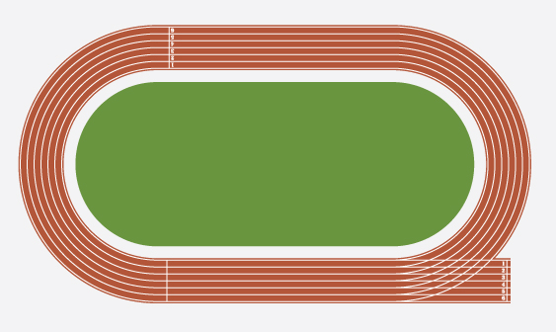400/800 Meters

400 Meters: One Lap 800 Meters: Two Laps

Warm up: All activities in track and field can be hard on muscles, so care must be taken to warm up with stretches and drills. Please use the stretches and drills on pages 4-5.

**Technique**

Starts: The standing start is the best way to start both of these races. Make sure to have your runners practice starting before the first meet. The starter should start by saying “Come to your marks” and the gun. Be sure to practice by adding “Set” in case that is added. (“Come to your marks” “Set” and the gun)

**Practice**

These events take a lot of endurance. These runners need to be treated like distance runners. They need both running background and interval work. This is best done with games and interesting activities, but it is important that runners understand the distance that has to be run so they are not surprised at the first meet.

**Drills**

Curves

You will need cones, a stopwatch, a measuring wheel/tape, and a whistle. Set up four cones (number them or use four different colors) in a horizontal line, each 10 yards apart, at a distance of 10-40 yard from the starting cone, depending on skill level.

In groups of two, runners begin at the starting cone and run straight ahead. When you call out a number or color, they will loop around that specific cone and return to the starting cone. Runners should loop around two or three cones before finishing their turn. You can alter the activity by varying the radius of the curves, increasing speed, or delaying the announcement of the next selected curve.

Strategy for the 400-Meters

* The first part of the 400-meter dash should be run aggressively, but not at an all-out sprint. Split the race into three parts.
* Accelerating near full speed for the first 50 meters
* For 150 meters you should run under a controlled deceleration. Focus on driving your arms and legs picking your knees up through the second turn
* Hold your form and finish strong over the last 100 meters

Drills for the 400-Meters

Interval Training: Use cones to divide a track into nine sections. Have your runners jog, sprint, do high knees, and run in different sections. They can start out jogging and do short sprints and drills. Have them finish with an all-out sprint. To make the intervals more difficult, increase the distance and time spend on each section.

For more information, see <http://www.nyrr.org/youth-and-schools/running-start/training-plans/track-and-field-training-plan/200-and-400-meters>

1500/3000 Meters: Distance Running

1500 Meters=3 ¾ laps 3000 Meters=7 ½ laps

Introduction to Coaching Distance Events

Most of you have coached distance runners. Here are some of the tips from the New York Road Runners. I hope these tips will add to your experience. Helpful pages that are listed below can be accessed through the provided CD.

Most children can develop a level of fitness that will support continuous running for two miles. Keep these four points in mind while teaching kids about distance running:

1. **Make running a habit:** Distance runners need to run consistently to make progress. Children new to running should eventually progress to doing some form of endurance three or four days a week.
2. **Do different activities:** Keep training fun and interesting by integrating different activities and drills.
3. **Proceed with caution:** Distance training should start very conservatively. Maintain thorough training records for your athletes, taking into account the volume and intensity of practice sessions. As championship meets approach, decrease the volume of activity at practice and increase the intensity.
4. **Take time to rest:** Rest and recovery are just as important as running and doing drills. Students need to take full days off from practice every week and need adequate rest between specific exercises and drills.

WARM-UP Light jog (2–5 minutes)

Building Leg Strength (10–15 minutes)

DRILLS Form Activities (3–5 minutes) Lead the group on a light jog. Have students form a circle around you and lead them in leg-strength exercises. Please see the Supplementary Session on Muscular Strength and Endurance.

**High Knees:** Students can do high knees in place for 15 to 20 seconds. Tell them to maintain an upright body position while bringing the knee level with the hip and pulling the toe up toward the shin, and to alternate legs quickly, while taking very small steps forward. They should move their arms in a coordinated fashion with their legs, as if running. Video: [High Knees Video](http://www.nyrr.org/youth-and-schools/running-start/coaching-videos/middle-school/form/high-knees)

**Butt Kicks**: Students can do butt kicks in place for 15 to 20 seconds. Tell them to keep the back straight while moving forward slowly with quick, light leg movements that bring the heels toward the butt. Emphasize speed, not moving forward, in completing the motion. Video: [Butt Kicks Video](http://www.nyrr.org/youth-and-schools/running-start/coaching-videos/middle-school/form/butt-kicks)

**High Skips**: Runners can practice power skipping at 10–, 20–, and 40–yard intervals. Drive arms and legs upward in an exaggerated skipping motion. Bring the leg toward the chest while the opposite arm reaches up. Emphasize getting as far off the ground as possible. Video: [High Skips Video](http://www.nyrr.org/youth-and-schools/running-start/coaching-videos/middle-school/form/high-skips)

**Distance Form**

Distance runners share a similar stride to sprinters but with slightly less leg lift and arm swing. A straight line should be drawn from the top of a runner's head through the ankles along the center of mass of the body.

Distance Run

Have new and intermediate runners go for a 5- to 15-minute run. Runners can go between running, jogging, and walking. For a more advanced session, have runners count their laps while running. After five to 15 minutes, let runners have a 2- or 3-minute water break before running again for the same amount of time and trying to run more laps.

**Chain Run**

Set up two cones 50 to 100 yards apart. Runners line up single file and start running around the cones. On your signal, the last runner in the line sprints to the front. When that runner has reached the front, he or she yells "Go!" and the runner who is now at the back sprints to the front. Repeat until all runners have led the group. The video below shows a slightly modified version of the exercise. Video: [Chain Run Video](http://www.nyrr.org/youth-and-schools/running-start/coaching-videos/high-school/pacing/baton-chain-run)

For More Information, see <http://www.nyrr.org/youth-and-schools/running-start/training-plans/track-and-field-training-plan/distance-races-800-and-1600-meters>

And <http://www.nyrr.org/youth-and-schools/running-start/training-plans/track-and-field-training-plan/distance-races-further-development>

Form Practice-[Bricks and Feathers Video](http://www.nyrr.org/youth-and-schools/running-start/coaching-videos/middle-school/form/bricks-feathers)

Continuous Relay Game-[Video](http://www.nyrr.org/youth-and-schools/running-start/coaching-videos/middle-school/games/continuous-relay)

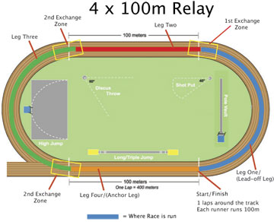4 x 100 Meter Relay

Warm-up relays*(5-10 minutes)*

You will need cones and a stopwatch. Divide team into even groups two yards apart from one another on a line. Each group stands opposite a cone 10 to 50 yards away (depending on the level of the group). Relay legs can include sprints, side steps, high knees, butt kicks, two-legged jumping, and hopping. Teams should tag each other on the hand at the changeover. This can serve as dynamic stretching at the same time.

Guidelines for Relays

In relays, individual runners come together as a team. Use this event as an opportunity to discuss teamwork and good sportsmanship. Official relays are run on the track and consist of four legs, each run by a different runner. During practice sessions you can add more legs and do different drills as noted below. The goal of a relay team is to move the baton around the track as quickly as possible. Athletes must move at a fast pace whenever they have the baton.

Starting With the Baton

You will need cones and relay batons. For younger groups, the starting runner can use the standing start with the baton grasped between all fingers in one hand. An older student can use the crouched start, gripping the baton with the middle, ring, and pinkie fingers and placing the thumb and forefinger behind the starting line. Depending on their level, athletes should practice both starts.

Baton Exchange

**The Exchange Zone:** The baton must be passed in a 20-meter exchange zone. Either runner may be outside of the zone during the exchange, but the baton must be inside the zone.

**Holding the Baton:**  The baton should be held at the bottom end for the easiest exchange.

**Timing:** Two subsequent legs must match their speeds during the exchange. This requires the outgoing runners to start running when the incoming runner is 5 to 6 meters away.

Exchange Technique

Except for the first leg, relay runners use a modified start. There are two types of baton exchanges: the Visual Exchange and the Blind Exchange.  (See the[Relays-Further Development](http://www.nyrr.org/youth-and-schools/running-start/training-plans/track-and-field-training-plan/relays-further-development) for Blind Exchange.)

Visual Exchange

The most effective starting position for the Visual Exchange is the crouch start. The outgoing runner's body should face forward with their left hand extended behind them—they can turn their head to look over their left shoulder (they will see the baton go into their hand). It is the responsibility of the incoming runner to place the baton in the outgoing runner's left hand (they then switch it to their right hand while running). Remind students to always receive with the left hand and pass with the right. The incoming runner must keep running at full speed until the outgoing runner has secured the baton in their hand.

Have athletes practice in pairs for five to 10 minutes for 50 to 100 meters and then in teams of four for five to 10 minutes.

Wrap-up Game

Olympic Relays

You will need cones and a stopwatch. Divide runners into teams and have each one choose a country to represent. Make each station a different strength-training exercise (jumping jacks, push-ups, sit-ups, etc.). Runners go from one station to the next doing a set of repetitions. You can have each runner do the entire course, or assign them "legs."

For a more difficult relay, add more stations or require more repetitions at each station. Please refer to the Supplementary Sessions for more station options.

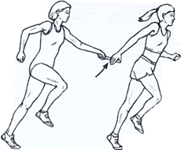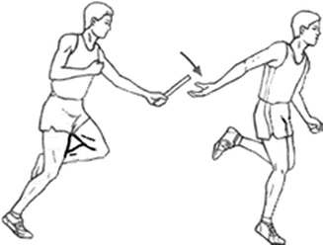The 4×100 [relay](http://en.wikipedia.org/wiki/Relay_race) or sprint relay is an [athletics](http://en.wikipedia.org/wiki/Athletics_%28sport%29) [track](http://en.wikipedia.org/wiki/Track_and_field) event run in lanes over one lap of the track with four runners completing about 100 meters each. The lead-off runners begin in the same stagger as for the individual [400m](http://en.wikipedia.org/wiki/400_metres) race. A relay baton is carried by each runner and must be passed within a 20 m exchange (or “passing” zone), which is usually marked by colored lines or triangles.  The center of the first exchange zone is 100m from the starting line, the second exchange zone is centered 200m from the starting line, and so on. The acceleration zone allows for the outgoing runner to gain speed and it extends 10m from the exchange zone.

Overhand Exchange Underhand Exchange

4 x 100 Relay (cont.) & 4 x 400 Meter Relay

Here are some guidelines to consider when matching an athlete to a 4x100 relay leg.

**Lead-Off Leg**

The lead-off leg requires an athlete who is fast out of the starting blocks and runs a good corner. The only exchange technique necessary is to be able to pass the baton.  This leg requires less practice time compared to the second and third legs, where receiving and passing the baton is required.

**Second Leg**

The second leg of the relay runs the backstretch, with very little or no curve running. The athlete needs to develop both passing and receiving skills to be effective in this leg.  Many coaches choose to place their best sprinter here, with the intention of having this runner carry the baton farther than the other runners.  This is done by getting the baton to the runner of the second leg early in the first exchange and passing it late to the third leg runner. Excellent speed and speed endurance is very important for this leg, particularly if you plan for this runner to carry the baton for an extended distance.  Being a quick accelerator is helpful if you want this runner to get the baton early in the exchange zone.

**Third Leg**

The third leg requires a runner who can run a good curve and has the ability to receive and pass the baton.  As with the second leg, the third leg can be intentionally lengthened or shortened by the coach.  Some coaches will place their slowest runner in the third position and try to pass the baton late to this runner and have the runner give up the baton early in the exchange zone to the fourth leg.  Some coaches will do the opposite and fill the third leg with a fast runner (Usain Bolt has run this leg for the Jamaicans) and in doing so try lengthen this leg.

**Fourth Leg**

Often coaches will put either their fastest or second fastest athlete in this position. It requires a very competitive athlete who can finish the event by either catching or holding off other challengers into the finish line. This athlete needs only to be able to receive the baton well, but does not need to pass it, and he or she does not need to run a curve well. As with the leadoff runner, practice time for this leg is reduced compared to the 2nd and 3rdlegs.

Baton Exchange: Below are exchange techniques that students can develop to improve their speed and effiency. Athletes should practice all exchanges in pairs and then in small groups. *A general guide for children is to start running when the incoming runner reaches a checkpoint that is five to six yards away.*

Blind Exchange: There is no visual contact between runners in a blind exchange. The only time the outgoing runner should look back is to see when the incoming runner reaches the checkpoint. At this point, the outgoing runner should accelerate at full speed as if he or she were running a 100-meter dash. Runners must have confidence that their practice and timing will allow the baton to be exchanged smoothly. Athletes should practice without the baton first, starting their run 5 to 6 yards away from the exchange.

Incoming and Outgoing Runners: Remind students it is the responsibility of the incoming runner to place the baton in the outgoing runner's hand. The outgoing runner must trust their teammate and not feel blindly for the baton. A lack of trust may result in a dropped baton or poor handoff outside the exchange zone. After accelerating, the outgoing runner should extend his or her left hand back. The exact hand position should be whatever is most natural and comfortable while running full speed—remind runners to keep their shoulders facing forward. This technique creates smoother baton exchanges by allowing a straight line for arms and shoulders to match up. It also allows the runners to use the inside of the lane, resulting in a slightly shorter distance. After making the exchange, the incoming runner should continue to run through the zone and stay in their lane. Athletes should practice this in partners and in teams for 10 minutes.

Push: The outgoing runner holds the receiving hand at shoulder height with the thumb down, the palm facing the incoming runner, and the fingers pointing to the inside of the track. The incoming runner holds the baton straight up and down and pushes the baton into the hand.

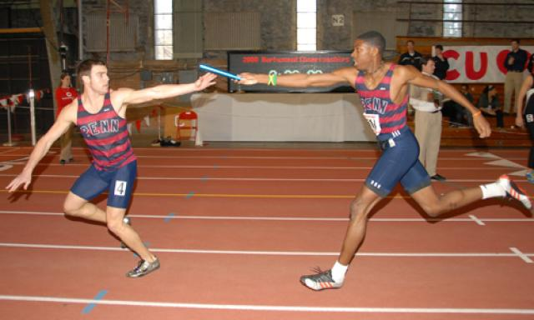

**4x400 Relay**

The 4x400 Relay handoffs are much simpler, but need to be practiced. Do not use blind handoffs as they tend to be much slower and don’t address the speed of the incoming runner. Handoffs have to be within the 20 meter zone which surrounds the finish line. The zone is almost never a problem, but should be addressed.

In a 4x400 relay, the first runner must stay in lanes all the way around the track as in a regular 400 meters. The second runner must receive the baton in the same lane as the first runner. The third runner will receive the baton according to his/her place in the race, usually with the help of an official. The fourth runner receives the baton in the same way. Runners must be careful to not bump another runner in receiving the baton or turning to run. Once the baton runner gives up the baton, he/she must get out of the way of other runners making the baton exchange.

For more information, visit: [4x100 Relay](http://www.nyrr.org/youth-and-schools/running-start/training-plans/track-and-field-training-plan/relays-further-development) and [More 4x100 Relay](http://www.nyrr.org/youth-and-schools/running-start/training-plans/track-and-field-training-plan/relays)

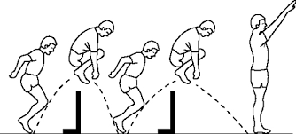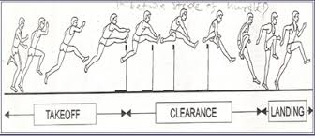100/200 Hurdles

**Hurdle distances for track:**

**100m hurdle spacing:**  13m to H1 with 8.5m between and 10.5m to the finish  
**100m hurdle spacing:**  13m to H1 with 8.5m between and 10.5m to the finish



8.5 meters

Start 13 m to the 1st hurdle 10 hurdles in the race-8.5 meters between each hurdle 10.5 m to finish line

It is not necessary to have a track or 10 hurdles. It is good to have at least 4 or 5 hurdles. The spacing is important so athletes can practice the correct distances from start to 1st hurdle, hurdle to hurdle and to the finish. All hurdles in the elementary school races will be the same height, 30,” the lowest setting on a high school hurdle. If you make your own hurdles, try to make them adjustable to a lower height for practice, especially if you have younger runners.

On the final page of this booklet I have given you a web site which will guide you through hurdle assembly. It takes a bit of time and costs close to $100.00 for 4 hurdles. You may be able to get someone to donate materials and even build them. If you wish to have hurdlers, and don’t have a track close by, this is a way to get started. BE CAREFUL! All hurdles should be made to fall in one direction, so teach kids to go over them properly and to take care of them. They should be aware of that same rule at each track meet. Going over a regular hurdle backward can cause problems for the athlete and the hurdle.

On the second hurdle page, I added some videos. Watch how the hurdler in the first one goes over the hurdle and work to get close to that with your runners. It doesn’t matter which leg each runner uses as a lead leg, but most will use the left leg if right handed. It is good to teach both legs as lead, especially if your runner wishes to run faster.

If a runner steps five times between the hurdles, he will always be using the same lead leg. To get faster, he must use four steps and then will have to switch legs. To go over a hurdle, the athlete needs to be running fast and begins jumping well before the hurdle. He leads with his knee, then kicks his foot up and over the hurdle. His leg should come back down into a running stride. The back let folds over the hurdle with the rear foot nearly touching his butt. It should just go over the top of the hurdle and snap back down to put the athlete into a full sprint again.

The hurdler will run the 100 (10 hurdles) or 200 meters (5 hurdles), while taking what amounts to a long, gliding stride over each hurdle. The competitors will spend as little time in the air as possible. They’ll get their feet back on the ground quickly after clearing each hurdle, then will continue running with consistent strides so they can clear the next obstacle just as smoothly as the last. At the youth level, the beginning hurdler is going to run up to the hurdle, slow down, jump over the hurdle, then start running again. It almost doesn’t matter how small you make the barriers in practice. Anything reasonably close to the size of an actual hurdle is going to elicit the run-jump-run reaction. Therefore, patience on the coaches’ part is just as important as skill development on the competitors’ part when teaching the sport to new hurdlers.

**Safety and comfort:**

As with any running event, a good stretching routine is a must. Even young, active, flexible runners will benefit from a good warm-up. The next step is getting the runners comfortable with clearing hurdles, and beginning to teach them to avoid the run-jump-run instinct, which can only be accomplished through repetition. While the youngsters are learning, they’ll need some barriers to clear. Youth events, depending on the competitors’ ages, generally begin with 30-inch hurdles, so beginners should start with lower barriers, if possible. Additionally, the barriers must be light and safe, so the kids won’t be injured when striking a hurdle. Some hurdles can be lowered for youth, but you may need to make your PVC hurdles adjustable to a low height.

**Technique:**

Among the teaching points for beginning hurdlers, the start will be the easiest. At higher levels, of course, races can be won or lost out of the blocks. But there’s plenty of time to work on starting technique. Novices must focus on selecting a lead hurdling leg (usually the left for right-handers), then developing a consistent stride pattern, because the stride pattern determines which leg is placed in the back of the starting blocks. If the hurdler takes an even number of steps to the first hurdle, the lead leg goes in the back block, and vice-versa for an odd number of steps.

Next, nothing beats repetition when you’re teaching hurdle clearance. But a little visualization never hurts. Have your prospective hurdlers walk up to a youth-sized hurdle. For those who are leading with their left leg, have them walk to the right of the hurdle, lift their lead leg and stretch it out, to demonstrate that their leg can rise above the hurdle. Repeat the drill on the other side of the hurdle, but have them lift their rear leg up in proper position off to the side, with the knee as high as possible, to show that the trail leg can also pass above the hurdle without a jump. Yes, they’ll still jump the first few times, but as their comfort increases, the visualization will remain in their mind and help them progress.

Start the novices out clearing just one practice barrier, but make sure they sprint to a finish line after clearing it, to get used to the rhythm of a hurdles race. Many races, after all, are won between the final hurdle and the tape. Next, add a second hurdle, so the competitors can begin developing a stride pattern between hurdles. Again, repetition is the best teacher. As the athletes progress, gradually increase the height of the practice barriers, and increase their number. At some levels, youth hurdlers will face eight barriers, moving up to a maximum of 10.

Most hurdlers will begin running with 5 steps between hurdles, reaching each hurdle with the same lead leg. For a hurdler to improve, he/she needs to run 4 steps between each hurdle. That means he/she must switch the lead leg, so switching the lead leg will need to be taught.

**Conclusion:**

Don’t worry about the fine points at the beginning. Just get the hurdlers comfortable clearing the barriers without jumping, while developing a reasonably consistent stride pattern. As they improve, begin to emphasize proper clearance techniques, with the lead leg snapping up, the upper body leaning forward, and the trial leg rising up and to the side, with the knee higher than the foot.

Developing Beginning Hurdlers  
1) To me, the most important thing to teach beginning hurdlers is to sprint on the balls of their feet, not on their toes (too tall), and not on their heels (too low), which is most common. Running between the hurdles on the balls of the feet, with the chin up and back straight, is essential to being able to execute proper hurdling mechanics. Beginning hurdlers will often rock back on their heels because they’re afraid of the obstacle, so getting back on their heels is a way to gear up for hurdle clearance. Once you’re on your heels, there’s nowhere to go but up, whereas a hurdler wants to go *forward*, *into* the crossbar, in order to reduce air time as much as possible.  
2) Lead with the knee, lead with the knee, lead with the knee. Want me to say it again? Lead with the knee. Coaches need to teach athletes that the knee of the lead leg should never be fully locked at any time during hurdle clearance. As the hurdler takes off into the hurdle, the knee of the lead leg should be driving directly at the crossbar in order to ensure low hurdle clearance and a quick snapdown back to the ground. Many beginning hurdlers swing the whole leg from the hip, which makes for all kinds of balance problems with the hips, the arms, as well as with the legs. One way I explain it to my hurdlers is to say that your lead leg knee is your steering wheel. It guides you, it directs you, it *leads* you. If the foot of the lead leg is getting ahead of the knee too soon, then the foot is leading the way, which is nothing but trouble.  
3) Beginning hurdlers should do a lot of hurdle drills. Even experienced hurdlers should, but it is essential that beginning hurdlers do so, so that they can develop muscle memory that will enable them to internalize proper hurdling mechanics. Walk-overs are a good drill for beginners. Set up five to ten hurdles at 30” to 33” high, lined up directly behind each other, and have the athlete walk over the hurdles, focusing on keeping the hips square and driving up the knees. Another good drill for trail-leg mechanics is the fence drill. Put a hurdle anywhere between 30” and 36” inches, and have the hurdler put his hands against a fence or wall, and circle his trail leg around the crossbar a series of times. Three sets of ten is usually a good number. This drill helps to develop mechanics, and it also strengthens the groin muscles which bear the brunt of the strain on the trail leg side of the body when hurdling at full speed. Another basic is the lead leg drill and the trail leg drill in which five hurdles are set up on the regular hurdle marks, and the hurdler bounces five steps between the hurdles, clearing with just one leg. Isolating one leg helps the hurdler to get a feel for how that leg should be moving up and over the hurdle without having to worry about bringing the whole body over the hurdle. It’s also a good warm-up. Three times each side over five hurdles is a good number.

**200 Hurdles**

There are only 5 hurdles in the 200 meter hurdle race. The first hurdle is 50 meters from the start, and it is 10 meters to the finish line from the final hurdle. It is 35 meters between hurdles. This event is only a 7th/8th grade event in the meets, but some younger runners may enter the 7th event if they are prepared.

I don’t worry very much about the distance in this race, but it is a good idea to try a couple of times, if possible, before a meet. Generally, I plan carefully for the 100 hurdles and let the athlete try the longer race. Hurdle form is the same, but it goes around a turn, which makes the race a bit more difficult.

Good technical video: <https://www.youtube.com/watch?v=yjly0wkPLHU> This video shows the arm action and the legs going over the hurdle. These are good basics.

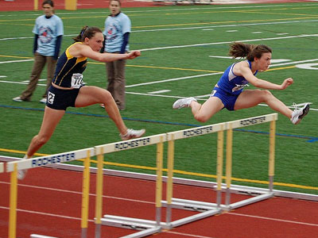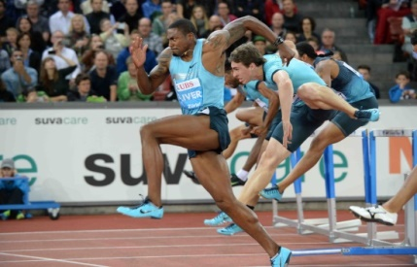Good advanced drills, but can be used to work with younger kids. Few hurdles needed. <https://www.youtube.com/watch?v=ATUfTQ7tESE>

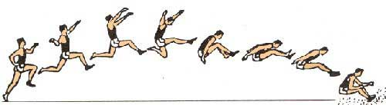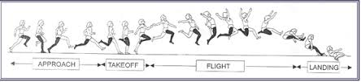Long Jump

Warmup: Be sure to use the stretching and drills before beginning any work on long jump. There is also a section on building your own long jump pit. If there is no pit, it is best to work on steps to the board and form. It is difficult to work on long jump without a pit, unless you can find a soft landing area.

**Long Jump Guidelines**

Long jump competitors use a runway, a takeoff board, and a sand pit. The objective is for an athlete to jump as far forward as possible. Athletes cannot plant their feet past a white take-off board before the sandpit. This is considered a foul and the jump does not count.

Explain to students that the longer they stay in the air, the further they will go. They need speed and height to go further. Athletes should land steady and with their feet as close together as possible. Their jump will be measured from the foul line to the closest point they touched. Therefore, it is important to tell athletes not to land with their hands behind them.

**Long Jump Techniques**

As a precursor to the running long jump, use the standing long jump and then the three-step long jump to solidify proper technique.

**Standing Long Jump**

You will need cones and a measuring tape for this activity. Athletes stand at the take-off board (or a marked-out line) with feet shoulder-width apart and knees bent. Swing both arms backward and then thrust them forward and upward while jumping explosively off the balls of both feet. Jumpers should land on both feet, thrusting the body forward at landing. Repeat this drill 20 to 30 times. Have athletes focus on jumping high and landing with control.

**Three-Step Long Jump**

Once athletes have mastered the standing long jump, begin teaching the three-step technique. You will need cones, measuring tape, and a long jump mat. As a general rule, righties takeoff on the left foot and lefties on the right foot, but there are exceptions. Take three brisk running strides before jumping. The right-handed jumper, for example, takes one brisk step with the left foot, one with the right, and then one more with the left. On the third step, the takeoff foot should be on the board, with the knee bent. Both arms should be thrust upward while jumping explosively off the ball of the foot. Emphasize landing on both feet with a forward thrust so that the jumper falls or hops forward. Use this method for a while before moving to the full running long jump.

**Approach**

You will need cones, measuring tape, and a long jump mat. Mark the recommended starting point with a cone, adjusting as needed for age and skill. A good starting point is eight strides away from the take-off board, but you can allow kids to start a few strides before or after the marker if they want. For the novice jumper, do not be concerned with the exact number of strides taken to the takeoff board. For most kids between 8 and 15 years of age, a run-up of eight to 10 strides, perhaps increasing to 12 or 16, is ideal.

Tell students to gradually build speed during the run-up so that they are near full speed a few strides before take-off. They should aim for fast, relaxed pace without over striding or slowing down in the last few steps. Give each athlete two to four jumps.

**Takeoff**

Adjust the distance from the takeoff board to the pit/mat depending on the age and skill of the jumper, leaving plenty of room for landing on the mat and falling forward after landing.

When the foot strikes the takeoff board, it should be in a â€œflat footâ€ position. Body weight should be directly over the board. A powerful extension of the opposite leg (from the toes to the hips) will provide a strong lift forward and upward; the knee should be thrust forward and high into a flexed position. At the same time, thrust both arms upward, with the chest, hips, chins, and eyes lifted to help achieve height. Give each athlete two to four jumps.

**Obstacle Course**

Set up five to 10 different stations. Depending on the course, you will need cones and/or boundary markers, a stopwatch, a measuring wheel, a whistle, a long jump mat, hoops, and a jumping box. In groups of up to 4, athletes spend 30 seconds to one minute at each station, moving to the next one on your signal. Stations can include a crab crawl or bunny hops between cones; exercises like squats, lunges, jumping jacks, hopping or balancing on one leg; box jumps or jumping in between hoops arranged on the course; sitting down and standing up with or without using hands; sprinting for 10-50 meters; or a speed drill using the agility ladder.

**Help for Long Jump:** <http://www.nyrr.org/youth-and-schools/running-start/training-plans/track-and-field-training-plan/long-jump>

**More Help:** <http://www.nyrr.org/youth-and-schools/running-start/training-plans/track-and-field-training-plan/long-jump-further-development>

**Triple Jump**

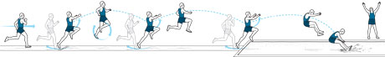

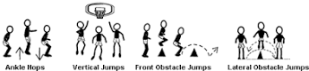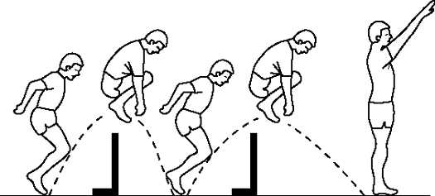The exercises below are good for both the long and triple jump.

The Triple Jump is one of the most enjoyable events for students and for coaches. It takes a lot of practice, but it is fairly easy to see a lot of improvement. Not many people can coach it well, so a good coaching job can create a great deal of success.

Triple jump technique is much like the game hop scotch that young children play. An athlete must take off and land on the same leg then land on the next opposite leg before landing in the pit. This event has many of the same characteristics that the long jump displays during the approach. At takeoff, however the differences end, good triple jumpers will take off at a much flatter angle than in the long jump. We will examine the technical requirements and methods to develop them as well as how to set up the training day and week. The triple jump has 1) Acceleration 2) Maximum Controllable Speed 3) Takeoff and the Hop 4) The Step and 5) The Jump and Landing.

**Teaching the Rocking Start**   
The athlete will begin with their takeoff foot forward and rock back so most of their weight is on the rear leg. Make sure they swing their arms in opposition to their legs when pushing out of this position and “rocking” back over their front leg. All forces should be directed horizontally into the ground. By starting in this fashion the athlete is able to use momentum generated from the rock to aid the start. It helps insure a consistent reliable, start that leads to an accurate approach.

**Coaching Cues for Acceleration Work**  
Push, lean from the ankle. Tell the athlete to be patient while executing this part of the approach, allowing the foot contact with the ground to gradually stand them up.

**The Takeoff and Hop**

Elite athletes set up the takeoff and first phase (hop), novice ones survive the landing from their long jump like takeoff. In the triple jump, there is no need to coach takeoff height most beginners will need to be convinced that running through the board is more important. There should be no marked difference between takeoff and previous steps of the approach other than the heel to toe (rocking) ground contact. Attempting to run past the foot while it is on the board is a great cue. Horizontal movement is the emphasis of the takeoff action. Allow the stretch on the hip flexors to put the takeoff leg in position for the step rather than actively “cycling”. By avoiding cycling the leg the transition to slower tempo of jumping is smoother. You can get very technical with coaching the free limbs, simply put have them continue to move as close to running as possible. The hop will generally be the longest of the three phases. Most importantly, it should set up the step and conserve horizontal momentum.

**The Step**

Getting athletes to be in position for the step is most important. Much of this is done by focusing on the approach and hop. Some work to ready the athlete for this crucial transition is necessary. General coaching cues are to maintain horizontal velocity and to be patient (wait for the ground to come to you). Contact is best made with the rocking full foot contact described in the other phases.

**The Jump**

At this point in the jump, the athlete has slowed considerably. It is crucial to success of the jump to have ground contact underneath the body. This reduces deceleration and allows the athlete to continue to apply forces horizontally. Most jump phase work will be done in conjunction with other phase work. Isolating this part could have the athlete setting up a long jump like takeoff. Some “weak leg” long jumps will help the athlete feel what will happen during this phase. Additional single leg hopping after some step work is a good way for the athlete to better align themselves during this phase. An example would be for a left foot takeoff LLRRR or LLRR.

Drills and practice information can be found at <http://www.everythingtrackandfield.com/webapp/wcs/stores/servlet/PBOnePieceView?storeId=10152&catalogId=10753&pagename=303>

Drill video: <https://www.youtube.com/watch?v=YTk6iimgzCg>

Triple Jump Slow Motion: <https://www.youtube.com/watch?v=X-euvqJONd8>

Drill video: <https://www.youtube.com/watch?v=4PMDDGoYxcQ>

Good basic triple video: <https://www.youtube.com/watch?v=9Pv2hUyODK4>

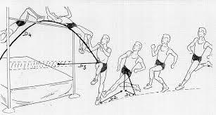High Jump

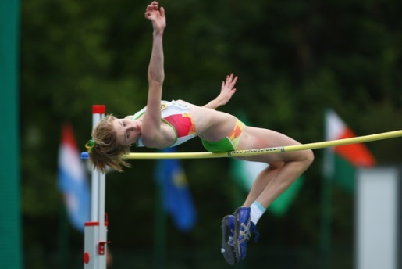

**As always, be sure to stretch before beginning.**

**Technique:**

There are three basic parts to a high jump – approach, takeoff and clearance. Each part will likely be taught separately at first, using a variety of high jump drills . When teaching the approach, coaches will likely focus on maintaining the correct running speeds at different parts of the approach, on taking a proper angle to the bar and on hitting the correct takeoff point. Intuitively, young jumpers may want to take off as close to the bar as possible. This, however, will cause the jumpers to leap almost straight up – at too narrow of an angle – and they’ll likely knock the bar off on the way down, even if they achieve sufficient height. Potential jumpers will also determine a takeoff leg – the strongest leg will be on the inside during the jump, making the opposite the takeoff leg. Takeoff and clearance drills may begin with the backflips mentioned previously. The young jumpers will then move on to clearance technique, perhaps learning the old-fashioned scissors kick first, to get them used to flying over the bar, then later advancing to the modern “flop” technique.

**Drill - Back flips:**

﻿To start getting your jumpers comfortable with landing in the pit, have them stand with their heels against the front of the pit, with the “bar” (rope, cord, etc.) low, and have them jump over the rope and land on their backs. At this point, don’t worry about getting their feet up in the air.

When the jumpers are comfortable landing in the pit on their backs, tell them to repeat the drill, but this time make sure they can see their hands and feet when they’re in the air. This will begin teaching them to clear the bar in a correct position.

﻿**Drill - Scissors kick:**

﻿To continue getting your young athletes comfortable with high jumping, have them simply take a step or two and scissor-kick over the bar, landing on their back. Make sure they push off with the outside leg, and raise the inside leg, closest to the bar. Begin the drill without any type of bar, then add your rope or cord. The jumpers can try this drill from both sides, to begin getting a feel for which side they’re comfortable with.

When they’re comfortable with this drill, repeat it, but have the coach stand a few steps in front of an upright, at a 45-degree angle to the center of the “bar.” As the jumpers clear, have them turn their feet to point at the coach. Next, the coach will move in front of the bar - but out of the jumpers’ paths, of course. The jumpers will again turn their feet toward the coach while in flight. This teaches your jumpers how to turn in the air.

﻿**Determining the takeoff leg:**

﻿Beginning jumpers must determine which leg they with take off with. There are several ways to figure this out. In the high jump, kids can simply try both sides and decide which is more comfortable. Alternatively, you can put a ball on the ground have them kick it. Whichever foot they kick the ball with is their inside foot for the high jump. Another method is to have them stand up straight and tell them to fall forward as far as they can. One foot will naturally shoot forward to break their fall. That is the inside leg. The other is the takeoff foot.

If the jumper’s right foot is the inside foot, he’ll begin his approach from the right side, and vice versa.

﻿**Setting up the approach run:**

﻿To set up the approach run - for a jumper starting from the right - have the jumper stand at the side of the pit, with the standard at his/her back. The jumper walks five paces forward, then turns around to be sure he/she is parallel to both standards (they should be lined up, from the jumper’s point of view). The jumper then turns 90 degrees, so his/her shoulders line up with the standards, and runs forward 10 steps, with the coach marking the position of the fifth and tenth steps. Try this at least three times to be certain the marks are consistent, then measure the final marks for the fifth and tenth steps.

The tenth step is the jumper’s takeoff point. The fifth step is where he/she will begin turning toward the bar.

Information about high jump: <http://trackandfield.about.com/od/highjump/p/highjumpdrills.htm>

Video for learning to turn and land in the flop position: <https://www.youtube.com/watch?v=_EetvCQanf0>

Nice student breakdown of the jump: <https://www.youtube.com/watch?v=wnaYlvlgLm8>

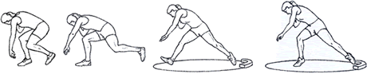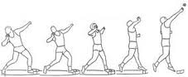Shot Put

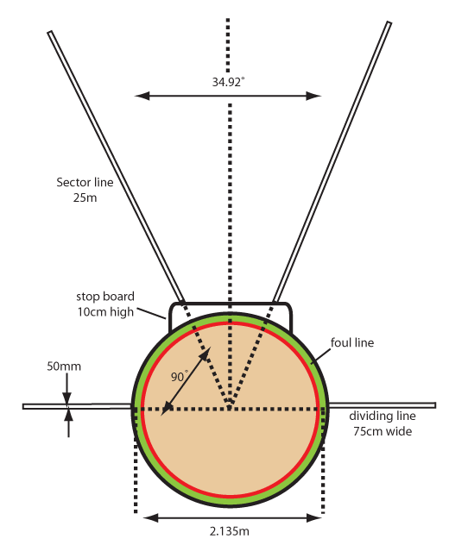Safety Considerations

Mastering shot put technique is crucial to prevent injuries. Before teaching shot put, remind your students that they should not throw the shot like a baseball; the motion will be more like a push. For beginners, it is best to use a shot or ball light enough that you can focus on technique. Regulate throwing and retrieving and

be sure to rope or fence off the landing area. Never turn your back on an athlete about to throw.

Core Exercises

Crunches: [watch the video](http://www.nyrr.org/youth-and-schools/running-start/coaching-videos/middle-school/stretches-strength/crunches)-[Crunches](http://www.nyrr.org/youth-and-schools/running-start/coaching-videos/middle-school/stretches-strength/crunches)

Leg Exercises

Squats: [watch the video](http://www.nyrr.org/youth-and-schools/running-start/coaching-videos/middle-school/stretches-strength/squats)-[Squats](http://www.nyrr.org/youth-and-schools/running-start/coaching-videos/middle-school/stretches-strength/squats)

Lunges: [watch the video](http://www.nyrr.org/youth-and-schools/running-start/coaching-videos/middle-school/stretches-strength/lunges)-[Lunges](http://www.nyrr.org/youth-and-schools/running-start/coaching-videos/middle-school/stretches-strength/lunges)

Arm Exercises

Push-ups: [watch the video](http://www.nyrr.org/youth-and-schools/running-start/coaching-videos/middle-school/stretches-strength/push-ups)-[Push Ups](http://www.nyrr.org/youth-and-schools/running-start/coaching-videos/middle-school/stretches-strength/push-ups)

Modified Push-ups for athletes that are unable to do full push ups

High Knee Skipping: [watch the video](http://www.nyrr.org/youth-and-schools/running-start/coaching-videos/middle-school/form/high-skips)-[Knee Skipping](http://www.nyrr.org/youth-and-schools/running-start/coaching-videos/middle-school/form/high-skips)

Guidelines for Shot Put

Track and field standards call for a circle seven feet in diameter. The "throw" is made from behind a 4-foot-long toe board. Demonstrate proper technique for the grip, stance, approach, and release. Show students how a "throw" is measured from the toe board to where it first lands. During practice, estimate distances using a measuring tape. Make sure to demonstrate a foul, which happens when the thrower steps past the thrower's line. It is best if each kid gets two or three "throws" per turn during practice.

**Grip**

You will need cones and/or boundary markers and shot puts (6 lb. for 7th & under and 8th girls and 8 lb. for 8th boys), depending on age and gender). Rest the shot in the hand at the base of the fingers. Wrap the thumb and fingers around the shot. The middle three fingers should be spread out slightly and serve as a force in the "throw." The pinkie and thumb are used for lateral support. Angle the wrist so the palm faces up. Have your athletes line up and practice the grip. They can watch one another to analyze proper technique.

**Stance**

You will need cones and/or boundary markers, and shot puts (4.4-8.8 lb., depending on age and gender). The thrower stands sideways, with feet shoulder-width apart, in the direction of the "throw," with the throwing arm furthest away from the toe board. If you do not have a toe board, you can mark the area with chalk or cones. Place the shot close to the chin so it rests against the neck under the jaw, with the thumb touching the collar bone. Lift the elbow of the throwing arm so it is parallel to the ground. Bend the knees slightly in preparation for the approach. Have all athletes line up and practice the grip and stance. Students can watch one another to analyze proper technique.

**Approach**

For beginners, progress from a standing put to a three-step (or shuffle) approach. During practice, you can place a cone in the landing area as a target for students to "throw" past. Other cones can designate new goals or to show the longest put for the day. Give athletes five to 10 attempts depending on ability with the standing throw before progressing to the three-step approach.

**Standing Shot Put**

Bend at the knees, leaning back to put most of the weight on the back foot.

Raise the non-throwing arm up for balance while keeping the throwing arm parallel to the ground.

Drive forward with the legs and body as the put is made.

**Three-Step Shot Put**

The thrower starts a few feet behind the thrower's cone. For added power, the thrower takes three sideways steps toward the throwers' cone, keeping the shot as far back as possible until the actual "throw." The thrower will then be in the basic standing shot put position and can complete the "throw." This should be a smooth, continuous motion.

All throwers begin in the proper stance. Right-handed throwers will stand sideways with the left side of their body facing the landing area; they will put weight on the right foot. To step sideways, they will start with their left foot, take their second step on the right foot, and take a third step on the left foot, sliding it to the thrower's cone while shifting weight back onto the right foot. Give athletes 5 to 10 attempts.

Wrap-up Game

**In the Hole!**

You will need chalk, cones, bean bags, hoops, and a stopwatch. In partners, athletes start behind a cone with hoops or chalk circles one, two, and three yards away. Place the hoops one behind the other and align them with the cone. Each team gets three bean bags. One at a time, partners aim their three bean bags at each circle, using the shot put motion to "throw". To make the game more difficult, increase the distance or introduce a time limit.

Details on exercise info can be found at: <http://www.nyrr.org/youth-and-schools/running-start/training-plans/track-and-field-training-plan/strength-and-endurance>

All shot put information can be found at: <http://www.nyrr.org/youth-and-schools/running-start/training-plans/track-and-field-training-plan/shot-put>

How to grip a shot: <https://www.youtube.com/watch?v=qpKZ2pSxXtk> How to hold the shot against the neck: <https://www.youtube.com/watch?v=14PZyqQWCEc>

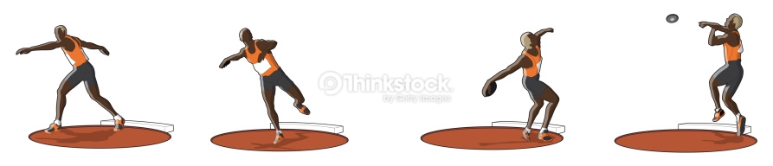Discus

The discus is a tough event to master, but kids love trying. It is also one of the more dangerous events, and coaches have to be very careful to set aside an area where the practice can be held safely.

A high school discus ring has a diameter of 2.5 m, which translates to 8 feet and 2.5 inches. This is larger than a shot-put ring, which is 7 feet in diameter. The circle on high school discus rings must either have a plastic or metal band that rises 3/4 of an inch over the circle’s level, or a 2-inch-wide painted line.

You do not need to have a perfect discus ring, but it is good to have an idea of the size so your thrower can know how to stand and the be able to follow the discus rules.



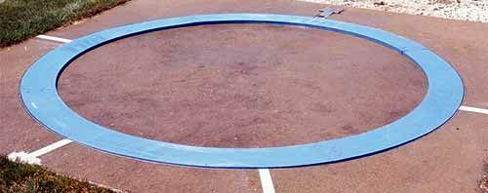

First, a thrower must walk correctly before he can run. In other words, he must know how to grip and release the discus properly before he takes standing throws. Then, he must master the standing throw before he throws from a pivot on the right foot. Last, he must pivot correctly before he takes complete throws.

    All beginning throwers see older throwers and want to attempt full throws, but when they begin these on their own, they develop and reinforce flaws which they may never lose.

    The first area of importance is the grip. The beginner may either spread his fingers or place the index and middle finger together with the joint of the first knuckle on the outside edge of the discus. Have the beginner stand with his arm at his side and squeeze the discus like a bar of soap so that it squirts out forward. Most beginners will release the discus out the back of their hand.

    Second, have two beginners stand five yards apart and "bowl" the discus back and forth. This teaches them to release the discus correctly. If they do not release it correctly, it will not roll to the partner. After they can bowl it back and forth several times without either one of them having to move sideways to catch it, they should back up to 10 yards until they are successful at that distance and so on back to about 20 yards.

    Next, the throwers move on to releasing the discus horizontally or "skimming" the discus. They stand about 20 yards apart and throw the discus back and forth releasing the discus horizontally working on level flight. They should understand that the faster a discus rotates, the farther it will travel, so a good release is vital.

**The Standing Throw**

    In teaching the discus we break the throw into four parts: 1) exiting the rear of the ring as the throw begins over the left foot; 2) driving out of the back and landing on the right foot in the center of the ring; 3) pivoting on the right foot until the left foot touches in the power position; 4) throwing from the power position.

    The teaching progression takes these four parts and works backwards. In teaching the discus, we will use a "whole-part-whole" approach. Show the beginner what a full throw looks like and explain that we will master the final step and then work backwards one step at a time before attempting the full throw.

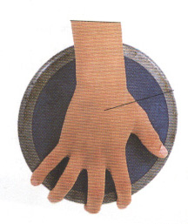    Standing throws should not only provide a warm-up, but they should emphasize technique that will improve the full throw, not just the standing throw. For example, excessive lunging forward during the standing throw will add distance to the standing throw but detract from the full throw.

You grip the discus loosely in your palm with the rim resting on your fingertips and use your thumb to hold it in place. Your feet will be hip-width apart and turn your body slightly back as you extend our arm back.

Great starter video: <https://www.youtube.com/watch?v=e5e16U5hnzY>

How to hold the discus: <https://www.youtube.com/watch?v=KytMRh2j_T8>

How to wind up the discus: <https://www.youtube.com/watch?v=5g55gNbpQVs>