

***2025 CROSS COUNTRY COACH’S CLINIC***

***TK TO 8TH GRADE***

***SEPTEMBER 7, 2025***

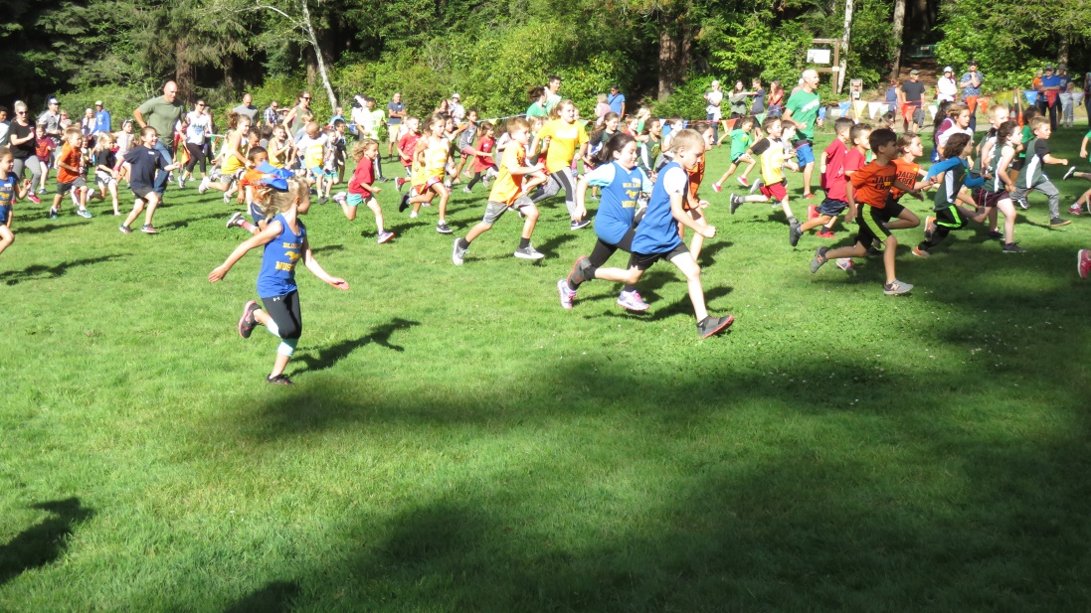

HRRAY is a running club that supports youth runners in Humboldt County. We are a subsidiary

of the Six Rivers Running Club. HRRAY has provided cross country and track and field

for youth for a decade. This year the club offers seven league meets, including a Humboldt

County Championship, and offers participation in two non-league events.

This is the first year HRRAY has offered a cross country clinic. Please use our website,

HRRAY.org, for information and results. You can contact HRRAY at HRRAY707@gmail.com.

Thank you for attending.

HELPERS & PRESENTERS:

DENISE WALKER-BROWN, JACK WEST, BREANNA CAHOON, ALYSIA DAVIDSON

HRRAY Website: [www.hrray.org](http://www.hrray.org)

Questions: [hrray707@gmail.com](mailto:hrray707@gmail.com)

2024 CROSS COUNTRY SEASON

* THERE ARE SIX REGULAR SEASON RACES AND THE CHAMPIONSHIP EVENT
* THERE ALSO THE MCKINLEYVILLE BEACH RUN THAT IS NOT A HRRAY EVENT, SO THERE IS A CHARGE
* ALL RACES WILL BEGIN ON TIME, BUT THE 3-5 AND 6-8 RACES COULD START EARLY OR LATE DEPENDING ON HOW FAST THE EARLIER RACES ARE COMPLETED. PLEASE ARRIVE EARLY
* BE COURTEOUS AND CONTROL YOUR CHILDREN OR TEAM MEMBERS.
* ANY STUDENT IN TK-8TH GRADE MAY RUN IN HRRAY RACES
* EACH RUNNER WILL RECEIVE A STICKER FOR EACH RACE.
* EACH STICKER WILL BE DIFFERENT AND REPRESENT THAT RACE
* IN ORDER TO COMPETE IN THE CHAMPIONSHIP RACE, EACH RUNNER MUST RUN TWO REGULAR SEASON RACES
* EVERY RUNNER WHO COMPETES IN FIVE REGULAR SEASON RACES AND THE CHAMPIONSHIP WILL RECEIVE A BONUS AWARD
* EVERY RUNNER WHO COMPETES IN ALL SIX REGULAR SEASON RUNS AND THE CHAMPIONSHIP WILL RECEIVE A SECOND BONUS AWARD

**The Cross Country Season**

The cross country season is short, beginning in mid-September an ending in late October. The 2022 season consists of six regular season meets and a championship. We begin the season with short distances and build to the championship distance of 1 mile for TK to 2nd grade runners and 2 miles for 3rd to 8th grade runners. There are three races at each meet. The TK to 2nd grade runners will be the first to run. They begin at 4:00 PM. The second race is the 3rd to 5th grade that begins after the first race is completed, usually at 4:20. The final race, the 6th through 8th grade race, begins about 4:40 after the completion of the 3-5 race. Boys and girls run together, but are separated by results. There will be six sets of results which will be sent to each person on the club’s email list.

**Healthy Lifestyle**

One of the most important aspects of running is promoting a healthy lifestyle. Running is one of the easiest and least expensive ways to stay in shape throughout a lifetime. However, it is important to stress working out regularly, a good diet and getting a good night’s sleep. It is also important to have a healthy attitude. All these lifestyle issues can be reinforced throughout the season.

**Types of workouts**

Warm Up

The season is short and there are not a lot of workout days. Use them wisely and try to make them enjoyable. Especially early in the season, have them get used to running. It is important to have the kids warm up. Find a course that is easy to run and not too far. This, of course, depends on the age group, but a ¼ mile for young kids to a mile for older kids. It is important to get them to run the full amount and it should be at an easy pace. After the warmup run, stretching is important. This is a good time to discuss the next meet, the day’s workout or any other important information. It is also a nice time to find something to make the team smile.

Distance Run

Especially early in the season, distance runs are essential. It is good to find a nice course that is easy to run and safe. The runs should be fairly short for younger runners, but older runners will need to be prepared for the 2 mile distance. It is important to make the course enjoyable and work towards running the whole distance. Running at a consistent pace is important. This is a good time to have them understand how to control pace to finish the run without stopping.

Fartlek (Speed play)

This is a funny name for a serious workout. Speed play has the runners continually run over a certain course, changing speed according to the coach’s directions. This is a fairly advanced workout that works with middle school runners. There are a number of ways to do fartlek training with youth runners, this is the easiest. One way is to have runners run around a course where they can hear a whistle. Have the runners start by running slowly and pick up to half speed when the whistle is blown twice. They pick up the pace again when the whistle is blown three times. It returns to a slow pace (jog) when the whistle is blown once. This is a hard workout, so be sure to give enough rest.

Hills

Hill running can be a terrific way to get into shape, but is very difficult. Runners need to learn how to run hills with good posture (staying perpendicular to gravity), getting some knee lift and using arms to keep the legs moving. Try to give them some incentives so they are willing to work at hills, but be careful to not let them burn out.

Running Schedule, Organized and Safe Practices

Scheduling regular workouts is important. With two meets a week, it is hard to get much running time. However, it is important that the runners show up at practice, so work out times so they can all meet together. Make sure you are in a safe location and that all the runners know where they should be at all times. Be sure to stay with the kids until everyone has been picked up after practice. Don’t be surprised if one or more parents are not timely.

**Sportsmanship and Etiquette**

It is important to review some of the important rules of etiquette and organizational information for the cross country season. When proper etiquette is observed, the cross country meets runs more safely and are much more enjoyable for the spectators, athletes, coaches and officials. Please take time to go over the rules of etiquette before each race.

Proper etiquette:

* Arrive to the start of the race on time.
* Be courteous. Athletes represent their schools.
* Be courteous to other runners, especially when they are running.
* All people are to stay behind the flagged areas.
* Stay away from the finish line and the scorer’s table during and after the race. They need to concentrate on the tags. Results will be sent to the school as quickly as possible.
* Don’t throw anything at anyone.
* During a race, do not obstruct or interfere with another runner. If this is reported to an official, the person doing the obstruction could be disqualified.
* Please cheer for your teammates or friends.

It is important to:

* Show up early since many locations have limited parking.
* Carpool if possible. The fewer cars at each event, the faster athletes and spectators can get to the race.
* Have labels filled out in advance and, if hand written, have them written by an adult so they can be read later.
* Please use a 1” x 2 5/8” label or one very close to that size. Large labels make the results more difficult. The 1” height is very important for our result sheets. Please write the full first and last name.
* Please use the following example to fill out your tags.



In order to qualify for the championship meet, each runner must have completed at least two of the regular meets. Those are the races not outlined in yellow on the schedule, so the McKinleyville Clam Beach Invitational and the Monster Dash do not count. A team is made up of five runners in the same division. There are six divisions: K-2 Boys, K-2 Girls, 3-5 Boys, 3-5 Girls, 6-8 Boys and 6-8 Girls. At the championship meet, the top two teams in each division will receive plaques. A school may move younger kids into older divisions to make a team, but no one may move into a younger level.

There can be 100 or more runners in some divisions, so prepare your runners for running in large crowds. They need to be courteous, but also should take care to avoid falling, getting pushed by other runners and watching for fences, holes and other obstacles. Most of the courses begin on grass, but one or two will begin on pavement. Kids need to be careful to line up carefully. It is a good idea to put your kids in order as a team at the starting line with your fastest runners in front so slower runners don’t get run over. Only up to 4 runners from each team will be allowed on the starting line.

**Games and Relays**

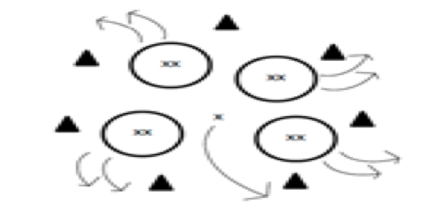**The Run is On!**

**Objective**: To learn more about group members while performing an activity similar to musical chairs.

**Description**: Form a large playing circle marked by cones. Distribute hula hoops randomly within the playing circle. Runners pair up and sit back to back inside a hoop with their partners. One runner does not pair up and is designated to be the standing runner and stand in the middle of the playing circle, but not in a hoop. The standing runner begins the game by saying, “The run is on for…” and finishes this sentence by saying something that is true about them. For example, they can say the “The run is on for anyone who has a pet dog. “If anyone has a pet dog, they must get up and run. Everyone on the team that matches this statement must get up and run (including the runner who called out the statement) one complete revolution around the circle in a clockwise direction and then fill an open position by sitting within a hoop (two people back-to-back in a hoop) that has been vacated by someone for whom the “the run is on. “The last runner standing without a hoop must go to the middle and become the new standing runner.

**Variations**: (1) Use a different number of runners within the hoop.

**Equipment:** Hula hoops, cones

**Cheetahs, Deer, and Elephants**

**Objective**: To simulate running like different animals to experience what the changing speeds of fartlek feels like

**Description**: Spread out over the designated playing area. Start running around the area. You have numerous animals to imitate. If you call out “cheetah,” you will sprint and imagine you are a cheetah. When “deer” is called out, run at a fast pace (but not all out), concentrating on good form imagining you are a deer running. When “horse” is called out, you will run at an easy pace. When “dog” is called out, you will jog. When “turtle” is called out, you will walk slowly. Call out both fast and slow animals to allow for both higher intensity running and recovery. This is an excellent activity for introducing fartlek training where you can feel the difference between changing speeds.

**Variations**: (1) Incorporate the use of different animals. (2) To progress to harder workouts, increase the length of time for faster animals. (3) To decrease the recovery time, allow less time for slower animals.

**Equipment:** None needed

**Cheetahs, Deer, and Elephants**

Animal Pace

Cheetah Sprint

Deer Fast Pace

Horse Easy Pace Run

Elephant Race Walk

Dog Jog

Turtle Walk slowly

**Games for Running Clubs**

**Rats & Rabbits**

Everyone pairs up with someone of a similar speed or ability. Each pair stands back to back, a couple of feet apart. One of all the pairs is a rabbit the other is a rat. When the coach calls rats, the rats run as fast as they can to the line or cones, while the rabbits turn around and chase, intending to catch their partner. Good Speed Session

**Partner Tag**

Again set up in pairs of athletes of similar ability. One starts off as “it” the other runs off. When the first runners catches their partner, number 2 turns around 3 times where they are standing, then goes in pursuit of their partner.

**Paarlaufs**

These are continuous relays. Set up several teams with even numbers and split them into two. Half the team stays at one line of the courts and the other half goes to another set line. Using batons the first runner goes to their front runner at the other line, this one then runs back to where the first runner started to hand the baton over to the next runner. This can go on for as long as they can keep going.

**Robbing the nest**

4 teams and 5 hoops with about 12 tennis balls. One member of each team to collect a ball from the central hoop and take it to their team hoop. Then the next member to collect a ball and bring it back. One all the balls have disappeared from the central hoop, teams need to steal balls from the other teams. The winners are the team who collects 4 balls in their hoop first.

**Cat & Mouse**

2 or 3 teams line up in separate places around a circuit. On the signal one member of each team runs around the circle and carries the baton to their next team member. This is another continuous relay until one team catches up with the next one. If teams are fairly evenly matches this may take some time.

**Trains (Fartlek Training)**

Split group into a few teams. Try to match the teams with runners of similar ability. The teams need to set off in a line at a steady pace (difficult to get youngsters to go slowly enough for each other) On the whistle, the runners at the back sprints to the front and becomes the leader of the train. This is a continuous session, though if the youngsters go off too fast they soon become very tired or the slower ones will drop out. Try to keep the group working and communicating together if they need to slow down etc.

**Get it first**

2 teams which are numbered. Number 1 for the team A needs to be standing opposite the last number of team B. In the center of the field is a hoop with a bean bag (which the coach needs to replenish each time one is collected) The coach calls a number and both runners with that number race to the hoop to collect a bean bag. The winner places it in a hoop for their team, then the next number is called. The bean bags can be counted at the end to see which team won.

**Cups and Domes**

Sets up a court with half the cones pointing upwards like a cup and half the cones pointing downwards like a dome. With 2 teams, one team must turn the cups over to make them domes and the other team must turn the domes over to make cups

**Farmers Tag**

Several athletes are the farmers and must tag (gently) the crows. This immobilizes the crows and turns them into scarecrows until other crows release them, by going under their arms.

**Pyramid Relays**

2 or more teams run relays of varying distances, of say 25m (A) 50m (B) and 75m (C). The first runner runs to A, then back to team, the 2nd runner runs to B and back, the 3rd runner runs to C, then the next runner runs to B, then the last runner runs to A.

**British Bulldogs**

1 or 2 athletes stand in the middle of the field. The other runners try to get past without being tagged. When they are tagged they join the athletes in the middle, until all athletes have been caught.

**Fox and Hounds**

Set a distance, then send one athlete off and after a few seconds all the other athletes try to catch the runners before they reach the set target. Keep changing the leader.