God and Creation
Sunday, November 1, 2020
Opening prayer: The Our Father
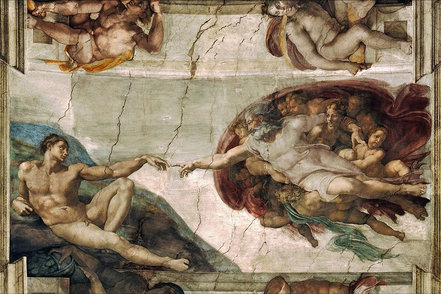
Genesis
- “In the beginning, when God created the heavens and the earth, the earth was a formless wasteland, and the darkness covered the abyss, while a mighty wind swept over the waters. Then God said, ‘Let there be light and there was light.’ God saw how good the light was. God then separated the light from the darkness. God called the light ‘day,’ and the darkness ‘night.’ Thus evening came, and morning followed-the first day… Then God said, ‘Let the earth bring forth all kinds of living creatures; cattle, creeping things, and wild animals of all kinds.’ And so it happened; God made all kinds of wild animals, all kinds of cattle, and all kinds of creeping things of the earth. God saw how good it was. Then God said: ‘Let us make man in our image, after our likeness. Let them have dominion over the fish of the sea, the birds of the air, and the cattle, and over all the wild animals and all the creatures that crawl on the ground.’ God created man in his image, in the divine image he created him; male and female he created them… God looked at everything he had made, and he found it very good. (Genesis 1:1-3, 24-27, 31)
- When the Genesis creation stories are interpreted in an open way which avoids over-literalism, these stories are in harmony with evolution and modern astronomy. A reader of Scripture he must be open to the view that God is not greatest of all creatures within creation, but that He transcends creation. Genesis shows God as giving order to the universe; this divine order supports the assumption of order in science. God is not proved or refuted by explanations of nature because He is the basis of all things. When God is seen in this way, scientific ideas harmonize with the creation stories and other religious ideas.
The Catholic Church and Science
- From a Catholic perspective, faith and science cannot be completely separated because both are based on facts and reason. Both faith and science have autonomy in their methods and conclusions. But science is explored because we have a sense of wonder and the desire to improve the world. Our longings that lead us to science are outside of science and must be explained by religion and philosophy. Also, the practical results that science produces have moral dimensions which are outside of science and must be scrutinized by theology and philosophy.

- Galileo Affair
  - At this time people did not understand gravity and thought the earth must be motionless (Geocentrism)
  - Galileo observed that the motions of the planets are mapped better if the sun is the center of rotation (Heliocentrism)
  - The Inquisition works out a compromise: the earth is stationary with the moon and sun rotating around it, the planets rotate around the sun
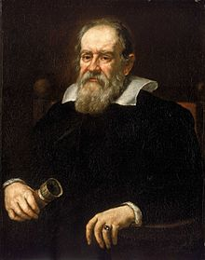

  - Pope Urban VIII rejected this compromise because Galileo had insulted him. He had Galileo tried and found guilty of violating an earlier agreement he perhaps had made to not teach Heliocentrism.
  - Later anti-Catholicism exaggerated the story. Church experts did not refuse to look through telescopes. Galileo was not harshly punished.
- Christopher Columbus did not prove that the earth was round. In the ancient and medieval worlds expert knew the world was round. This is another falsehood of 19th century anti-Catholicism
Creationism verses Scientism
- Isaac Newton was a great scientist who developed the Theory of Gravity
- His theological idea of a ‘Divine Watchmaker’ contradicts earlier thinking by placing God inside time and space.
- Creationists reject evolution because they think that the direct creation of the world and its creatures by God is the long held view of Christianity. It isn’t.
- Scientism rejects religion because evolution proves that direct creation didn’t happen. God created man through evolution, not direct creation.
- God is similar to an author who creates a play but is not in the play
- God continually wills nature, including evolution, every day and is the author of all creation
- The Trinity is a communion of self-emptying love between the Father, Son and Holy Spirit. This love overflows and creates goodness where none existed. This is the love of mercy since no prior claim could be made for this love. This overflowing love is the Power of the Father which drives creation. We sense this power in natural forces on earth and in the majesty of the stars. God’s love creates the Order in creation. The Logos or Son brings harmony and unity by drawing all things to Himself. We see this order in natural beauty and in mental ideas such as geometry and music. Order is a great gift; it allows us and the whole universe to prosper and grow. Love also surprises and allows openness. The Holy Spirit is the Openness in creation. God’s creation often surprises us and we surprise each other with instances that mirror God’s love. We have the potential to mirror God by willing the good of others in a love of mercy. God left the world incomplete so we can share in God’s love of mercy by exercising our power, order and openness in living our lives.
- In the last century physics has become more conceptual and less available to sight and observation. At the atomic level, we can’t ‘see’ subatomic particles because our eyes cannot operate at this scale. This invisible nature of matter at a fundamental level can be drawn out of this verse by St. Paul: “For by him all things were created, in heaven and on earth, visible and invisible…” Recent cosmology theorizes that the laws of nature, space and time were all created during the Big Bang. These concepts are not the background on which God exists, they are His creations. Space, time and the laws of nature are ‘dominions’ of a sort that we inhabit but God has created. St. Paul concludes this passage, “… whether thrones or dominions or rulers or authorities-all things were created through him and for him.”
Break/snacks
The Fall of Man
- Modern genetics shows that all men are descended from a few thousand, perhaps a few hundred humans who lived 60,000 to 100,000 years ago. Something dramatic and mysterious happened at this time. This is called the Human Revolution. A small, nearly extinct species, homo sapiens, came to dominate the world is a relatively short time. Humans developed symbolic thought and could sense spiritual ideas such as truth, beauty and God.
- The Book of Genesis tells of two people, Adam and Eve, being made in the image of God. They were given freedom and immortal souls; but they soon sinned. This Original Sin has corrupted the relationships between men and between man and God ever since.
- The story in Genesis fits with what science has discovered about the origin of man. We have common ancestors and we suddenly found a sense of spiritual concepts such as good and evil.
Christ, the New Adam
- The mythical narrative of Genesis expresses a deeper content which prefigures the coming of Jesus Christ. Christ is the ‘new Adam’, the image of God, who is the fulfillment of what humans are meant to be. By following Christ we share in God’s creativity and love by giving others a love of mercy. Through openness and love Christ is entirely for and with others. In following Christ we bring the world closer to its perfection and unity with God.
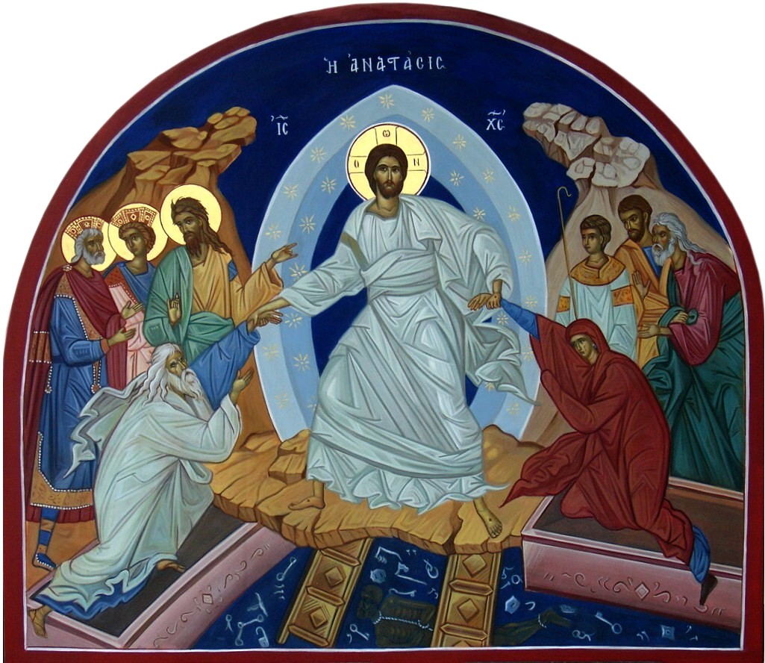
Christ’s Descent into Hell
- Christ’s Resurrection shows his triumph over death and sin. The first to experience this triumph are the righteous deceased who could not yet enter heaven because of Adam’s sin. Christ descended into hell or hades to bring these righteous to heaven: “Therefore it says, ‘When he ascended on high he led a host of captives, and he gave gifts to men.’ (In saying, ‘He ascended,’ what does it mean but that he had also descended into the lower regions, the earth? He who descended is the one who also ascended far above all the heavens, that he might fill all things.)” (Ephesians 4:8-10)
In this icon Christ is pulling Adam and Eve from hades. Since they were the first man and woman to sin, they are also the first saved by Christ. In the background is the cave or underworld of hades. This depiction shows an opening at the top for Christ to ascend with those freed from imprisonment. Christ is surrounded by the stars; this indicates that his destination is heaven.
- To the left of Christ is John the Baptist. Just as John pointed the way to Christ in life, so he also does in this icon: “’I baptize you with water for repentance, but he who is coming after me is mightier than I, whose sandals I am not worthy to carry. He will baptize you with the Holy Spirit and fire.” (Matthew 3:11) To his left are King David and King Solomon. To the right of Christ are Abel, the son of Adam and Eve who was killed by his brother Cain, then the prophets Daniel and Moses. All these will be taken up by Christ to heaven.
- Christ is standing on the gates of hades which he has broken down. The locks and keys of this gate, the chaos of hades, and a bound figure of Satan, who is the figure of death, are all beneath Christ. Satan and death have been defeated by Christ’s resurrection: “For he must reign until he has put all his enemies under his feet. The last enemy to be destroyed is death. For ‘God has put all things in subjection under his feet’.” (1 Corinthians 15: 25-27)
- Christ is dressed in dazzling white with his wounds visible. His expression is clear, calm and rested. The ordeal of his crucifixion is over. His body is now glorified. Christ will appear on earth to his apostles and many others over the next 40 days.
- Christ’s Resurrection is also a triumph for us. Our sins cannot destroy God’s love for us. Christ did not come to hate the world because of his crucifixion. Rather He continues to love us and He pulls us out of our sin into eternal life and happiness.
The Body of Christ
- Because Christ was born as a man in the Incarnation, God has both material and spiritual natures. We are made in the image of God. Both body and soul are necessary for a complete human. When one is missing, the remaining element is not fully human. Christ was born into the world to be one of us, physically and spiritually, and to communicate his self-emptying love for us.

- Proper rituals are needed for effective communication. Religious rituals are a material means of connecting us spiritually to God and to each other. The Sacraments make spiritual grace available to us in a material form. Therefore, a baptismal ritual without water is not a Baptism because it lacks the physical connection to Christ’s action.
- 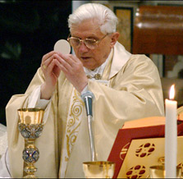

- The material element of water is needed for the grace to be effective. In the Eucharist, Christ becomes present through His unity with the material form of the Host. Ritual both sustains and elevates humanity. During the mass, we become the Body of Christ both spiritually and physically. The Mass was instituted by Christ to form us into one Church. United with the Church we are guided towards God and our salvation.
Next Week: The Church, Reflecting the Light of Christ, Chapters 10 & 11
Closing Prayer

