My Soul Longs for You, O God
Sunday, October 11, 2020

Opening Prayer: The Our Father

Why Go to Church?

There are these two young fish swimming along, and they happen to meet an older fish swimming the other way, who nods at them and says, “Morning, boys. How’s the water?” And the two young fish swim on for a bit, and then eventually one of them looks over at the other and goes, “What the hell is water?”


The world fills us with awe and wonder. The beauty of a rainbow, the vastness of the universe and the playful laughter of children all lead us to contemplate the source and meaning of creation. In our search, we use our reason and faith to find purpose. We sense an invisible meaning behind what we see in the world. To find our purpose and goal in life, we need to know God, who is the author of this meaning.

“Faith and reason are like two wings on which the human spirit rises to the contemplation of truth; and God has placed in the human heart a desire to know the truth-in a word, to know himself-so that, by knowing and loving God, men and women may also come to the fullness of truth about themselves.” (John Paul II, Fides et Ration, Prologue)

God has a plan for us
- How can we know about the meaning of creation and how we fit into it?
- The history of the world is the story of God’s self-emptying love
- Being part of God’s plan gives our lives meaning. St. Augustine wrote “…you have made us for yourself, O Lord, and our hearts are restless until they rest in you.” (Confessions, 1.1.1)
- We participate in God’s plan together, not individually
- We need to see the invisible reality behind the visible world

Invisible Meaning Visible Sign

Friendliness Wave hand
Love Kiss
Married “I do”
Volunteer Raise hand

- Can you do the visible without the invisible?
- Can you do the invisible without the visible?



- If we do one without the other then something is wrong
- Visible sign + invisible meaning = a relationship, need both
- We need the sacraments to bridge the gap between the visible world and the invisible spiritual meaning
- Sacraments give us a relationship to God and to all of us in the Church

Christ Joins the Visible and Invisible

- The sacraments are effective signs of grace, instituted by Christ and entrusted to the Church, by which divine life is dispensed to us. (CCC 1131)
- We encounter God in the seven sacraments (Baptism, Confirmation, Confession, Eucharist, Marriage, Holy Orders and Anointing of the Sick)
- The entire universe is a like the sacraments because we encounter God throughout it

In Christ the invisible love of God appeared in the flesh of a man
- The invisible appeared in the visible flesh of Christ; it now appears in the Eucharist
- The visible draws its meaning from the invisible
- The world is a vast incarnation which the devil tries to contradict
- Diablos = δια + βαλλω = apart + throw
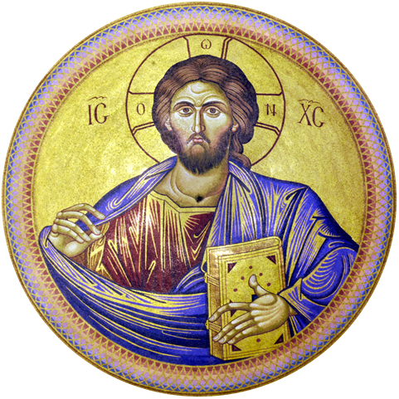

Religion and Symbols

- Symbol = συν + βαλλω = together + throw
- Symbols manifested the presence of the sacred in rituals
- Symbols became a means of mutual participation between man and God
- Religion brings the sign and its meaning together in rituals and symbols
- “What Christ is doing invisibly in this world through the Spirit, he is at the same time doing visibly through the mission of the apostles and of the members of the church community.” (Schillebeeckx, Christ the Sacrament of the Encounter with God, pg. 50)

Break/snacks

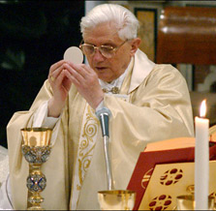

Sacraments

- Christian symbols are the union in Christ of the divine and the human
- Sacraments are true outward signs of an inward reality
- Sacraments are efficacious signs of grace, instituted by Christ, by which divine life is dispensed to us

Why the RCIA Process?

- We started this discussion with a search for meaning
- We find in the sacraments a real union with Christ which gives our lives purpose.
- The search for meaning leads to the sacraments. This is the RCIA process in a nutshell
- We strive to understand and experience God so that the sacraments give our lives meaning.
- We are all images of God but we have difficulty seeing ourselves in this way. When we who we really are, then the sacraments have great meaning because they are encounters with God.

Next week: Chapter 2 and 3, Revelation and Tradition

RCIA Inquirer Information Sheet

Snack Signup Sheet

Questions?

