The Church, Reflecting the Light Of Christ
Sunday, November 8, 2020

Opening prayer: The Our Father

Survey-How do you see the Church

- The Church is the body of Christ
  - The Church reflects Christ’s love
  - The Church as the body and Christ as the head make the whole Christ
  - We are united with Christ through the Church but retain our individuality
  - The Church asks that you ‘become what you are’

- More than a club
  - The Church is more than the will of its members
  - St. Augustine called the Church a hospital for sinners
  - Membership in the Church is the basis of our relationship with Christ

- “The world was made for the sake of the Church”
  - The Church is a sign and instrument of our unity with God and with each other
  - We should see ourselves, first and foremost, as members of the Church
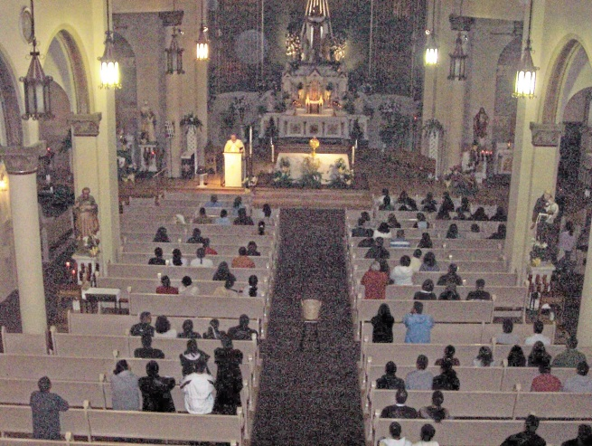

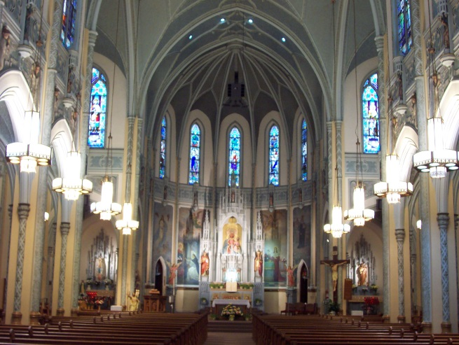

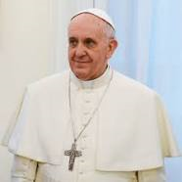

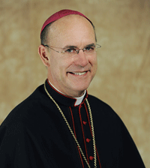

Four Marks of the Church

- The Church is One
- Its source is Christ
- “Love binds everything together in perfect harmony” Colossians 3:14
- The Church ‘subsists’ in the Catholic Church. This leaves room for other Christian denominations
- Other religions are united to the Catholic Church to the extent that we agree

- The Church is Holy
- The Holy Spirit guides the Church and makes it holy.
- Christ loves the Church and suffered on the cross to sanctify her
- The Church is both holy and in need of purification
- Church looks forward to the perfection of this gift

- The Church is Catholic (Universal)
- Christ is present in the Church
- The Church has been sent by Christ to all people
- The Church has an obligation to evangelize

- The Church is Apostolic
- The Church is guided by the successors to the original twelve apostles who were chosen by Christ.
- Love is the soul of the apostolic mission
- The kingdom of Christ grows mysteriously in those incorporated into Him

Break

History of the Church, the Papacy and St. Peter Basilica

- Matthew 16-18: “…you are Peter and upon this Rock I will build my Church”

- 1st century: The later life of Saint Peter according to tradition
  - He settled in Rome
  - Lead the Church of Rome for 25 years
  - He was martyred in Rome
  - He named Linus, Anacletus and Clement as his successors
- 2nd century
  - We have lists of Bishops from various cities indicating apostolic succession.
  - Shrine known as Trophy of Gaius marked St. Peter’s tomb on Vatican Hill.
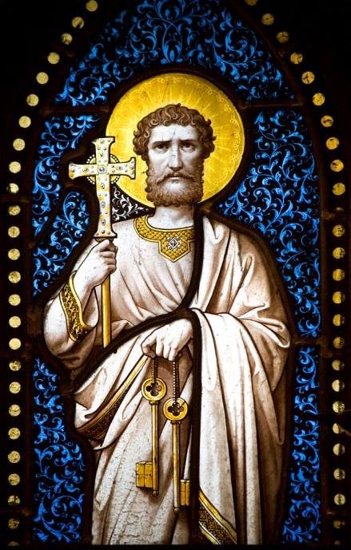

- First several centuries: Papal elections
  - Local people and clergy of diocese chose their Bishops
  - Rome was probably no different.
  - We don’t know exactly how
  - Local rulers interfered in elections

- 313: Christianity legalized by Roman Emperor Constantine the Great in 313

- 4th century
  - Constantine and his son and successor Constance built original St. Peter’s Basilica
  - Old St. Peter’s built quickly with pieces of other buildings
  - Cathedral of Rome and seat of the Popes is St. John Lateran, not St. Peter’s
  - St. Peter’s became destination of pilgrims to Rome

- 452: Pope Leo the Great persuades Attila the Hun to not attack Rome

- 533: 1st Papal name change. John II changed his name from Mercury. Mercury was the name of a Roman god and thought too pagan

- 7th and 8th centuries
  - Byzantine Emperors demanded right to approve Papal
  - Church never formally consented to this

- 769: Roman Synod issued a decree on Papal elections
  - Only Roman clergy could vote, no laity or rulers
  - Only Cardinal priests and deacons could be elected, Bishops were ‘married’ to their diocese

- Cardinals are important officers in the Church
  - Latin word cardo means hinge
  - Cardinals were important clergy from the area around Rome
  - Originally the College of Cardinals consisted of 28 Cardinal Priests, 7 Cardinal Bishops, 18 Cardinal Deacons
  - Often fewer than a dozen Cardinals in medieval period
  - This lead to many deadlocks

- 10th century: Name changes became common
  - A Pope with the baptismal name of Peter changed his name to John XIV
  - There has never been a Peter II
  - Legend that the world will end when Peter II is elected

- 1059: Election Decree of Nicholas II
  - No election until 3 days after Pope’s funeral
  - Cardinal Bishops identify candidates
  - Other Cardinals ascent to a candidate
  - Roman public proclaims election
  - No imperial consent needed

- 1179: Alexander II decreed that 2/3 majority needed to elect a Pope.

- 1241: 1st Conclave
  - Attempt to break a deadlock by locking the Cardinals in a church
  - Latin con clave means with key

- 1269: People tried to break a deadlock by removing the roof of a church in which the Cardinals were locked in a Conclave

- 1274: Gregory X issued rules for Conclaves
  - 9 days of mourning after Pope’s funeral
  - Conclaves to begin 10 days after funeral
  - Cardinals locked in with one assistant each

- 1305-1417: Papacy in Avignon
  - 1305 to 1378, Papacy left Rome for Avignon France because of chaos in Rome
  - This caused the Great Schism in 1378 when Roman’s appointed their own Bishop
  - At times from 1378 to 1417 there were two to four men claiming the Papacy
  - During this period, candidates would have to agree to a series of conditions, or Capitulation, before being named Pope
  - Rome reduced to small, deteriorated town

- 1417: Election of Martin V
  - Papacy reunited in Rome
  - Starts to rebuild Rome and reunite the Church

- 1506: Julius II
  - Hired Bramante to demolish Old St. Peter’s and build new church
  - New church originally designed with nave and transepts the same length
  - Cornerstone laid on April 18, 1506
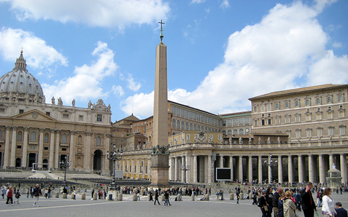

- 1517: Sold indulgences (get out of purgatory free cards), partially to finance building of St. Peter’s. Martin Luther objected to this and started the Protestant Revolution

- 1521: Leo X excommunicates Martin Luther

- 16th through 19th centuries: Monarchs believed their power came from God, Divine Right of Kings. One king, one people and one religion in each country

- 1534: Henry VIII of England breaks with Rome. Has himself declared head of the Church of England

- 1545-63 Paul III
  - Calls Council of Trent. Council rejects Protestant theologies of reliance on the Bible alone and predestination. Council also ends abuses in the Church.
  - Hired Michelangelo to design dome for St. Peters
  - Called Council of Trent to respond to Protestant Revolution
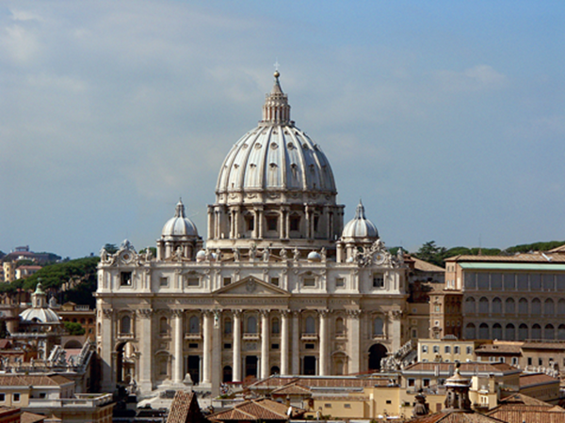

- 1555: Marcellus II was the last Pope to keep his baptismal name

- 1566: Pius V was a Dominican. Dominican priests wear white cassocks. Popes have worn white ever since.

- 1586: Sixtus V increased the number of Cardinals to 70

- 1591: Gregory XIV banned choosing Pope by adoration and betting on elections

- 1605-21 Paul V
  - Hired Maderno who extended the nave of St. Peters to accommodate larger services
  - New St. Peter’s completed in 1620

- 1621: Gregory XV limited the number of candidates a Cardinal could vote for to one, instituted secret ballots, and required Cardinals to disguise their handwriting

- 1623-44 Urban VIII
  - Hired Bernini to build the colonnade around the piazza
  - Bernini also built the main altar with its cupola

- 17th and 18th centuries: The Enlightenment, many intellectuals believed reason was important than faith and love

- 1792: French Revolution: revolutionaries tried to abolish the Church and start cults based on reason

- 1799: Pius VI arrested in Rome by the French and died in exile. Emperor Francis of Austria allows a conclave to choose next Pope in Venice

- 1801: Pius VII
  - Makes peace and signs concordat with French ruler Napoleon in 1801
  - Later arrested by Napoleon and exiled. Napoleon loses power in 1814
  - Returns to Rome; restores the Jesuits

- 1869-70: Pius IX calls 1st Vatican Council. Council defines papal authority and infallibility. Ends suddenly because of an Italian revolution.

- 1962: John XXIII calls 2nd Vatican Council. Council call for greater role for laity, allows use of English and other languages in the mass, and supports dialogue with other religions

- 1975: Paul VI revised the rules for Conclaves
  - The number of Cardinal was expanded from 130 to 183 to allow more Cardinal from third world countries
  - Only Cardinals under 80 years of age to eligible to vote

- 1978-2005: John Paul II
  - Travels widely
  - Inspires protests that leads to fall of Communism
  - Decreed in 1994 that the Papacy could only become vacant by death or resignation

- 2005: Distribution of Cardinal: 38 Italians, 57 other European, 25 Central and South American, 24 North American, 18 Asian, 16 African and 5 from the South Pacific

- February 28, 2013: Benedict XVI becomes first Pope to resign the office since 1415

- Papal Conclave
  - In past, Cardinals slept on cots in the Sistine Chapel
  - John Paul II built St. Martha’s Hotel at the Vatican which will house the Conclave
  - Once in Conclave, the Cardinals cannot contact the outside world
  - All Cardinals swear an oath to uphold the rules of the Conclave
  - Average length of Conclaves in the 20th century is 3 days
  - Saying: “he who enters the Conclave as Pope leaves as a Cardinal”

- March 13, 2013: “Habemus Papam” (We have a Pope)
  - Once he is elected, the candidate is asked if he accepts
  - If he does, he is Pope at that moment
  - The Dean of the College of Cardinals asks what name he takes
  - The Pope is lead to the balcony and introduced.
  - The new Pope gives a short blessing
  - Solemn installation mass held a few days later
  - The Pope is called the Pontifex Maximus, Latin for Great Bridge-Builder
  - Every Pope is called a successor to Peter, not his immediate predecessor

Next week: Jesus Christ, Chapters 7 & 8

