**Pinnacle Hockey Spring Camp April-June, 2020**

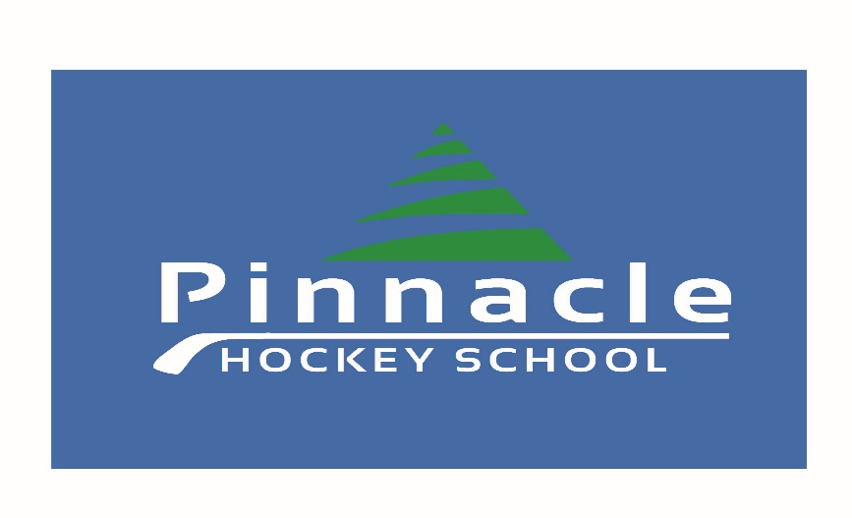

**Registration Information**

Please carefully complete and sign this form. Full payment is required at the time of registration. Space is limited. If camp is full, participant registrant will be notified immediately. Please mail completed registration form and cheque to the address below. No post-dated cheques please. NSF cheques will be subject to a $30.00 Fee. Cash payments may be dropped off in person. E-transfer payments are accepted by e-mailing [information@pinnaclehockeyschool.com](mailto:information@pinnaclehockeyschool.com). Cancelations before March 15th will be charged a 15% administration fee. Cancelations after March 15th are non-refundable. For portions of the on ice sessions, players will be divided into age/developmental groups. Players at a more advanced level may request to skate with the above age group. This will be analyzed and determined on a case by case basis. We offer multi-family member discounts, please contact us for more information. The camps for children whose Birth Year is from 2004-2014 will be held on the following eight dates:

**2012 – 2014 Birth Years – White Skills & Development Camp**

8 X 60 minute ice sessions focusing on power skating, skills and fundamentals, small area games. Players divided into various groups based on experience and ability to ensure players are challenged at an appropriate level.

1. Friday April 17 – 4:15-5:15 p.m. ATB West
2. Friday May 1 – 4:15-5:15 p.m. Civic
3. Saturday May 2 – 12:15-1:15 p.m. Civic
4. Sunday May 3 – 1:00-2:00 p.m. Civic
5. Sunday May 10 – 6:00-7:00 p.m. Civic
6. Saturday May 23 – 10:30-11:30 a.m. ATB West
7. Saturday May 30 – 10:00-11:00 a.m. ATB West
8. Sunday May 31 – 1:30-2:30 p.m. ATB West

**2009-2011 Birth Years – Blue Skills & Development,**

**3 on 3 Game Play & Mini-Skills Camp**

8 X 60 minute ice sessions. Each ice session will take during weekends to allow players to participate in other weeknight sports. Each ice session will be 60 minutes in length. Players will take part in a 35-40 minute mini-skills session focusing on skating mechanics, power skating, puck control fundamentals, shooting, passing, and individual tactics. Following the skills sessions players will play 3 on 3 full ice in appropriate player groupings.

1. Friday April 17 – 5:15-6:15 p.m. ATB West
2. Saturday May 2 – 1:15-2:15 p.m. Civic
3. Sunday May 3 – 2:00-3:00 p.m. Civic
4. Sunday May 10 – 7:00-8:00 p.m. Civic
5. Saturday May 23 – 11:30-12:30 p.m. ATB West
6. Sunday May 24 – 9:00-10:00 a.m. ATB West
7. Sunday May 30 – 11:00-12:00 p.m. ATB West
8. Sunday May 31 – 2:30-3:30 p.m. ATB West

**2004 – 2008 Birth Years – Gold Elite Specialized Training - This program is designed for AA, A, or players aspiring to play at a competitive tiered level for the 2020-21 season. These skates will be high intensity, and demanding for participants. Where required players will be grouped for drills based on age and ability. This camp will also feature drills focusing on confidence with contact for those transitioning from Pee Wee to Bantam, and those requiring support with proper hitting techniques, and how to absorb/receive checks. For players progressing to Pee Wee, drills will be structured appropriately for that cohort of athletes.**

1. Friday April 17 – 8:15 p.m. - 9:15 p.m. ATB West
2. Saturday May 2 – 7:00-8:00 p.m. Civic
3. Sunday May 3 – 7:00-8:00 p.m. Civic
4. Sunday May 24 – 12:30-1:30 p.m. ATB West
5. Saturday May 30 7:00-8:00 p.m. ATB West
6. Friday June 12 4:15-5:15 p.m. ATB West
7. Saturday June 13 – 10:00-11:00 a.m. ATB West
8. Sunday June 14 – 1:00-2:00 p.m. ATB West

**Please Print Legibly:**

Participant’s Name___________________________________________________

Date of Birth________________________________________________________

Level / Team 2019-20_________________________________________________

Position Preference___________________________________________________

Parent’s Name(s)____________________________________________________

Address (Incl. Postal Code)_____________________________________________

City/Town__________________________________________________________

Contact Phone(Home)________________(Mobile)________________________

Contact E-mail_______________________________________________________

Health Card #_______________________________________________________

Past Injuries / Notable Health Information_______________________________

Additional Notes__________________________________________________

**Liability Waiver and Medical Release**

I agree I shall provide health insurance to cover any personal injury and property damage sustained by the player while participating in any activities during Pinnacle Hockey Camp Sessions. In consideration of the participant in the Pinnacle Hockey Camps, we do hereby forever release and discharge Pinnacle Hockey Camps, its directors, Employees, and any person or corporation connected herewith from all manner of action, injury, damages, costs, claims or demands which we shall or make hereafter have, suffer or receive by reason of such participant in the program. The release shall be binding on our heirs, assigns, executors and administrations. It is agreed that Pinnacle Hockey Camps does not and shall not be considered to guarantee or warrant such equipment as maybe used in conducting of the said camp. It is further agreed that the Pinnacle Hockey School is not responsible for the loss of stolen personal articles or hockey equipment. There are no exceptions. This is also my permission to have my child admitted and attended to for medical or dental treatment in case of sickness or injury (if parent/guardian is not present). Cancelations before March 15th will be charged a 15% administration fee. Cancelations after March 15th are non-refundable. Your signature confirms that you have read and understood our waiver form and registration information on this paper.

Parent/Guardian Signature:_______________________________________

Date:_________________________________________________________

**Total Cost (Options): Please check off the camp and programs you are registering for.**

**______$195 Incl. GST White = (Eight ice sessions: Birth Year 2012 - 2014).**

**\*\*\* Note: Special rate if payment and registration is received prior to March 10, 2020. Regular ~~$195~~ Special promo rate $149. \*\*\***

**_____ $195 Incl. GST Blue 3 on 3 game play, & mini-skills camp = (Eight ice sessions Birth Year 2009 - 2011).**

**\*\*\* Note: Special rate if payment and registration is received prior to March 10, 2020. Regular ~~$219~~ Special promo rate $149. \*\*\***

**_____ $195 Incl. GST = Gold Elite Specialized Training(Eight ice sessions: Birth Year 2004 - 2007). This program is designed for AAA,AA, A, Tier 1/2/3, or players aspiring to play at a competitive tiered level for the 2020-21 season.**

**\*\*\* Note: Special rate if payment and registration is received prior to March 10, 2020. Regular ~~$199~~ Special promo rate $149. \*\*\***

**_____ $99 Incl. GST = ‘ANY 4’ Life is busy, at Pinnacle Hockey we get that. This flexible package allows you to pick any 4 spring camp dates and times for your child’s program to attend. Please either list the four sessions you will be attending below or email us with your personalized schedule by April 10, 2020.**

**\*\*\* Note: Special rate if payment and registration is received prior to March 10, 2020. Regular ~~$99~~ Special promo rate $79. \*\*\***

**___________________________________________________________**

**_____ $50 Incl. GST = (Special Goaltender Rate List Birth Year Here ____).**

**\*\*\* Note: Special rate if payment and registration is received prior to March 10, 2020. Regular ~~$50~~ Special promo rate $15. Please note below which camp you are signing your child up for. \*\*\***

**Camp goaltender is registering for ___________________________.**

**_____ $20 Pinnacle TM Jersey.** Required if participant does not currently have a Pinnacle jersey. New jerseys may be purchased. All players on ice must wear Pinnacle jerseys.

**_____ $Pinnacle Hockey’s Thank You Very Much Referral Programl!** If your family recommends our program to another family who has never yet done a Pinnacle camp we will offer a special thank you gift for both you and our new participant ($20 in savings total)!! Both you, and the new family will each receive $10 off of an upcoming camp ($20 in savings total)!!

Name of referring family: ___________________________________

Name of new participant: ___________________________________

**Total Payment: ____________ Cash / Cheque / E-Transfer**

Send completed Registration form and cheque payable to:

**Pinnacle Hockey School**

**446 Twinriver RD. W**

**Lethbridge, AB T1J 3Y9**

**If paying by E-transfer please ensure registration is either mailed or e-mailed. E-transfers should be e-mailed to pinnaclehockeyschool@gmail.com.**

For more information Contact:

Phone: **(403)-892-9755** E-mail: [**pinnaclehockeyschool@gmail.com**](mailto:pinnaclehockeyschool@gmail.com)

Website: **www.pinnaclehockeyschool.com**

