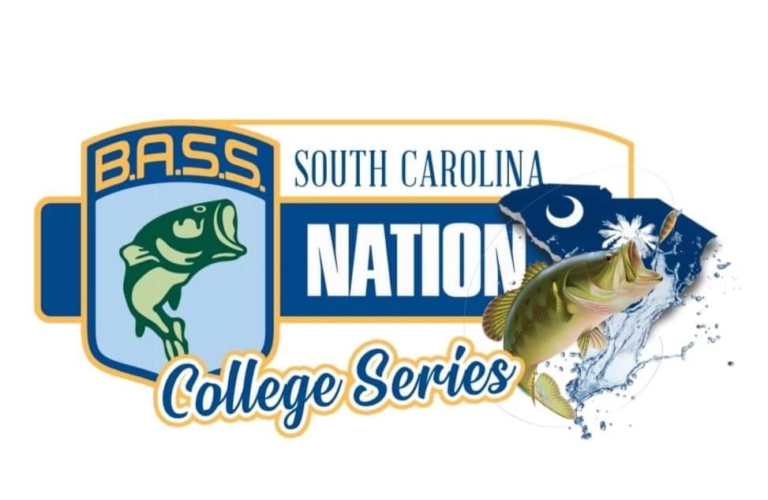
(BASSMASTER NATIONAL CHAMPIONSHIP QUALIFING TRAIL)
2025 TOURNAMENT SCHEDULE
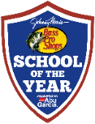
SEPTEMBER 20, 2025 @ LAKE HARTWELL @ GREENPOND LANDING


OCTOBER 11, 2025 @ SANTEE COOPER @ BLACKS CAMP


NOVEMBER 8, 2025 @ CLARKS HILL @ DORN BOATING FACILITY

DECEMBER 12 & 13, 2024 @ LAKE KEOWEE (Friday & Saturday are Points, Top 10 in points ADVANCE to Championship Saturday)

"Events with the logo are sanctioned to be eligible for points to count towards the Bass Pro Shops School of the Year presented by Abu Garcia."

TOURNAMENT TRAIL FEES
$25 Angler Trail Membership / $25 Angler SC Bass Membership / $60 TEAM Entry Fee **All Fee’s payable to: SC Bass Nation Youth Director)

CONTACT INFO: TONY GRAY – SC BASS NATION YOUTH DIRECTOR (803) 534-1720 / scyouthdirector@gmail.com Website: schighschoolbasschallenge.com Facebook @ SC Bass Nation College Tournament Trail

