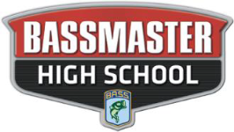

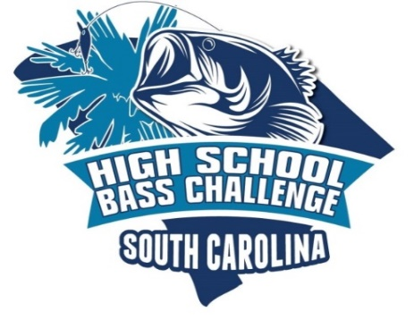

**2020-2021**

**HIGH SCHOOL TOURNAMENT TRAIL SCHEDULE**

**(REVISED - AUGUST 4, 2020)**

**September 19, 2020    WINYAH BAY-WACCAMAW RIVER @ CARROLL CAMPBELL LANDING**

**October 3, 2020 LAKE MOULTRIE @ BLACKS CAMP**

**November 7, 2020 LAKE WATEREE @ CLEAR WATER COVE**

**December 5, 2020 LAKE MURRAY @ DREHER ISLAND STATE PARK**

**January 9, 2021 FALL TOURNAMENT MAKE UP DATE (TBD)**

**February 13, 2021 COOPER RIVER @ CYPRESS GARDENS (JR BASSMASTER ONLY)**

**February 27, 2021 COOPER RIVER @ CYPRESS GARDENS (HIGH SCHOOL ONLY)**

**March 6, 20221 LAKE MARION @ JOHN C LAND**

**April 10, 2021 2021 BASSMASTER STATE CHAMPIONSHIP**

**(LAKE WYLIE @ BUSTER BOYD LANDING)**

**April 17, 2021 SPRING TOURNAMENT MAKE UP DATE (TBD)**

**May 1, 2021 LAKE MURRAY (TBD) (TRAIL CHAMPIONSHIP WEEKEND)**

**May 22,2021 “BATTLE of the CAROLINAS” TOURNANENT (TBD) (Top 25 High School & Top 5 JR Bassmaster Teams Qualify)**

**(DATES & LOCATIONS SUBJECT TO CHANGE WITH PROPER NOTIFICATION)**

**SC HIGH SCHOOL BASS CHALLENGE, PO BOX 361, ORANGEBURG, SC 29116**