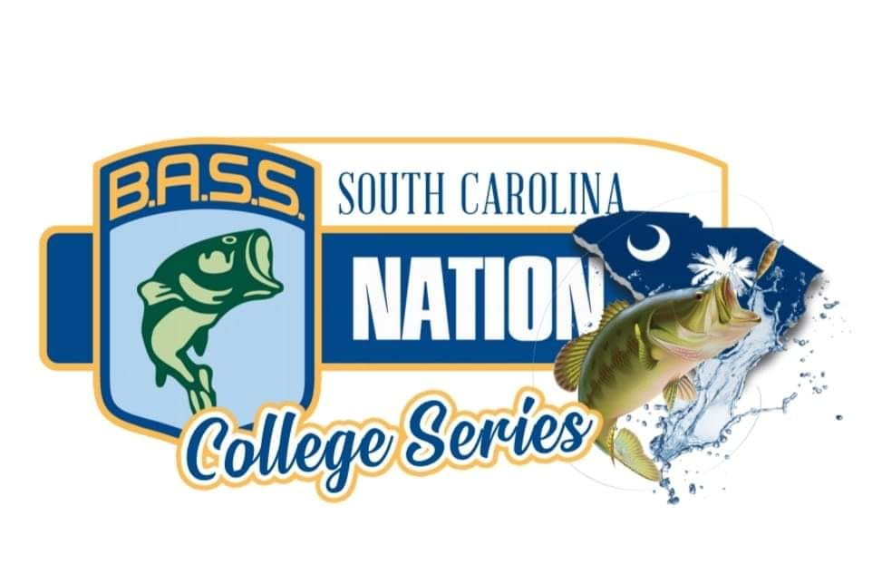

2021-2022 TOURNAMENT SCHEDULE
(REVISED AUGUST 1, 2021)

SEPTEMBER 25, 2021 LAKE HARTWELL @ GREENPOND LANDING
(PHANTOM OUTDOORS “OPEN” INVITATIONAL)

OCTOBER 16, 2021 LAKE MARION / MOULTRIE @ BLACKS CAMP

NOVEMBER 13, 2021 LAKE WYLIE @ BUSTER BOYD BOAT RAMP

DECEMBER 3 & 4, 2021
COOPER RIVER @ REMBERT C DENNIS LANDING

FALL 2021 SEASON ENDING POINTS WILL DECIDE 2022 BASSMASTER COLLEGE NATIONAL CHAMPIONSHIP QUALIFICATION

