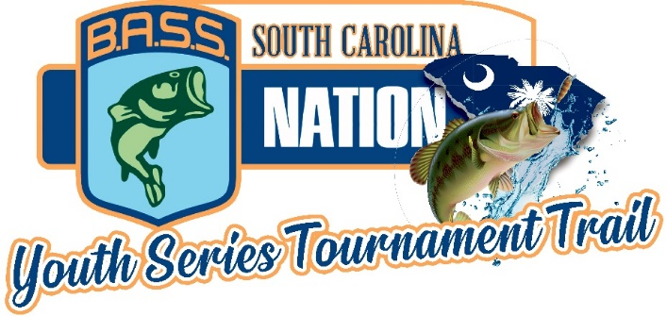

**(PUBLISHED MAY 8, 2022)**

**2021-2022 TOURNAMENT SCHEDULE**

**SEPTEMBER 25, 2021 LAKE HARTWELL @ GREENPOND LANDING**

**OCTOBER 23, 2021 LAKE KEOWEE @ SOUTH COVE COUNTY PARK**

**NOVEMBER 20, 2021 LAKE WYLIE @ BUSTER BOYD BOAT RAMP**

**DECEMBER 11, 2021 LAKE GREENWOOD @ GREENWOOD STATE PARK**

**\*\*DECEMBER 18, 2021\*\***

**(FALL MAKE UP DATE IF NEEDED)**

**JANUARY 15, 2022 LAKE RUSSELL @ LAKE RUSSELL STATE PARK**

**FEBRUARY 12, 2022 LAKE MURRAY @ DREHER ISLAND STATE PARK**

**MARCH 19, 2022 CLARKS HILL @ DORN FACILITY BOAT RAMP**

**APRIL 9, 2022 SC BASS NATION YOUTH STATE CHAMPIONSHIP LAKE GREENWOOD @ GREENWOOD STATE PARK**

**\*\*APRIL 30,2022\*\***

**(SPRING MAKE UP DATE IF NEEDED)**

**MAY 6 & 7, 2022 TRAIL CLASSIC – LAKE HARTWELL – GUM BRANCH BOAT RAMP**

**MAY 21, 2022 “BATTLE of the CAROLINAS” - (TBD)**

**\*\*\*ALL SC BASS NATION STUDENT ANGLERS ARE ELIGIBLE TO FISH THIS TRAIL\*\*\***