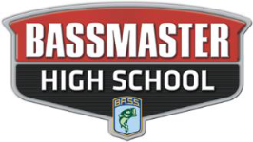

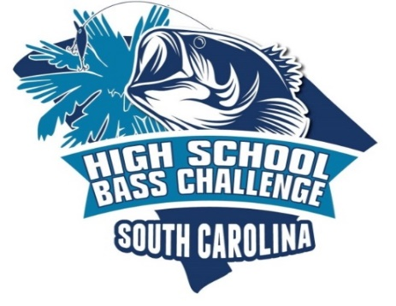
2025-2026 TOURNAMENT SCHEDULE (PUBLISHED 6/23/25)

OCTOBER 4, 2025 SANTEE COOPER LAKES @ JOHN C LAND

NOVEMBER 1, 2025 LAKE WATEREE @ CLEAR WATER COVE

DECEMBER 20, 2025 FALL MAKE UP DATE IF NEEDED

FEBRUARY 28, 2026 COOPER RIVER @ BUSHY PARK

MARCH 14, 2026 LAKE MURRAY PHANTOM DREHER ISLAND & SEISTA COVE (POINTS TOURNAMENT)

MARCH 28, 2026 SC BASSMASTER YOUTH STATE CHAMPIONSHIP LAKE KEOWEE @ SOUTH COVE ***JR. BASS & HIGH SCHOOL DIVISIONS***
**MANNDATORY FRIDAY 4PM TOURNAMENT MEETING** (NON POINTS EVENT)

APRIL 25, 2026 SANTEE COOPER LAKES @ JOHN C LAND TRAIL CHAMPIONSHIP WEEKEND

MAY 16, 2026 SPRING MAKE UP DATE IF NEEDED

(25-26 SCHEDULE INCLUDES 1 DROP TOURNAMENT)
***(DATES & LOCATIONS SUBJECT TO CHANGE WITH PROPER NOTIFICATION) ***
SC HIGH SCHOOL BASS CHALLENGE, PO BOX 361, ORANGEBURG, SC 29116

