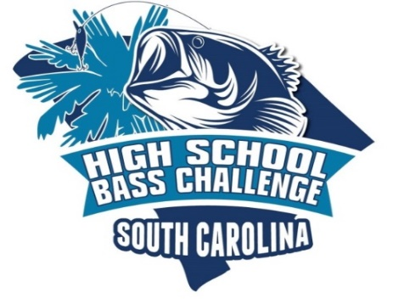

COVID-19 Recommendations for Attendance of Events

Coronavirus, COVID-19, has been declared a worldwide pandemic by the World Health Organization and other various medical authorities. The SC High School Bass Challenge, sponsoring agencies, and those conducting tournaments CANNOT GUARANTEE that you will not become infected with COVID-19 or any other diseases while attending a scheduled event. Further, you acknowledge that attendance of ANY SC High School Bass Challenge events is voluntary & could increase your risk of contracting COVID-19 or other diseases.

SAFETY is the ULTIMATE goal of our Student Anglers, Boat Captains, Staff & guest during ALL SC High School Bass Challenge events, therefore, in accordance with Federal, State, and/or county municipal health guidelines, the SC High School Bass Challenge Executive Director has set the following guidelines in an effort to keep everyone safe while attending scheduled events based on CDC,WHO & other medical agencies.

- The IMMEDIATE Check In & Weigh In area’s will be marked off allowing ONLY essential participates known as Student Anglers, Boat Captains & Staff to be within the boundaries maintaining the REQUIRED 6’ social distancing rules. ALL others, known as non-essential will be REQUIRED to stay outside of the immediate Check In & Weigh In areas.
- If you have been sick with COVID 19 or experienced symptoms at least 14 days leading up to a scheduled tournament, you are requested stay home.
- Anyone that has had COVID 19 or experienced symptoms must be medically cleared to be able to participate in the upcoming tournament.
- Nose & Mouth coverings are REQUIRED to be worn during morning check in, afternoon check in & weigh ins. Anglers, Boat Captains, and Tournament Staff are responsible for their own nose and mouth coverings (buffs are acceptable nose and mouth coverings).
- Holding tanks set up so that there can be two teams per tank and no more than ten teams in the holding tank area at any time.
- Holding tanks will be set up on the release side of the trailer will be separated to ensure adequate distance is provided while waiting to take pictures and release fish.
- Spectators will be allowed to set up tents. It will be the responsibility of the respective teams, coaches, and staff to hold all anglers and spectators to the MANDATED social distancing guidelines. It is vital that we have no large gatherings during the event.
- Wash and/or use hand sanitizer frequently.
- Electronic tournament registration will be set up to eliminate paperwork handling
- Teams will be FREQUIRED to place ALL tournament paperwork & tournament entry fees in a marked envelope & placed in a predetermined collection receptacle during morning check in.
- Reduce the number of boats per flight to 20, checking in every 15 mins
- Clean key floats before and after use
- Call teams to weigh in in groups of 10
- Sterilize mesh weigh in bags between uses before, during, and after the tournament

