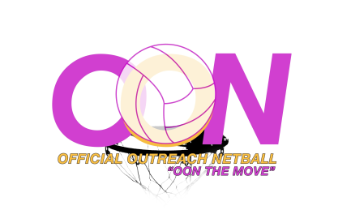
Official Outreach Netball

18 – 1801 NICHOL AVENUE, WHITBY, ONTARIO LIN 9K1
Phone (905) 626 – 6188 ~ (416) 698 – 3848 ~ Email: info@oonthemove.com

Want to know where you can get your own netball equipment?

Netball Poles in Toronto:
LAURENTIAN ATHLETICS INDUSTRIES (1970) LTD.
15 MELANIE DRIVE, BRAMPTON, ONTARIO L6T 4K8
1-800-354-0071 LOCAL 905-791-5757 FAX 905-791-0068
www.laurentianltd.com

Gilbert
http://www.netballshop.org/_INF.aspx
Carry:
Pinnies
Balls
Sports Wear

