Danbury Museum and Historical Society Authority
Huntington Hall
Meeting Minutes – December 10, 2020

In compliance with Connecticut General Statute § 1-225, these minutes are being provided for informational purposes and are subject to approval of the Danbury Museum & Historical Society Authority Board of Trustees at its next regular meeting.
In attendance were, Geoff Herald, Roberto Alves, Marian Hesemeyer, Brigid Guertin (DMHS), Michele Amundson (DMHS), Bob Doyle, Patrick Wells (DMHS), Elizabeth Hudson, Paul Valeri, Doug Polistena, Paul Steinmetz (standing in for John Clark) and James Beschle (Potential board member).
Members not in attendance: Brandon Whitfield and Bob Young

President Report, President Geoff Herald called the meeting to order at 5:30 pm and asked the board for any changes or corrections to the November meeting minutes.

A motion to accept the minutes from the November meeting was made by Elizabeth Hudson and seconded by Doug Polistena, all in attendance voted to accept the meeting minutes in a unanimous vote.

Finance Report: Bob Doyle presented the financial report and explained where the Museum stands financially.

A motion to accept the Financial Reports was made by Paul Valeri and seconded by Elizabeth Hudson, all in attendance voted to accept the Financial report.

Executive Director’s Report: Brigid Guertin informed the Board that the Mayor held the General Budget meeting and at this point we are slated for the same funds as last year. The Museum has resubmitted its Capital Budget request for the exterior painting of the Museum campus buildings. The windows in the Ryder house are almost finished so we can commence with the painting of the house.

Brigid Guertin will be doing a couple of trial virtual field trips with some third-grade classes to see if this is a workable program. These field trips will be tailored to each class and be in a story telling format.

Charles Ives House rehabilitation is going forward. The work is slower due to COVID protocols.

Exterior repairs and interior painting is moving forward on the Marian Anderson studio.

The museum is working on a grant that will supply funds for archival support.

The new exterior exhibit, “Winter in Danbury” is being installed on December 12th.

Old Business: Brigid Guertin addressed the plans and what is needed from members of the Board for the upcoming Hat City Ball (Heart City Ball). This includes but is not limited to, Silent Auction items, Corporate Sponsorship and selling tickets to the event.

Doug Polistena asked what our plans were for the food being supplied by the Amber Room. After discussion it was decided that only individual meals will be offered (to be picked up at the Amber Room).
The Ball is being held for Valentine’s Day and add on items will be offered to help make the meals a celebration.

The money raised will be used to support both the Museum and The New American Dream, which provides meals for at risk Seniors.

New Business: Paul Valeri introduced James Beschle to the Board. James is going through the process for joining the Museum Board of Trustees.

Meeting was adjourned at 6:48pm with a motion Roberto Alves, seconded by Doug Polistena.

The next meeting of the Board will be January 14, 2021 at 5:30 pm via Zoom. Link to mtg. is available at www.danburymuseum.org, Bottom of Museum from Home page.

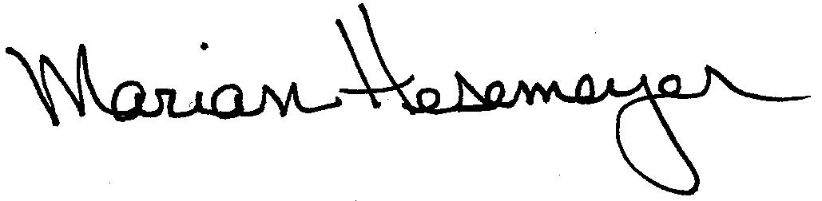
Respectfully submitted,

Marian Hesemeyer

