Danbury Museum and Historical Society Authority

Special Meeting – December 22, 2020

In compliance with Connecticut General Statute § 1-225, these minutes are being provided for informational purposes and are subject to approval of the Danbury Museum & Historical Society Authority Board of Trustees at its next regular meeting.

In attendance were, Geoff Herald, Marian Hesemeyer, Brigid Guertin (DMHS), Michele Amundson (DMHS), Bob Doyle, Elizabeth Hudson, Paul Valeri and James Beschle (Potential board member).

Voting members present, Geoff Herald, Marian Hesemeyer, Bob Doyle, Elizabeth Hudson and Paul Valeri

Geoff Herald, Board President called the meeting to order at 5:08 pm

Bob Doyle motioned that the Authority Board authorize the Executive Director, in the name of the Museum, to apply for money through the new PPP program being offered by the Federal Government.

Paul Valeri seconded the motion, all in attendance voted in favor of the motion in a unanimous vote.

A motion to adjourn the meeting was made by Elizabeth Hudson and seconded by Paul Valeri.

The special meeting was adjourned at 5:22 pm

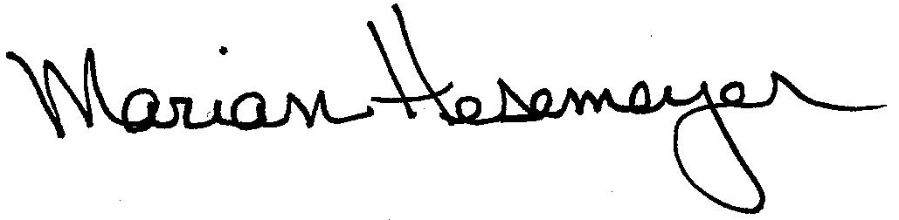
Respectfully submitted,

Marian Hesemeyer

