Danbury Museum and Historical Society Authority
Huntington Hall
Meeting Minutes – February 18, 2021

In compliance with Connecticut General Statute § 1-225, these minutes are being provided for informational purposes and are subject to approval of the Danbury Museum & Historical Society Authority Board of Trustees at its next regular meeting.
In attendance were, Geoff Herald, Roberto Alves, Marian Hesemeyer, Bob Doyle, Patrick Wells (DMHS), Ed Siergiej (Friends Board), Paul Valeri, Doug Polistena, James Beschle and Bob Young
Members not in attendance: Brandon Whitfield, Elizabeth Hudson and John Clark

President Report, President Geoff Herald called the meeting to order at 5:05 pm and thanked everyone for the work they did to make the Hat City Ball successful this year.
Geoff asked the board for any changes or corrections to the January meeting minutes.

A motion to accept the minutes from the January meeting was made by Bob Doyle and seconded by Bob Young, all in attendance voted to accept the meeting minutes in a unanimous vote.

Finance Report: Bob Doyle presented the financial reports for both the Hat City Ball and the Museum. The museum has received funds from PPP2.

A motion to accept the Financial Report was made by Paul Valeri and seconded by Doug Polistena, all in attendance voted to accept the Financial report.

Executive Director’s Report: No Report

Old Business: There will be extremely limited access to the Museum due to continued COVID-19 concerns.

New Business: No new business

Meeting was adjourned at 5:35 with a motion Bob Young, seconded by Bob Doyle.

The next meeting of the Board will be March 11, 2021 at 5:00 pm via Zoom. Link to mtg. is available at www.danburymuseum.org, Bottom of Museum from Home page.

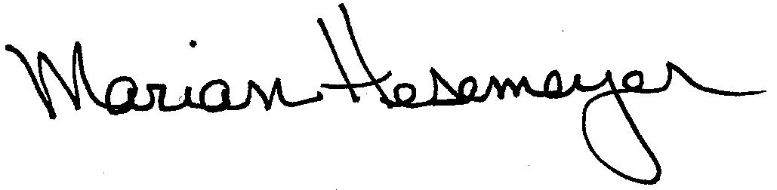
Respectfully submitted,

Marian Hesemeyer

