Danbury Museum and Historical Society Authority
Huntington Hall
Meeting Minutes – February 9, 2023

In compliance with Connecticut General Statute § 1-225, these minutes are being provided for informational purposes and are subject to approval of the Danbury Museum & Historical Society Authority Board of Trustees at its next regular meeting.
In attendance were, Marian Hesemeyer, James Beschle, Elizabeth Hudson, Brigid Guertin (DMHS), Patrick Wells (DMHS), Michele Amundsen (DMHS), Julie Siergiej (DMHS), Paul Valeri, Bob Young, Geoff Herald, Bob Doyle
FDMHS Board members in attendance: Ed Siergiej, Ann Harrigan & Dr. Thomas Valluzzo
Members not in attendance: Brandon Whitfield, Roberto Alves and Doug Polistena

President Report: Board President Geoff Herald called the meeting to order at 4:59 pm

Geoff Herald asked for a motion to accept the minutes from the January meeting.

A motion to accept the minutes from the January meeting was made by Paul Valeri and seconded by James Beschle, all in attendance voted to accept the meeting minutes in a unanimous vote.

Finance Report: Bob Doyle went over the Museum’s financials.

Members of the board are concerned that the museum is paying for maintenance, insurance and an audit for city property, all of which are legitimately expenses to be borne by the City not the Museum. This means we are fund raising to pay salaries. There are concerns by the board of why our employees cannot be covered by the City health insurance plan as it is clearly too expensive for us on our extremely limited budget to insure them through the board and the museum.

A motion to accept the Financial Report was made by Liz Hudson and seconded by Bob Young, all in attendance voted to accept the financial report in a unanimous vote.

Executive Director’s Report: Brigid Guertin stated that there has been a lot going on at the museum. Tours and research slot are booked and there are several music programs being arranged.

The museum has been is working on a research project for Cramer & Anderson, LLP who are representing the City. The project is in regards to the City Wards. This is a large project using a great deal of the Museum employee’s time.

Time slots for reading at the Marian Anderson Program being held February 24th & 25th will be opened.

Old Business:

Social Media – Patrick Wells stated we had pretty good numbers

250th Anniversary – Nothing New

Fundraisers & Events - Ed Siergiej informed the Board that the Friends are working on a few fundraising options and the Annual Meeting of the Museum, which includes the Friends & Authority Boards.

New Business:

Bob Young and Geoff Hearld met with members of the Redding Historical Society to turn over the 1724 deed from the local Sachem granting Redding land for the town.

Liz Hudson made a motion to go into executive session to discuss Salary, Payroll and HR. The motion was seconded by Bob Young

Bob Doyle made a motion to come out of executive session. The motion was seconded by Bob Young.

It was determined during the Executive session to give a salary increase to the Head Docent.

Meeting was adjourned at 5:58pm with a motion by Bob Doyle and seconded by Bob Young

The next meeting of the Board will be March 9th at 5:00 pm in Huntington Hall.

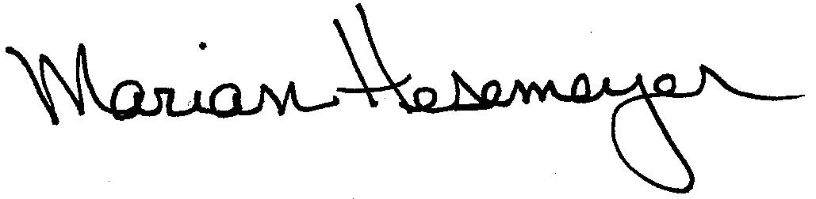
Respectfully submitted,

Marian Hesemeye

