Danbury Museum and Historical Society Authority
Huntington Hall
Meeting Minutes – January 14, 2021

In compliance with Connecticut General Statute § 1-225, these minutes are being provided for informational purposes and are subject to approval of the Danbury Museum & Historical Society Authority Board of Trustees at its next regular meeting.
In attendance were, Geoff Herald, Roberto Alves, Marian Hesemeyer, Brigid Guertin (DMHS), Michele Amundson (DMHS), Bob Doyle, Patrick Wells (DMHS), Paul Valeri, Doug Polistena and Paul Steinmetz (standing in for John Clark)
Members not in attendance: Brandon Whitfield, Elizabeth Hudson, James Beschle and Bob Young

President Report, President Geoff Herald called the meeting to order at 5:37 pm and asked the board for any changes or corrections to the December meeting minutes.

A motion to accept the minutes from the December meeting was made by Paul Valeri and seconded by Bob Doyle, all in attendance voted to accept the meeting minutes in a unanimous vote.

Finance Report: Bob Doyle presented the financial report and explained where the Museum stands financially. Bob informed the board that the application for PPP2 is being completed so it is ready to submit when it comes online.

Bob Doyle made the motion to give Brigid Guertin permission to sign the paperwork for the $10,000.00 overdraft protection program on the Museum’s General Operation Account with Union Savings Bank. Seconded by Doug Polistena, all in attendance voted to approve the motion in a unanimous vote.

A motion to accept the Financial Report was made by Paul Valeri and seconded by Roberto Alves, all in attendance voted to accept the Financial report.

Executive Director’s Report: Brigid Guertin informed the Board that they tried the New virtual school programs, and it didn’t go very well. Microsoft has contacted the Museum about using their platform. They will explore this option with Story Telling Programs. The Museum hopes to be able to offer virtual field trips in the Spring.

Things are “pandemic” normal at the Museum and the Charles Ives House rehabilitation is moving forward.

Old Business: No Old Business

New Business: There was a general discussion about Museum Opperations.

Bob Doyle made a motion to call a Hat City Ball committee meeting at 5pm on February 4^{th.}
Seconded by Paul Valeri, all in attendance voted to approve the motion in a unanimous vote.

Bob Doyle made a motion to move the monthly Authority Board meeting from February 11th to the 18th. Seconded by Marian Hesemeyer, all in attendance voted to approve the motion in a unanimous vote.
Meeting was adjourned at 6:30pm with a motion Roberto Alves, seconded by Paul Valeri.

The next meeting of the Board will be February 18, 2021 at 5:30 pm via Zoom. Link to mtg. is available at www.danburymuseum.org, Bottom of Museum from Home page.

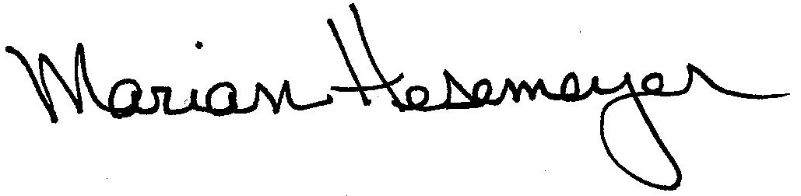
Respectfully submitted,

Marian Hesemeyer

