Danbury Museum and Historical Society Authority
Huntington Hall
Meeting Minutes – January 13, 2022

In compliance with Connecticut General Statute § 1-225, these minutes are being provided for informational purposes and are subject to approval of the Danbury Museum & Historical Society Authority Board of Trustees at its next regular meeting.
In attendance were, Geoff Herald, Marian Hesemeyer, Brigid Guertin (DMHS), Bob Doyle, Patrick Wells (DMHS), Michele Amundsen (DMHS), Paul Valeri, Doug Polistena, James Beschle, Bob Young, Ed Siergiej (FDMHS), Roberto Alves and Paul Steinmetz (for John Clark)

Members not in attendance: Brandon Whitfield, Elizabeth Hudson and Erick Espinoza (Board Candidate)

President Report: Board President Geoff Herald called the meeting to order at 5:04 pm and asked for a motion to accept the minutes from the December meeting.

A motion to accept the minutes from the December meeting was made by Bob Young and seconded by James Beschle, all in attendance voted to accept the meeting minutes in a unanimous vote.

Finance Report: Bob Doyle presented the financial report. We recieved the balance of the City of Danbury money for the year. This has helped to put us in a healthier financial position, although we did spend more on general maintenance.

A motion to accept the Financial Report was made by Marian Hesemeyer and seconded by Doug Polistena, all in attendance voted to accept the financial report in a unanimous vote.

Executive Director’s Report: Brigid Guertin informed the board that we won the CT State Grant for general operational support.

The Ives house project is almost finished, the Savings Bank of Danbury provided the funds to finish the project. We will be planning a special event for the Savings Bank of Danbury, then follow with a Grand Opening for the public.

The Garden Club will be working at the Museum campus creating new Gardens.

The Eagle Scout project has been finished at the museum. The museum will work with the Scouts on more projects.

The buildings are in good shape, a few repairs are still needed at the Marian Anderson Studio.

The Court House is still a possibility, the City will be moving forward with this project and the Museum taking occupancy of the second floor is still in discussion.

Hat City Ball – Due to the current increase of COVID infections in the city. The FDMHS board voted to go from a live to a virtual event on February 11th.

Marian Hesemeyer made the motion that the Authority Board vote in solidarity with the FDMHS board to change the Hat City Ball from a live to a virtual event. Bob Doyle seconded the motion, all in attendance voted in favor of the motion in a unanimous vote.

250th Anniverary of the Revolutionary War/Raid on Danbury:
The 250th anniversary of the Revolutionary War is coming up in 2026. Committees are being formed to start planning for the anniversary.

Michele and Patrick reported on Social Media efforts. They have been very successful, and we have reached 1,000,000 views. Our monthly numbers have been impressive.

Old Business:

New Business:

Meeting was adjourned at 6:19 pm with a motion by Bob Doyle seconded by Doug Polistena.

The next meeting of the Board will be February 10th, at 5:00 pm via Zoom. Link to mtg. is available at www.danburymuseum.org, Board of Trustee page.

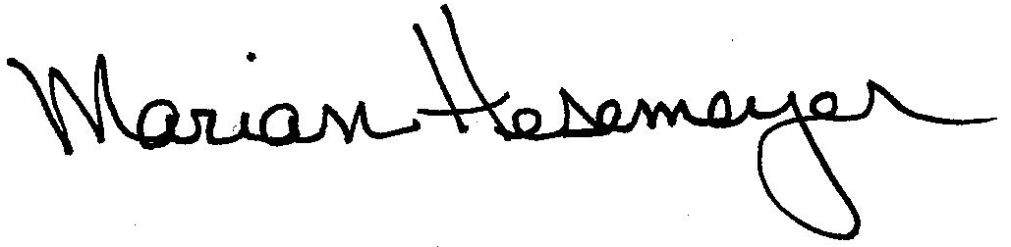
Respectfully submitted,

Marian Hesemeyer

