Danbury Museum and Historical Society Authority
Huntington Hall
Meeting Minutes – July 9, 2020

In compliance with Connecticut General Statute § 1-225, these minutes are being provided for informational purposes and are subject to approval of the Danbury Museum & Historical Society Authority Board of Trustees at its next regular meeting.
In attendance were, Geoff Herald, Paul Valeri, Marian Hesemeyer, Brigid Guertin (DMHS), Michele Amundson (DMHS), Bob Doyle, Patrick Wells (DMHS), Elizabeth Hudson, Roberto Alves and Bob Young.
Members not in attendance: Brandon Whitfield, John Clark and Doug Polistena

President Report, Vice-President Elizabeth Hudson called the meeting to order at 5:34 pm and asked the board for any changes or corrections to the June meeting minutes.

A motion to accept the minutes from the June meeting was made by Bob Young and seconded by Roberto Alves, all in attendance voted to accept the meeting minutes in a unanimous vote.

Finance Report: Bob Doyle went over the budget for 2021 with the Board. A motion to accept the 2021 budget as presented was made by Roberto Alves and seconded by Paul Valeri, all in attendance voted to accept the budget in a unanimous vote.

Bob Doyle presented the Financial reports. A motion to accept the Financial Reports was made by Roberto Alves and seconded by Paul Valeri, all in attendance voted to accept the Financial reports in a unanimous vote.

Executive Director’s Report: Brigid Guertin went over the COVID-19 safety procedures (posted on the website and in Huntington Hall) for entering the museum. Brigid also went over the re-opening statement (available on the website).

The Museum is exploring new locks for the Museum buildings.

Ives Project Update: The exhibition designer has been hired and has begun working to make the Charles Ives Birthplace ready to open. The goal is to have the opening of the exhibit in November. The current tenant in the apartment at the house will be asked to vacate the apartment at the end of his lease in November (will be given a 90-day notice). There is a lot of work that needs to be done on that side of the house.

The Museum had received Capital Budget Funds to paint the building on the Main Street campus.

Smithsonian Affiliate Program: A motion was made by Marian Hesemeyer to pursue the application to the Smithsonian Affiliate Program under the umbrella of the Danbury Museum & Historical Society Authority. The motion was seconded by Elizabeth Hudson, all in attendance voted in favor with a unanimous vote.

Michele Amundson let the board know that the Murals for the outside exhibit are ordered and will be installed along the back fence on the Main Street campus. The online exhibits on the Pandemic of 1918, WW I, Influenza outbreak etc. are in the process of being put up on the website.

Old Business: Brigid Guertin is still waiting to receive keys to the Old Jail. A Museum wish list has been posted to the website for anyone who wants to make a donation to review.

New Business:

Meeting was adjourned at 6:08 pm with a motion by Bob Young, seconded by Bob Doyle.

The next meeting of the Board will be August 13, 2020 at 5:30 pm via Zoom. Link to mtg. is available at www.danburymuseum.org, Bottom of Museum from Home page.

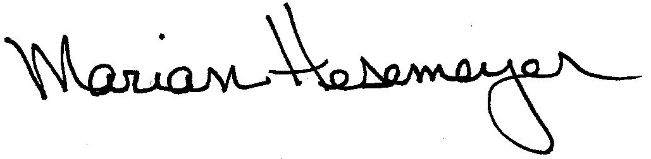
Respectfully submitted,

Marian Hesemeyer

