Danbury Museum and Historical Society Authority
Huntington Hall
Meeting Minutes – July 8, 2021

In compliance with Connecticut General Statute § 1-225, these minutes are being provided for informational purposes and are subject to approval of the Danbury Museum & Historical Society Authority Board of Trustees at its next regular meeting.
In attendance were, Marian Hesemeyer, Brigid Guertin (DMHS), Michele Amundson (DMHS), Bob Doyle, Patrick Wells (DMHS), Paul Valeri, Doug Polistena, Paul Steinmetz (standing in for John Clark), Elizabeth Hudson and Bob Young

Members not in attendance: Geoff Herald, Roberto Alves, Brandon Whitfield and James Beschle

President Report, Vice President Bob Young called the meeting to order at 5:35 pm
Bob asked the board for any changes or corrections to the June meeting minutes.

A motion to accept the minutes from the June meeting was made by Paul Valeri and seconded by Bob Doyle, all in attendance voted to accept the meeting minutes in a unanimous vote.

Finance Report: Bob Doyle presented the financial report.

A motion to accept the Financial Report was made by Marian Hesemeyer and seconded by Doug Polistena, all in attendance voted to accept the financial report.

Executive Director’s Report: Brigid Guertin let the board know that the Museum has overgrown its archival space. Due to an incident that cause a threat to someone at the Museum (thankfully no harm), stacked archive items have been moved to the floor making it very difficult to move around or use the archives. We need to find new space to house the Museum archives.

The Summer focus for the museum will be creating a document location on the website to support the sixth, seventh and eighth grade history curriculum.

The Garden Club has created incredible gardens at the Museum. The Museum is planning on offering programs in the Gardens. Matthew Slokin on September 11th, a pianist and a violinist in August and September.

The museum has been exploring new Auditor and Insurance for the museum. Quotes are being gathered.

The Museum is in the process of having a committee formed to create an Indigenous Land Statement.

Brigid had reached out to community leaders to form a subcommittee for research and bring forward the difficult truth of the use of enslaved people during the first centuries of Danbury history. The goal is to create community discussion points and possible programs.

Old Business: Bob Young is continuing to organize and complete the Veteran Burial cards found in Wooster Cemetery files. He also informed the Board that the Wooster Cemetery is divesting items that have nothing to do with the cemetery. Bob is reviewing these items.

New Business: Paul meet with a 100-year-old lifelong Danbury Resident, Hana King and has let the Museum know that she is willing to do a video history of Danbury for the Museum. Brigid will arrange to record this important firsthand history.

Meeting was adjourned at 6:12 pm with a motion by Bob Doyle, seconded by Doug Polistena.

The next meeting of the Board will be August 12, 2021, at 5:30 pm via Zoom. Link to mtg. is available at www.danburymuseum.org, Bottom of Museum from Home page.

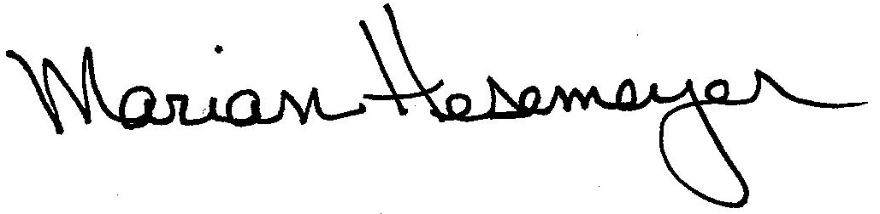
Respectfully submitted,

Marian Hesemeyer

