Danbury Museum and Historical Society Authority
Huntington Hall
Meeting Minutes – June 9, 2022

In compliance with Connecticut General Statute § 1-225, these minutes are being provided for informational purposes and are subject to approval of the Danbury Museum & Historical Society Authority Board of Trustees at its next regular meeting.
In attendance were, Geoff Herald, Marian Hesemeyer, Brigid Guertin (DMHS), Bob Doyle, Patrick Wells (DMHS), Paul Valeri, Elizabeth Hudson, James Beschle, Bob Young, Brandon Whitfield and Michele Amundsen (DMHS)

Members not in attendance: Roberto Alves, John Clark and Doug Polistena

President Report: Board President Geoff Herald called the meeting to order at 5:07 pm and asked for a motion to accept the minutes from the May meeting.

A motion to accept the minutes from the May meeting was made by Elizabeth Hudson and seconded by James Beschle, all in attendance voted to accept the meeting minutes in a unanimous vote.

Finance Report: Bob Doyle presented the financial report and went on to talk about what he presented to the City Council.

Members of the board are concerned that the museum is paying for maintenance, insurance and an audit for city property, all of which are legitimately expenses to be borne by the City not the Museum. This means we are fund raising to pay salaries. Further discussion indicates concerns by the board of why our employees cannot be covered by the City insurance plan as it is clearly too expensive for us on our extremely limited budget to insure them through the board and the museum.

A motion to accept the Financial Report was made by Bob Young and seconded by Elizabeth Hudson, all in attendance voted to accept the financial report in a unanimous vote.

Executive Director’s Report: Brigid reported that the museum will be working in cooperation with the Danbury NAACP on Juneteenth celebrations.

Juneteenth programs are:
- The Museum will host a community panel at Huntington Hall on Thursday June 16th from 6 to 8pm. The topic is: Juneteenth and the African American Experience.
- Two sets of walking tours will be set up at WestConn Downtown campus at the center green.
- QR codes will be printed on the signage, used to explore the African American History of Danbury and to invite a deep dive into this history at the Danbury Museum.

Brigid will be contacting the Cultural Commission to fund tours and entrance fees at the Museum for four months. This is to allow those who might not come to the Museum due to the cost to have True Equity and True Access.

The School programs went well at the Museum. Since the museum is not fully funded by the City, there is a charge to the students for the field trips which helps to cover some of the costs the museum incurs.

Discussions of the Old Court House and the proper use of the building without degrading the historical interiors are ongoing. This is an opportunity for the city to make a generational change to increase availability for services and the arts in this area of the city.

The committee involved with the mural being installed at Kennedy Park is addressing concerns as to what has been created so far and will have it corrected.

Old Business:
Social Media – Patrick reported that all is going well and shared that posts for fundraising reduce our engagements. People prefer our content posts.

250th Anniversary – More to come, packets from the State will be coming in.

Bob Young has been reviewing found original documents which include property deeds. The original deed for a section of Redding from the local Sachem is in our possession and Bob is working on returning it to Redding.

New Business: No new business

Meeting was adjourned at 6:53 pm with a motion by Bob Young seconded by Bob Doyle

The next meeting of the Board will be July 14th , 5:00 pm at the Huntington Hall.

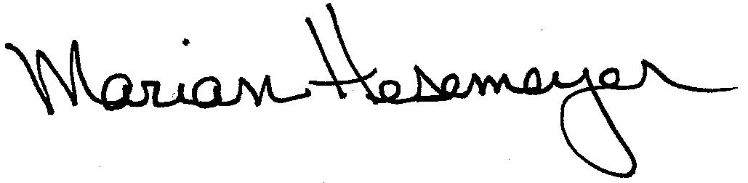
Respectfully submitted,

Marian Hesemeyer

