Danbury Museum and Historical Society Authority
Huntington Hall
Meeting Minutes – March 11, 2021

In compliance with Connecticut General Statute § 1-225, these minutes are being provided for informational purposes and are subject to approval of the Danbury Museum & Historical Society Authority Board of Trustees at its next regular meeting.
In attendance were, Geoff Herald, Roberto Alves, Marian Hesemeyer, Bob Doyle, Patrick Wells (DMHS), Ed Siergiej (Friends Board), Paul Valeri, Brigid Guertin (DMHS), Michele Amundson (DMHS), Doug Polistena, James Beschle, Liz Hudson and Paul Steinmetz (standing in for John Clark). Members not in attendance: Brandon Whitfield and Bob Young

President Report, President Geoff Herald called the meeting to order at 5:34 pm
Geoff asked the board for any changes or corrections to the February meeting minutes.

A motion to accept the minutes from the February meeting was made by Bob Doyle and seconded by Doug Polistena, all in attendance voted to accept the meeting minutes in a unanimous vote.

Finance Report: Bob Doyle presented the financial report.

A motion to accept the Financial Report was made by Liz Hudson and seconded by Marian Hesemeyer, all in attendance voted to accept the Financial report.

Executive Director’s Report: Brigid Guertin went over the reopening plan for the Museum with the Board. This will be posted for the public to the website and given to City Hall.

Due to the continued risk from COVID-19 the museum will continue at this time to have the buildings on the campus closed and the people who work at the museum will continue with their current schedule. Updates to this policy may be made as employees get vaccinated, social distancing and masks will still be required. A few of the groups that meet at the Museum may hold outside meetings at the campus.

There are several outside exhibits planned and will include locations such as City Hall and the Library. The Museum will be working with the Library to present Zoom programing. There is a Social Media push with Danbury Fair Fridays and Patrick Wells gave a Social Media Report.

Old Business: The Hat City Ball Auction will be held online, the dates for the auction are June 1-25, 2021. We will be looking for a few sponsors for the Auction.

New Business: No new business

Meeting was adjourned at 6:38 pm with a motion by Bob Doyle, seconded by Liz Hudson.

The next meeting of the Board will be April 8, 2021 at 5:30 pm via Zoom. Link to mtg. is available at www.danburymuseum.org, Bottom of Museum from Home page.
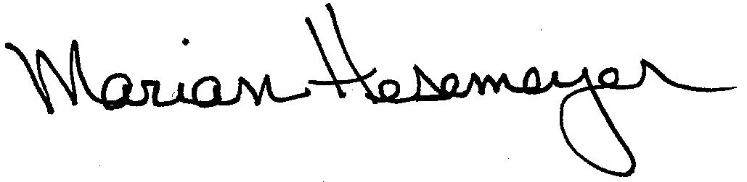
Respectfully submitted,

Marian Hesemeyer

