Danbury Museum and Historical Society Authority
Huntington Hall
Meeting Minutes – March 9, 2023

In compliance with Connecticut General Statute § 1-225, these minutes are being provided for informational purposes and are subject to approval of the Danbury Museum & Historical Society Authority Board of Trustees at its next regular meeting.
In attendance were, Marian Hesemeyer, James Beschle, Elizabeth Hudson, Brigid Guertin (DMHS), Patrick Wells (DMHS), Michele Amundsen (DMHS), Julie Siergiej (DMHS), Doug Polistena, Bob Doyle
FDMHS Board members in attendance: Ed Siergiej
Members not in attendance: Brandon Whitfield, Roberto Alves, Paul Valeri, Bob Young and Geoff Herald

No official business was done due to a lack of a quorum.

The next meeting of the Board will be April 13th at 5:00 pm in Huntington Hall.

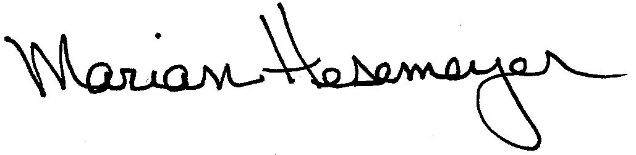
Respectfully submitted,

Marian Hesemeye

