Danbury Museum and Historical Society Authority
Huntington Hall
Meeting Minutes – May 13, 2021

In compliance with Connecticut General Statute § 1-225, these minutes are being provided for informational purposes and are subject to approval of the Danbury Museum & Historical Society Authority Board of Trustees at its next regular meeting.
In attendance were, Geoff Herald, Marian Hesemeyer, Bob Doyle, Patrick Wells (DMHS), Ed Siergiej (FDMHS), Paul Valeri, Brigid Guertin (DMHS), Michele Amundson (DMHS), Roberto Alves, James Beschle, Liz Hudson and Bob Young
Members not in attendance: Doug Polistena, Brandon Whitfield and John Clark

President Report, President Geoff Herald called the meeting to order at 5:35 pm
Geoff asked the board for any changes or corrections to the April meeting minutes.

A motion to accept the minutes from the April meeting was made by James Beschle and seconded by Bob Young, all in attendance voted to accept the meeting minutes in a unanimous vote.

Finance Report: Bob Doyle presented the financial report.

A motion to accept the Financial Report was made by Marian Hesemeyer and seconded by Liz Hudson, all in attendance voted to accept the Financial report.

Executive Director’s Report: Brigid Guertin let the board know that the Museum is making plans for a limited opening of the Museum which will include making appointments for tours and research.

Brigid will be trialing a new program for the 3rd grade, “Third Grade Rock” which involves the monuments around the city. This will be presented virtually.

The Museum is looking into offering 2 weeks of ½ day Cursive Camp in August.

Old Business: The CIFC new plans for the first floor of the Old Jail will include better access to the Museum Archives that are on the 2nd and 3rd floor.

A large cache of Veteran Burial Cards have been returned to the ownership of the City. Bob Young is working with Danny Hayes to track more of these records down in the hopes of returning them to the City’s archives. Thank you, Bob for getting this important information back into the City’s hands.

New Business: Election of Officers – The following slate was presented: Geoff Herald, Chairman; Elizabeth Hudson, 1st Vice Chairman; Robert Young, 2nd Vice Chairman; Marian Hesemeyer, Secretary; Robert Doyle; Treasurer.
A motion to accept the slate of officers was made by Roberto Alves and seconded by Liz Hudson. The Board Secretary cast a single vote to elect the slate of officers as defined above.

Paul Valeri made a motion to make James Beschle and alternate liaison to the Friends of the Danbury Museum Board, Bob Doyle seconded the motion. All in attendance voted in favor of the motion in a unanimous vote.

Meeting was adjourned at 6:25 pm with a motion by Bob Young, seconded by Marian Hesemeyer.

The next meeting of the Board will be June 10, 2021 at 5:30 pm via Zoom. Link to mtg. is available at www.danburymuseum.org, Bottom of Museum from Home page.

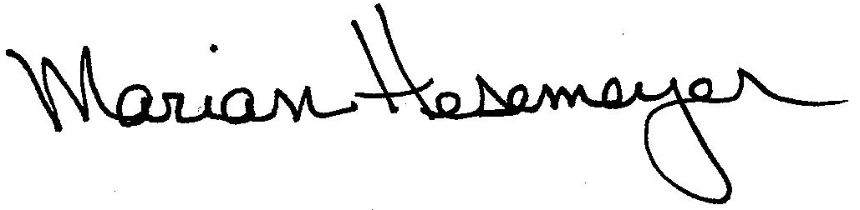
Respectfully submitted,

Marian Hesemeyer

