Danbury Museum and Historical Society Authority
Huntington Hall
Meeting Minutes – November 12, 2020

In compliance with Connecticut General Statute § 1-225, these minutes are being provided for informational purposes and are subject to approval of the Danbury Museum & Historical Society Authority Board of Trustees at its next regular meeting.
In attendance were, Geoff Herald, Roberto Alves, Marian Hesemeyer, Brigid Guertin (DMHS), Michele Amundson (DMHS), Bob Doyle, Patrick Wells (DMHS), Elizabeth Hudson, Bob Young and Doug Polistena.
Members not in attendance: Brandon Whitfield, John Clark, and Paul Valeri

President Report, President Geoff Herald called the meeting to order at 5:36 pm and asked the board for any changes or corrections to the October meeting minutes.

A motion to accept the minutes from the October meeting was made by Robert Young and seconded by Doug Polistena, all in attendance voted to accept the meeting minutes in a unanimous vote.

Finance Report: Bob Doyle presented the financial report and explained where the Museum stands financially.

A motion to accept the Financial Reports was made by Elizabeth Hudson and seconded by Doug Polistena, all in attendance voted to accept the Financial report.

Executive Director’s Report: Brigid Guertin informed the Board that the Charles Ives House rehabilitation is going well. The work has slowed down as COVID protocols have been put in place to make it safer for the people working in the building.

Exterior repairs and painting are moving forward on the Marian Anderson studio. The work on the Ryder house will move forward once all the windows have been replaced. We will need to address the back wall of the Dodd house soon.

The Winter exterior exhibit will be titled “Winter in Danbury”. The Children’s walk will be changes in collaboration with the Danbury Library.

The John Oliver Memorial Sewerage Plant items for sale in our store are doing well.

There will be no school programs at this time. The Museum is working with the schools to see if there is a possibility to do Revolutionary War program via media.

Old Business: No old business.

New Business: Michele Amundson informed the board that there are (7) rugs in the Charles Ives house that have deteriorated to the point they cannot be cleaned or repaired. A motion to deaccession these rugs was made by Doug Polistena and seconded by Elizabeth Hudson, all in attendance voted to pass the motion in a unanimous vote.

Meeting was adjourned at 6:06 pm with a motion by Doug Polistena, seconded by Bob Doyle.

The next meeting of the Board will be December 10, 2020 at 5:30 pm via Zoom. Link to mtg. is available at www.danburymuseum.org, Bottom of Museum from Home page.

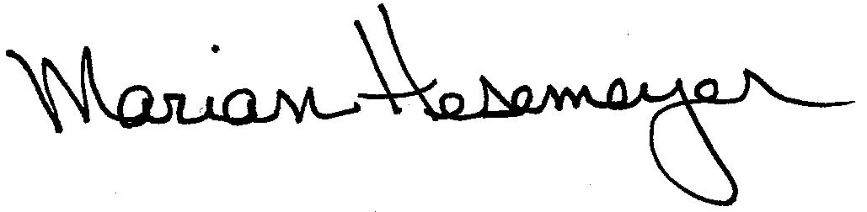
Respectfully submitted,

Marian Hesemeyer

