Danbury Museum and Historical Society Authority
Huntington Hall
Meeting Minutes – September 9, 2021

In compliance with Connecticut General Statute § 1-225, these minutes are being provided for informational purposes and are subject to approval of the Danbury Museum & Historical Society Authority Board of Trustees at its next regular meeting.
In attendance were, Geoff Herald, Marian Hesemeyer, Brigid Guertin (DMHS), Bob Doyle, Patrick Wells (DMHS), Michele Amundsen, Paul Valeri, Doug Polistena, Elizabeth Hudson, James Beschle and Erick Espinoza (Board Candidate).

Members not in attendance: Roberto Alves, Bob Young, John Clark and Brandon Whitfield

President Report, President Geoff Herald called the meeting to order at 5:06 pm
Geoff asked the board for any changes or corrections to the August meeting minutes.

A motion to accept the minutes from the August meeting was made by Elizabeth Hudson and seconded by Jim Beschle, all in attendance voted to accept the meeting minutes in a unanimous vote.

Finance Report: Bob Doyle presented the financial report. Bob stated that we need to be frugal over the next few months.

A motion to accept the Financial Report was made by Doug Polistena and seconded by Elizabeth Hudson, all in attendance voted to accept the financial report.

Executive Director’s Report: Brigid Guertin reported that the Museum’s 6th, 7th and 8th grade online program content is continuing to go up and thanks all of the Museum staff for their efforts in accomplishing this. The Museum has been very busy with tours etc. during the State’s Free Museums for the summer program. The State may do this again next year. The Museum will remain open (and busy) two days a week and will reassess each week as COVID mandates change.
Reservations are still needed for tours and research. There will be no onsite at school programs but we may be able to do some offsite programs later in the year.

Repairs on the buildings at the Main Street Campus have been progressing. The replacement of building’s exterior siding which was rotting, adding fencing, cleaning up from flooding due to extensive rain. We need new sump pumps as the ones in the Museum buildings are NOT working.

The Ives House is almost ready to open. We are waiting for the furnishings to be finished being rehabilitated and returned. Then we can do the staging of the house for opening. Exhibits will be added as we go forward.

The new Exhibit is up in Huntington Hall: The Fair That John Built and the Outside exhibit: The History of Danbury Fair.

Danbury Fair panels have been delivered to the Danbury Library for exhibit.

Old Business: Bob Doyle and Brigid Guertin went over the struggle the Museum has affording the Insurance and yearly Audit the City requires. They have been having meetings with the people concerned. We are looking for options as paying these costs has made it difficult to pay other necessary running expenses, an example being the maintenance of City buildings the Museum is the responsible for.

Paul Valeri is working with Patrick Wells to arrange for video capture of personal Histories of Danbury.

New Business: Brigid commented that the 245th anniversary of the Raid on Danbury is in April 2022. The Museum will plan a week of fun programs. The Putnam County Historians have reached out and would like to start a joint committee to plan for the 250th anniversary.

Meeting was adjourned at 6:28 pm with a motion by Bob Doyle, seconded by Jim Beschle.

The next meeting of the Board will be October 14, 2021, at 5:00 pm via Zoom. Link to mtg. is available at www.danburymuseum.org, Bottom of Museum from Home page.

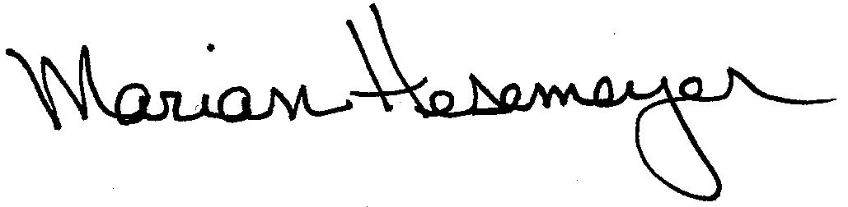
Respectfully submitted,

Marian Hesemeyer

