Danbury Museum and Historical Society Authority
Huntington Hall
Meeting Minutes – September 8, 2022

In compliance with Connecticut General Statute § 1-225, these minutes are being provided for informational purposes and are subject to approval of the Danbury Museum & Historical Society Authority Board of Trustees at its next regular meeting.
In attendance were, Geoff Herald, Marian Hesemeyer, Brigid Guertin (DMHS), Patrick Wells (DMHS), Michele Amundsen (DMHS), Paul Valeri, James Beschle, Bob Young, Elizabeth Hudson, Julie Siergiej (DMHS) and Doug Polistena
FDMHS Board members in attendance: Robert Strusik, Jeanne Kaltenstein, Kathy Eli, Joretta Kilcourse, Ed Siergiej and Anne Harrigan

Members not in attendance: Bob Doyle, Roberto Alves and Brandon Whitfield

President Report: Board President Geoff Herald called the meeting to order at 5:02 pm and turned the meeting over to Brigid to discuss the Hat City Ball, to be known going forward as the Danbury Museum Gala. The date for the Gala has been changed to March 10, 2023, it will have a Mardi Gras theme.
A discussion of sponsorship options and entertainment was had. The Packets for Sponsorship etc. will be going out soon.

Geoff Herald asked for a motion to accept the minutes from the August meeting.

A motion to accept the minutes from the August meeting was made by Paul Valeri and seconded by James Beschle, all in attendance voted to accept the meeting minutes in a unanimous vote.

Finance Report: Brigid Guertin presented the report and stated that as we are going, we will be running low in funds come the end of November. We receive a grant from the State of Connecticut Cultural Committee that will fund keeping the Museum free through December. This donation will help us significantly towards keeping the Museum available to the public, as we try to avoid the fiscal cliff approaching

Members of the board are concerned that the museum is paying for maintenance, insurance and an audit for city property, all of which are legitimately expenses to be borne by the City not the Museum. This means we are fund raising to pay salaries. There are concerns by the board of why our employees cannot be covered by the City health insurance plan as it is clearly too expensive for us on our extremely limited budget to insure them through the board and the museum.

A motion to accept the Financial Report was made by Bob Young and seconded by Doug Polistena, all in attendance voted to accept the financial report in a unanimous vote.

Brigid talked about the upcoming Audit. We are waiting for direction from City Hall on who will be doing the audit and who is going to pay for it.

Executive Director’s Report: Brigid Guertin informed the board that she is working on multiple programs for 2023, the Library and the Music Center are to be involved is some of this programing.

The Music Center wants to do Ives programing with the Museum, more information to come.

There will be a program to celebrate Charles Ives Birthday on October 22nd.

Old Business: Social Media: Michele Amundsen reported we had the best month ever. There will be fun things coming soon including a submission on the Danbury Fair by Jack Stetson for the newsletter.

250th Anniversary – The State Committee for the Anniversary will be sending out packets of information soon.

Geoff Herald thanked Jim Beschle for the use of his tent at the Museum over the summer.
Old Court House: Brigid stated that we are aware of several things going on at the City but we have not been given any information at this time.

New Business: Brigid explained several grants that she will be going for.

A motion was made by Elizabeth Hudson that the Board empower the Director to apply for any Grant that may be applicable to the Museum for 180 days. The motion was seconded by Doug Polistena, all in attendance voted in favor of the motion in a unanimous vote.

Meeting was adjourned at 6:015:35 pm with a motion by Bob Young seconded by Elizabeth Hudson

The next meeting of the Board will be October 13th at 5:00 pm at the Huntington Hall.

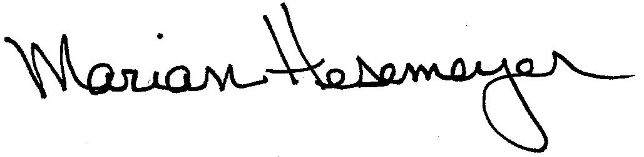
Respectfully submitted,

Marian Hesemeyer

