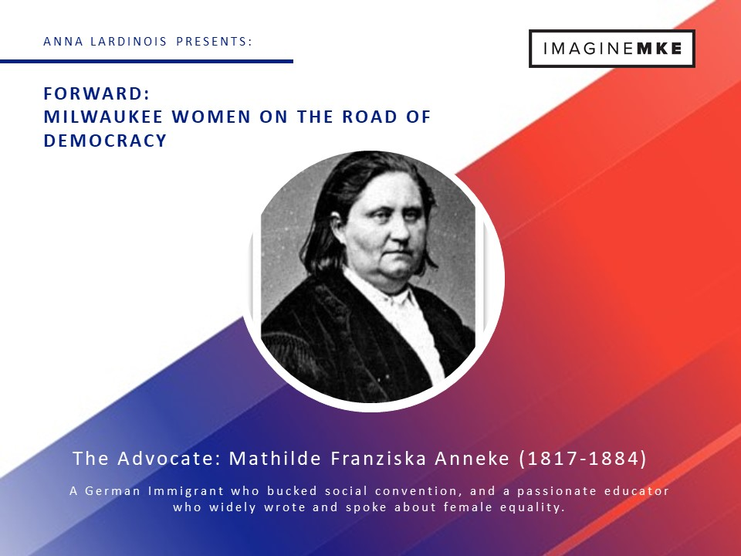
Mathilde Franziska Anneke (1817-1884): The Advocate
Remembered by Milwaukeeans as the editor of Deutsche Frauen-Zeitung (German Women’s Times), a feminist newspaper with a female typesetting staff launched in 1852, her journey as an internationally known equal rights activist began years earlier in Germany.
Born into a noble Westphalian family, Anneke was a well educated girl whose early marriage was arranged for the financial benefit of her relatives. At 19, she found herself unhappily married to an abusive alcoholic and the mother of an infant daughter. Discontent, she filed for divorce, despite the moral protests of her Catholic family and the social ostracization that would follow the then taboo act. Her fall from the upper class into poverty after she left her husband, coupled with her legal battle to keep custody of her daughter, galvanized her spirit and created in her a fierce woman’s rights advocate. After six years of judicial wrangling, her divorce was finally granted in 1843.
Anneke married her second husband, Fritz, in 1847 and the pair were active participants in the Revolution of 1848. She followed her husband onto the battlefield and wrote about the uprising as she rode her horse alongside the rebels. Together, the pair published a newspaper for the resistance until her husband was arrested for his political beliefs. While awaiting his trial for treason, Anneke brought the printing press into their home and continued to single-handedly produce the newspaper until it was shut down by the French government. She then published her first iteration of Deutsche Frauen Zeitung. Ultimately, the 1848 revolution failed, which forced the Annekes to flee Europe and settle in Wisconsin.
By 1850, Anneke was speaking on gender equality to standing-room only crowds of German speakers in Milwaukee. Her popularity caught the attention of the notable feminists Susan B. Anthony and Elizabeth Cady Stanton; soon Anneke was translating the famous women’s works into German and speaking throughout the Midwest in her quest for equal rights. She launched her Milwaukee-based version of Deutsche Frauen-Zeitung on March 30, 1852 with a largely female staff, including the traditionally male role of typesetter because men refused to work for the feminist newspaper. The act enraged local typesetters, who saw female typesetters as a threat to their profession, so they organized one of the nation’s first typesetter unions in an effort to keep the trade exclusively male. Through targeted pressure on businesses who worked with Deutsche Frauen-Zeitung, the union was instrumental in the demise of the newspaper.
Her cause expanded beyond gender equality to the abolition of slavery and soon she saw herself as not an advocate for women’s rights, but human rights. In 1865, the internationally known activist opened Milwaukee Tochter Institute, a German language education school for girls. The school attracted pupils from Milwaukee’s most prominent families and focused on the intellectual development of the students, providing little instruction in neither religion nor domestic arts. Anneke ran her popular school until her death in 1884.

Golda Meir (1898-1978): The Revolutionary
Golda Meir is arguably one of the most written about, analyzed and debated female politician of the last century. In this collection of influential Milwaukee women, we look at the Golda Meir Milwaukee knew, the girl who would one day grown up to lead a nation.
She was known as Goldie Mabowehz in the Haymarket neighborhood in which she was raised. Her family faced violent pogroms and religious persecution when they fled their native Urkraine and emigrated to Milwaukee in 1906, when Goldie was eight years old. She was an academic star at Fourth Street School, despite poor attendance due her family’s demands she prioritize working in the family store over her education. In 1912, she was the valedictorian of her eighth grade class. Goldie was eager to attend high school, something which her parents opposed. They saw a future for her that included few years of work, followed by marriage, but she wanted something more.
Unwilling to give up her pursuit of an education, she began to make plans to reach her goal, despite her parents’ unwillingness to allow her to continue her studies. With the help of her friends, fourteen year old Goldie scraped together enough money to purchase a train ticket to Denver, where she planned to live with her older sister and attend high school. It was in her sister’s home she was introduced to the political ideas that would shape the trajectory of her life.
She returned to her family home in Milwaukee the following year and continued her education at North Division High School. Upon her graduation in 1916, she worked at Schuster’s Department Store and enrolled in Milwaukee Normal School, the teacher training college that would eventually become University of Wisconsin, Milwaukee. While studying to become an educator, she taught reading, writing and history at a Folk-Schilen, the Abraham Lincoln House. After just a year, she left college and devoted herself politics. She was a key member of the Zionist movement in Milwaukee during those years. As her passion to create a Jewish homeland grew, she realized she needed to relocate to the Middle East to more effectively work for her cause. She left Milwaukee in 1921, and while she would occasionally visit the city of her youth in the years to come, she would never again live in Milwaukee.
Today, many of the places familiar to Golda Meir in her lifetime are gone, but her legacy lives on in her first American home. Fourth Street School, where she notably advocated for all children to have access to education was named in her honor in 1979. Additionally, the main library on the UW-Milwaukee campus also bears her name. Meir’s legacy can also be explored in permanent exhibit at the Jewish Museum of Milwaukee.

Vel Phillips (1923-2018): The Change Agent
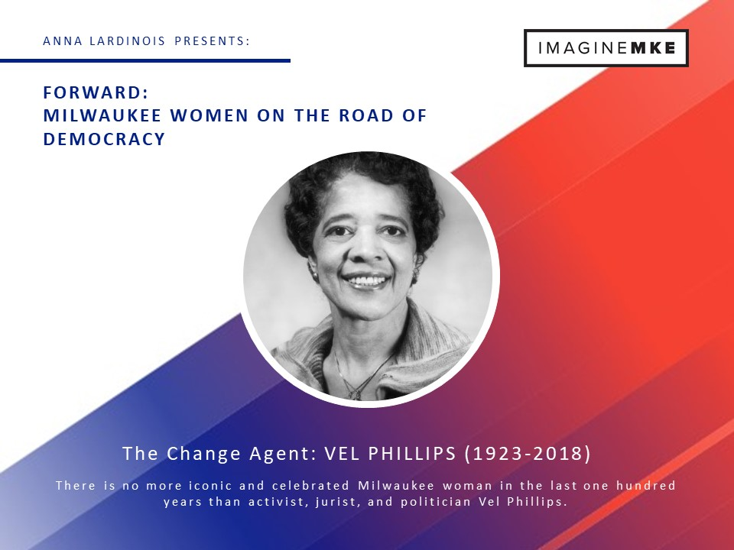
Is there anything more than can be said about Vel Phillips? In her lifetime she became a legend and is remembered as one of historic Milwaukee’s most prominent citizens. Vel Phillips is included in this collection of women who influenced the shape of democracy in Milwaukee not because her story is unknown, but rather because her exclusion would be inexplicable.
Former Milwaukee County Reserve Judge Russell Stamper once said of Phillips, “Vel is past, present and future.” By looking at this remarkable woman and her role in the past, we can draw clear parallels to our present, and be inspired by her to create a better future for all of Milwaukee’s citizens.
Vel Phillips left an indelible mark on Milwaukee. Her professional life contains an impressive list of firsts which include: the first African American woman to graduate from the University of Wisconsin Madison Law School, the first woman and first African American to be elected to the Milwaukee Common Council, the first African American judge in Wisconsin and the first female African American Secretary of State in Wisconsin.
The woman whose life is parade of notable accomplishments was born on February 18, 1923. As a child, Velvalea Hortense Rodgers attended Garfield School where she shone as a talented student. Her scholastic success, coupled with her hard work, made her an academic star at North Division High School. Her academic achievements earned her a scholarship to Howard University. Upon completion of her undergraduate degree, Phillips enrolled in the University of Wisconsin Law School. As a child, she was inspired to practice law by family friend James Dorsey, a Milwaukee attorney with his own list of impressive achievements. Her dream to become a lawyer propelled her past the many obstacles between her and a law license, and in 1951 she became the first African American woman to graduate from UW Law School. While attending the school she struggled with the problem of segregated student housing, a wrong later acknowledged in 2011 when the school named a residence hall in honor of this notable graduate.
Phillips first ran for office in 1953 when she unsuccessfully ran for a seat on the Milwaukee Public Schools schoolboard. Undaunted, she continued her quest and became the first African American woman to be elected to the Milwaukee City Council in 1956. While historic, her election to the Common Council was fraught with problems unique to trailblazers. As the first woman to hold the role, she found there was no woman’s restroom for her to use. When she wasn’t battling her colleagues for citizens’ rights on the floor, she was battling them behind the scenes for the right to use the facilities designated for the Council. She eventually won the right to use the restroom, but it was not without the fierce opposition of a few of her white, male counterparts.
In 1962, she proposed the Fair Housing Law which would prevent landlords and realtors from denying access to property based solely on the color of a client’s skin. This proposal was rejected each time Phillips brought it to the Council. Still fighting for this legal protection five years later, the Milwaukee Sentinel noted on June 14, 1967 after Phillips, again, brought the issue to the Council, “Seventeen white Milwaukee aldermen listened silently for 30 minutes Tuesday while their lone Negro colleague urged them to consider the adoption of a city fair-housing ordinance. Then, without a word of comment or criticism, they voted to reject the proposal.” By the summer of 1967, the city would no longer accept silence and inaction. Milwaukee citizens were eager for change and took to the streets to demand equal rights for its citizens.
It was the start of 200 nights of marching in Milwaukee. The protests turned a spotlight on segregated Milwaukee and Phillips and activist Father James Groppi rose to national prominence. Her fight for housing equality was not without consequence. As she marched in the streets, she and other protestors were pelted with eggs and doused in human waste. At work she received angry telephone calls and stacks of threatening letters. As tension in Milwaukee grew during the summer of 1967, Phillips wasn’t even safe in her own home. One evening she returned home to discover her a gunshot had been fired into her house, coupled with a note that stated “Go back to Africa.” While shaken enough to send her children to stay with out of state relations, she was undeterred from fighting for what she believed were the fundamental human rights of the citizens she represented. In the end, the people’s voices were heard and an open housing bill, which had greater protections than the one Phillips originally proposed, was finally passed in 1968.
After what may have been the peak in most political careers, Phillips’ star continued to rise. In 1971 she became Wisconsin’s first African American judge when Governor Lucey appointed her to the Milwaukee County Circuit Court. In 1978, she became the first black candidate to win a statewide office in Wisconsin when she was elected the Secretary of State. Even after Phillips no longer held public office she was active in public life and worked for the remainder of her days to create a more equitable Milwaukee.
During her lifetime, Phillips made it known she wanted what was formerly known as Fourth Street to be renamed in her honor. The street is significant to the Phillips story in many ways. It runs through the heart of the Aldermanic district she represented for years, and it is also the location of her former grade school and the original location of St. Mark AME, where she and her husband W. Dale Phillips were married on September 12, 1948. Alderwoman Milele Coggs is often quoted regarding Philllips desire for the street, indicating Phillips said, “when I get my street, I want it to run from Capitol all the way to Saint Paul.” Phillips was disappointed that the road named for Civil Rights champion Martin Luther King only bore his name on the portions of the road that ran through predominantly Black neighborhoods. She wanted the entire street, as it ran through each neighborhood, to bear her name. Phillips was posthumously granted that honor in 2018.
Vel Phillips died on April 17, 2018 at the age of 95. To be inspired into action by Phillips we needn’t do anymore than ask ourselves the question she often asked during her lifetime, “what did you do today that was good?”
The Mothers of Invention: Marjorie Stevens, Marge Funmaker, and Darlene Neconish
Active in the American Indian Movement (AIM), these Oneida women started a cultural education program for indigenous youth. What began as a group of ten students meeting in local homes grew into the Indian Community School that today unites and educates hundreds of Milwaukee students from over 25 Tribal Nations.
The Indian Community School and the Oneida Nation of Wisconsin were contacted for biographical information on these influential women, but were unable to participate due to time constraints. I found the piece, 50 Years, Our Story Indian Community School, published by the Indian Community School in 2019 and the article “What Came Out of the Takeovers: Women's Activism and the Indian Community School of Milwaukee” written by Susan Applegate Krouse and published in The American Indian Quarterly in 2003 helpful when working on this project.

