CENTRAL STATES ASSOCIATION OF SHRINE MOTOR CORPS
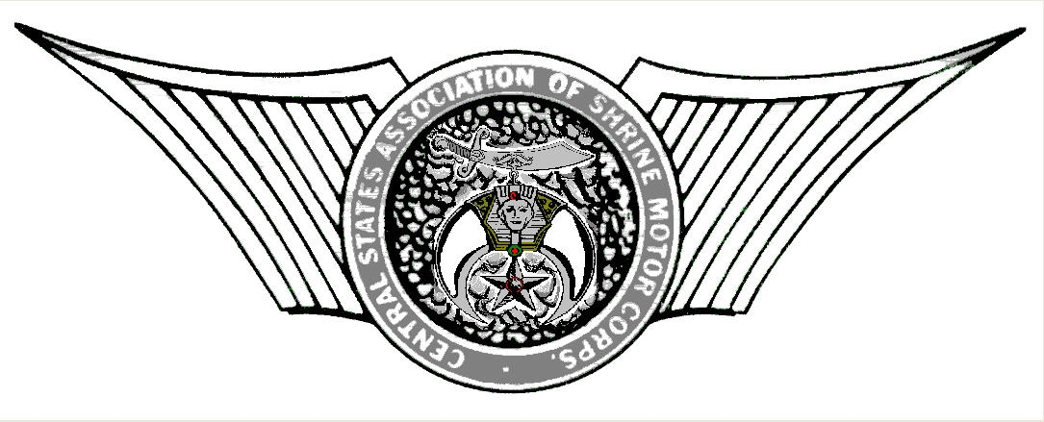
January 8, 2021

Nobles,
Please find in the enclosed mailing the dues remittance sheet for 2021 dues for CSASMC. Dues for 2021
are only $10.00 per member, with a $75.00 per unit or club minimum if paid to the Secretary prior to March 1, 2021. Any dues received after March 1 will be $11.00 per member. Please keep in mind that the CSASMC By Laws require dues payment for all members of the Unit, not just those attending CSSA. If you have any questions concerning this requirement please feel free to give me a call.

Any Unit whose membership exceeds 25 members, need only pay the maximum dues cap which is $250.00, or $275.00 if paid after March 1. Please list all members so dues cards can be printed to allow them to participate in all CSASMC activities. If you have new members to your Unit after dues have been submitted, please forward their name with their dues and I will print a card for them. No dues will be required for new members if you exceed the 25 member dues cap, but please send me their name so I can print them a dues card. If you have a printed copy of your Unit membership, that may be submitted in lieu of listing individual names on the dues sheet. That same membership list may also be e- mailed to csmotorcorps@cox.net. Also please submit the name, address, e-mail address, and phone numbers of the Officer in Charge, and Secretary to receive all CSASMC information. If any member would like to be added to the Secretary’s e mail list, please indicate those on the dues remittance sheet. Please write those addresses neatly so they can be read. I have many e- mails returned because of wrong addresses. Those returned will be deleted from the list. If you have too many members to fill out the worksheet a roster is acceptable but please add the required information stated above on the work sheet.

On August 22, 2020 an interim board meeting was convened in Oklahoma City at the India Temple.
It was motioned and seconded all elected line officers be advanced to the next office and the presiding President be a past president. It was also motioned and seconded that all members who paid dues in 2020 will have those dues carried over to 2021. For those of you in St. Louis that means if you paid last year, you don’t have to pay this year. WE STILL NEED THE DUES WORKSHEET SO WE CAN PRINT MEMBERSHIP CARDS. WITHOUT A MEMBERSHIP CARD YOU CANNOT PARTICIPATE IN MIDWINTER OR CSSA ACTIVITIES.

The 2021 CSASMC Mid Winter Meeting will be April 22, 2021 to April 25, 2021 in St. Louis, MO.. Additional information is attached in a PDF titled Midwinter Meeting and is being sent to all Units according to the latest information available to the Secretary. All CSASMC information is also available on our website at csasmc.org.

Fraternally yours,
Gary W Shepherd

Gary W Shepherd
Sec.-Treas. CSASMC

